CSS GENDER STUDIES
PR
The Prediction Papers
CSS Gender Studies — three complete papers set as FPSC prints them, with explained MCQ answers and full model answers
WHAT THIS DOCUMENT GIVES YOU
◆ Three complete CSS Gender Studies papers in the FPSC format — Part I (20 MCQs) and Part II (Q. No. 2 to Q. No. 8)
◆ Set 1 — the most probable paper
◆ Set 2 — a difficult paper (about 70% difficult, 30% medium)
◆ Set 3 — a mixed paper of probable and difficult questions
◆ Every MCQ explained, with the answer in bold straight after each question
◆ Full model answers to all 25 descriptive items (1,050–1,350 words
◆ short notes 580–650), each with an answer map, decoding, headed model answer, figures and why it scores
◆ The reasoning behind every predicted question, and a coverage map of all seven topics and every blind spot
Federal Public Service Commission · CSS Competitive Examination · Optional paper, 100 marks
Written for CE-2027 onwards · Record: CE-2016 to CE-2026 · Facts current to October 2026

Contents
HOW TO BUILD THE CONTENTS
The contents list below fills itself in. When Word asks "This document contains fields that may refer to other files. Update the fields?", click Yes.
If it does not ask: right-click the grey contents area → Update Field → Update entire table → OK. On a Mac, Control-click the same area. Or press Ctrl + A, then F9 (Windows), to update every field at once. Repeat after any edit, before you export to PDF.

Right-click here and choose Update Field to build the contents.

How to Use This Volume

What this volume is
This volume contains three complete prediction papers for the CSS Gender Studies examination, each set exactly as the Federal Public Service Commission prints the paper: the Roll Number box, the heading, the time-and-marks lines, the printed NOTE, Part-I (Q. No. 1, twenty MCQs with options (a) to (d)) and Part-II (Q. No. 2 to Q. No. 8, attempt any four, 20 marks each, with one question of short notes).
Table 1 · The three sets at a glance.
Set | Design | What it tests
Set 1 | The most probable paper | The questions the record makes most likely for the next paper: the families that rotate back, the blind spots most likely to break, and the 2023–2026 style of long, current stems
Set 2 | The difficult paper: about 70% difficult, 30% medium | Theory-heavy and cross-topic questions — historicizing constructionism, men's feminism, the political economy of adjustment, Galtung, the "Western import" debate — that separate high scorers from the rest
Set 3 | The mixed paper | Probable and medium questions alongside difficult ones — the shape of most real papers — covering the lines the first two sets leave out

How each set is built
1. The paper — Part-I and Part-II, set as FPSC prints them. Nothing in the paper gives the answer away.
2. Part I explained — every MCQ again, with its four options and the correct answer in bold straight after it, followed by a one-line reason.
3. The model answers — one for every question in Part II, including every short note. Each model answer follows the house format of the Question Answers: the question in a box, an answer map, decoding the question, the model answer with numbered headings, sub-headings and sub-sub-headings, at least one figure besides the map, and why this answer scores.

How to sit a paper
EXAMINER'S EYE · SIT EACH PAPER AS IF IT WERE THE REAL EXAMINATION
1. Part I — 30 minutes. Answer all twenty MCQs on a separate sheet. Do not look at "Part I explained" until you have finished.
2. Choose — 10 minutes. Read all seven questions of Part II twice and choose the four where you have both theory and Pakistani evidence.
3. Write — about 30 minutes per question. Draw a quick answer map in the margin, then write 1,000–1,300 words under numbered headings, with at least one diagram.
4. Mark yourself. Compare each answer with the model: did you answer every limb of the question? Did each heading carry a thinker, a law or a dated figure? Did you include a figure, a Pakistani angle and a judgement?
5. Space the papers out. Sit Set 1 three weeks before the examination, Set 3 two weeks before and Set 2 one week before.

How the Papers Were Set

The method
No one can predict a paper. But the eleven papers from 2016 to 2026 show clear patterns, analysed in the Master Anatomy, and the three sets are built on them:
1. The rotation of families. The examiner returns to a small number of question families — gender-based violence, WID/WAD/GAD, the waves, the movement in Pakistan, development theories, social construction, quotas — in new forms.
2. The blind spots. Syllabus lines never asked as a descriptive question are filled sooner or later. Every Tier 3 blind spot of the Master Anatomy appears at least once across the three sets.
3. The contemporary layer. Since 2024 the examiner has named reports, laws and figures from the previous year or two. Every set includes current material: the 2025–2026 laws, the Global Gender Gap reports of 2025 and 2026, the 2024 elections, Beijing+30, the IMF programmes of 2023–2024 and the digital gender gap.
4. The objective paper's shift to theory. The MCQs are weighted like the 2023–2026 papers — more concepts and thinkers than dates — with several keys of "None of these", as in 2026.
5. Topics 1, 4 and 7 in every set, as the Master Anatomy's format requires.

Every descriptive question, and why it was set
Table 2 · The 25 descriptive items across the three sets.
Set · Q | Topic | Question (in short) | Why it was set
1 · 2 | T1 | Women's to Gender Studies; status in Pakistan; autonomy versus integration | The discipline half of T1, asked four times, silent since 2023
1 · 3 | T7 | The domestic-violence laws, 2013–2025, and why legislation alone fails | GBV in 9 of 11 papers; the Islamabad law of 2025 completes the set
1 · 4 | T4 | Gender mainstreaming: tools, achievements, limits | The next angle on WID/WAD/GAD; never asked in full
1 · 5 | T3 | The fourth wave, #MeToo and the Aurat March | The waves asked five times; the fourth wave is the next step
1 · 6 | T5 | Women's education and Article 25A | The clearest blind spot in the paper
1 · 7 | T6 | Women as voters and candidates; Elections Act 2017; 2024 elections | A blind spot with rich, current data
1 · 8(a) | T2 | Liberal feminism | The most famous school, never asked alone
1 · 8(b) | T3 | The UN World Conferences and Beijing+30 | Never a descriptive question; Beijing+30 in 2025
2 · 2 | T1 | Historicizing constructionism; is the sex/gender distinction constructed? | A syllabus line never asked by name; follows the 2024 and 2026 questions
2 · 3 | T2 | Men's feminism, Connell and the manosphere | Never asked in either part of the paper
2 · 4 | T4 | Structural adjustment, IMF programmes 2023–2024 and the care economy | Asked once (2022); IMF programmes make it topical
2 · 5 | T7 | Honour killing through Galtung's triangle; the 2004 and 2016 laws | Galtung named in 2019; honour killing a constant
2 · 6 | T3 | "Feminism is a Western import" | The most common objection to feminism in Pakistan; joins T2 and T3
2 · 7 | T5 | Family law: MFLO 1961 and the child-marriage laws | Women and law asked directly only once; new laws of 2025–2026
2 · 8(a) | T6 | Gender and good governance | Defining governance has never been asked
2 · 8(b) | T4 | World-system theory and the sexual division of labour | Asked only as a partner of other theories (2019, 2025)
3 · 2 | T1 | Gender roles, stereotypes and the agents that make them | A reliable construction question in a new, applied form
3 · 3 | T4 | BISP through Moser and Kabeer | GAD applied to Pakistan's largest programme
3 · 4 | T2 | Patriarchy: radical, Marxist and socialist explanations | Schools of feminism recur as full questions and notes
3 · 5 | T5 | Women's paid work (24.4%) and unpaid care | Asked in 2019; new LFS data
3 · 6 | T6 | Reserved seats and substantive representation | Quotas asked six times; a harder evaluative angle
3 · 7 | T7 | Mukhtaran Mai, Malala and Sharmeen Obaid-Chinoy compared | Each asked singly; the comparison never
3 · 8(a) | T7 | Technology-facilitated violence | The digital layer of the 2026 paper
3 · 8(b) | T4 | SDG 5 and Pakistan's progress | The SDGs never asked in full
3 · 8(c) | T5 | The National Commission on the Status of Women | An MCQ favourite, never a descriptive question

Coverage of the seven topics
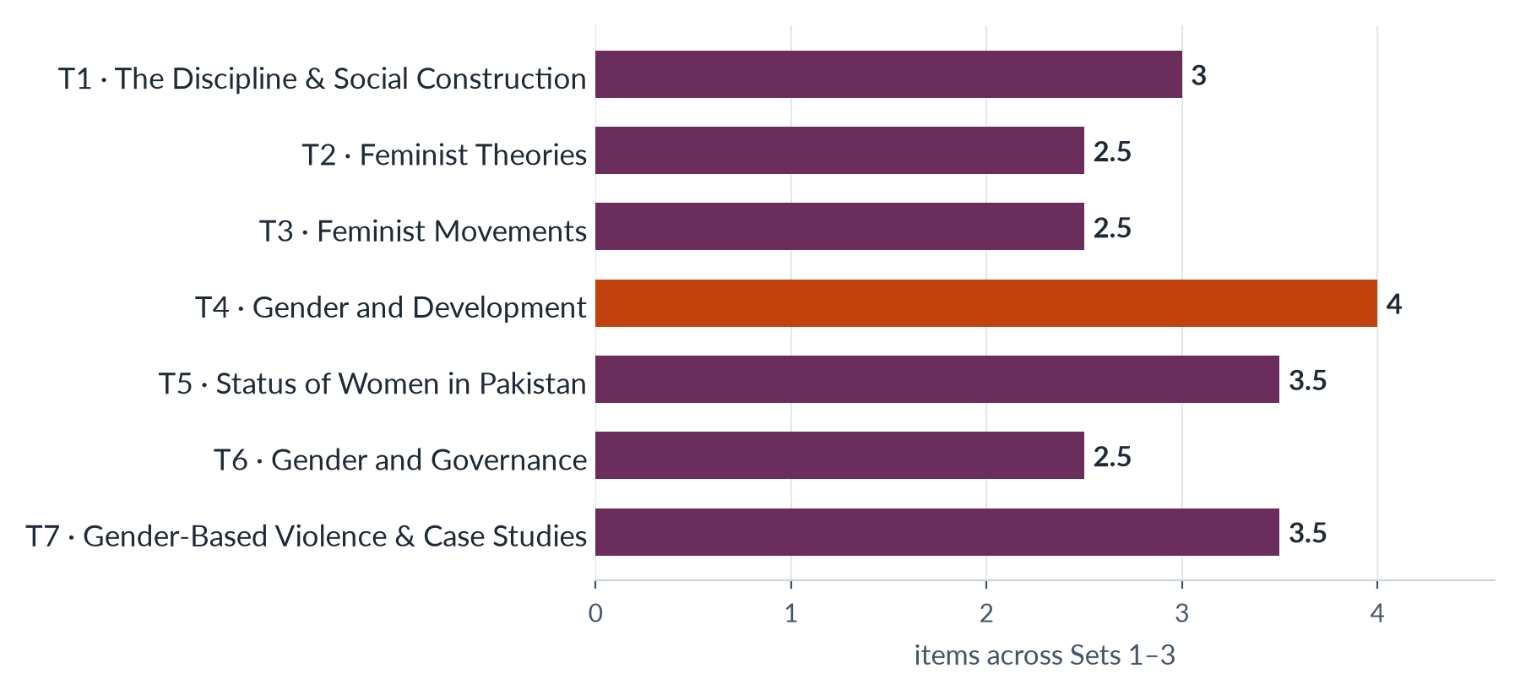
Figure 1 · Descriptive items per topic across the three sets (full question = 1; short note = ½).
The spread follows the record — Topic 4, the heaviest topic, has the most items — with Topic 5 raised slightly because two of the Master Anatomy's Tier 3 blind spots (education and women and law) belong to it.

The blind spots covered
Table 3 · Every Tier 3 blind spot of the Master Anatomy appears at least once.
Blind spot | Topic | Where it is set
Status of women in education | T5 | Set 1 · Q. No. 6
United Nations Conferences on Women | T3 | Set 1 · Q. No. 8(b)
Women as voters | T6 | Set 1 · Q. No. 7
Defining governance | T6 | Set 2 · Q. No. 8(a)
Men's feminism | T2 | Set 2 · Q. No. 3
Liberal feminism on its own | T2 | Set 1 · Q. No. 8(a)
Women and law — family law, inheritance, child-marriage laws | T5 | Set 2 · Q. No. 7
Historicizing constructionism | T1 | Set 2 · Q. No. 2
World-system theory on its own | T4 | Set 2 · Q. No. 8(b)
The SDGs | T4 | Set 3 · Q. No. 8(b)
A comparison of the three case studies | T7 | Set 3 · Q. No. 7

Set 1 · The Most Probable Paper
The paper the record makes most likely: families that are due to return, the blind spots most likely to break, and the long, current stems of the 2023–2026 papers.
Set 1 brings back the discipline half of Topic 1 (silent since 2023), asks about gender-based violence through the newest laws, turns WID/WAD/GAD to its next angle (mainstreaming) and the waves to the fourth wave, and breaks three blind spots — education, women as voters and the UN conferences. Its MCQs mirror the recent objective papers, with four keys of "None of these".

Roll Number
FEDERAL PUBLIC SERVICE COMMISSION
COMPETITIVE EXAMINATION-2027
FOR RECRUITMENT TO POSTS IN BS-17
UNDER THE FEDERAL GOVERNMENT
GENDER STUDIES

TIME ALLOWED: THREE HOURS TOTAL MARKS: 100
PART-I (MCQS): MAXIMUM 30 MINUTES PART-I (MCQS): MAXIMUM MARKS = 20
PART-II PART-II: MAXIMUM MARKS = 80

NOTE: | (i) First attempt PART-I (MCQS) on separate Answer Sheet which shall be taken back after 30 minutes.
 | (ii) Overwriting/cutting of the options/answers will not be given credit.

PART-I (MCQS) (COMPULSORY)
Q. No. 1. (i) Select the best option/answer and fill in the appropriate box on the Answer Sheet.
(ii) Answers given anywhere else, other than Answer Sheet, will not be considered. (20×1=20)
1. The distinction between "sex" and "gender" was brought into sociology by:
(a) Ann Oakley | (b) Talcott Parsons | (c) Émile Durkheim | (d) None of these
2. According to Judith Butler, gender is:
(a) A biological fact fixed at birth | (b) A stable inner essence
(c) A role chosen once and for all | (d) None of these
3. The term "hegemonic masculinity" was coined by:
(a) Michael Kimmel | (b) Michael Kaufman | (c) Judith Lorber | (d) None of these
4. Which statement about androgyny is correct?
(a) It means having no gender traits
(b) It is a medical condition
(c) It combines positive masculine and feminine traits
(d) It is a form of queer theory
5. A Vindication of the Rights of Woman (1792) was written by:
(a) Mary Wollstonecraft | (b) Harriet Taylor Mill | (c) Olympe de Gouges | (d) None of these
6. "The personal is political" is most closely associated with:
(a) Liberal feminism | (b) Postmodern feminism | (c) Radical feminism | (d) None of these
7. The term "intersectionality" was coined by:
(a) Patricia Hill Collins | (b) bell hooks | (c) Audre Lorde | (d) None of these
8. Betty Friedan's The Feminine Mystique (1963) described:
(a) The sex class | (b) The problem that has no name
(c) The male gaze | (d) The second shift
9. Pakistan acceded to CEDAW in:
(a) 1981 | (b) 1996 | (c) 2000 | (d) 2006
10. The Beijing Platform for Action (1995) identified how many critical areas of concern?
(a) 10 | (b) 12 | (c) 15 | (d) 20
11. The Women's Action Forum was formed in:
(a) 1981 | (b) 1983 | (c) 1986 | (d) None of these
12. Gender mainstreaming was adopted as a global strategy by:
(a) CEDAW (1979) | (b) The Nairobi Conference (1985)
(c) The Mexico City Conference (1975) | (d) None of these
13. Woman's Role in Economic Development (1970), the founding text of WID, was written by:
(a) Caroline Moser | (b) Naila Kabeer | (c) Ester Boserup | (d) None of these
14. SDG target 5.5 concerns:
(a) Violence against women
(b) Child marriage
(c) Women's participation and leadership in decision-making
(d) Unpaid care work
15. Article 25A of the Constitution of Pakistan provides for:
(a) Free and compulsory education for children aged 5 to 16
(b) Equality of citizens
(c) Protection of marriage and the family
(d) None of these
16. Pakistan's rank in the World Economic Forum's Global Gender Gap Report 2025 was:
(a) 143rd | (b) 145th | (c) 146th | (d) None of these
17. How many seats are reserved for women in the National Assembly of Pakistan?
(a) 50 | (b) 60 | (c) 70 | (d) None of these
18. Under section 206 of the Elections Act 2017, political parties must award women at least:
(a) 5% of general-seat tickets | (b) 10% of general-seat tickets
(c) 17% of general-seat tickets | (d) 33% of general-seat tickets
19. The Protection against Harassment of Women at the Workplace Act was passed in:
(a) 2006 | (b) 2010 | (c) 2016 | (d) None of these
20. The "cycle of violence" (tension building, acute battering, loving contrition) was described by:
(a) Evan Stark | (b) Liz Kelly | (c) Lenore Walker | (d) None of these
**********

Roll Number
FEDERAL PUBLIC SERVICE COMMISSION
COMPETITIVE EXAMINATION-2027
FOR RECRUITMENT TO POSTS IN BS-17
UNDER THE FEDERAL GOVERNMENT
GENDER STUDIES

TIME ALLOWED: THREE HOURS TOTAL MARKS: 100
PART-I (MCQS): MAXIMUM 30 MINUTES PART-I (MCQS): MAXIMUM MARKS = 20
PART-II PART-II: MAXIMUM MARKS = 80

NOTE: | (i) Part-II is to be attempted on the separate Answer Book.
 | (ii) Attempt ONLY FOUR questions from PART-II. ALL questions carry EQUAL marks.
 | (iii) All the parts (if any) of each Question must be attempted at one place instead of at different places.
 | (iv) Write Q. No. in the Answer Book in accordance with Q. No. in the Q. Paper.
 | (v) No Page/Space be left blank between the answers. All the blank pages of Answer Book must be crossed.
 | (vi) Extra attempt of any question or any part of the question will not be considered.

PART-II
Q. No. 2. Trace the evolution of Women's Studies into Gender Studies. Critically evaluate the status of Gender Studies as an academic discipline in Pakistan and give your views on the autonomy versus integration debate. (20)
Q. No. 3. Since 2013, every province and the Islamabad Capital Territory has enacted a law against domestic violence. Critically evaluate this legal framework. Why has legislation alone failed to reduce violence against women in Pakistan, and what workable strategies would you suggest? (20)
Q. No. 4. What is gender mainstreaming? Discuss its tools, and evaluate its achievements and limitations as the strategy of the Gender and Development (GAD) approach, with reference to Pakistan. (20)
Q. No. 5. Discuss the key features of the fourth wave of feminism. How have digital activism, the #MeToo movement and the Aurat March reshaped feminist activism in Pakistan, and what backlash have they faced? (20)
Q. No. 6. Discuss the status of women's education in Pakistan in the light of Article 25A of the Constitution. What are the causes of the gender gap in education, and what measures would you suggest to close it? (20)
Q. No. 7. Discuss the gender issues faced by women as voters and as candidates in Pakistan. How far have the provisions of the Elections Act 2017 addressed these issues? Refer to the General Elections 2024 in your answer. (20)
Q. No. 8. Write short notes on the following: (10+10)
(a) Liberal Feminism.
(b) The United Nations World Conferences on Women and Beijing+30.
**********

Set 1 · Part I Explained
Each MCQ of Set 1 with its options. The correct answer is printed in bold straight after each question, with a one-line reason.
1. The distinction between "sex" and "gender" was brought into sociology by:
(a) Ann Oakley (b) Talcott Parsons (c) Émile Durkheim (d) None of these
Answer: (a) Ann Oakley — Ann Oakley, Sex, Gender and Society (1972), building on Money (1955) and Stoller (1968).
2. According to Judith Butler, gender is:
(a) A biological fact fixed at birth (b) A stable inner essence (c) A role chosen once and for all (d) None of these
Answer: (d) None of these — For Butler gender is performative: it is produced by repeated, stylised acts (Gender Trouble, 1990).
3. The term "hegemonic masculinity" was coined by:
(a) Michael Kimmel (b) Michael Kaufman (c) Judith Lorber (d) None of these
Answer: (d) None of these — R. W. (Raewyn) Connell (Gender and Power, 1987; Masculinities, 1995).
4. Which statement about androgyny is correct?
(a) It means having no gender traits (b) It is a medical condition (c) It combines positive masculine and feminine traits (d) It is a form of queer theory
Answer: (c) It combines positive masculine and feminine traits — Sandra Bem's androgyny: high on both positive masculine and positive feminine traits.
5. A Vindication of the Rights of Woman (1792) was written by:
(a) Mary Wollstonecraft (b) Harriet Taylor Mill (c) Olympe de Gouges (d) None of these
Answer: (a) Mary Wollstonecraft — Mary Wollstonecraft, the founding text of liberal feminism; she blamed women's "weakness" on lack of education.
6. "The personal is political" is most closely associated with:
(a) Liberal feminism (b) Postmodern feminism (c) Radical feminism (d) None of these
Answer: (c) Radical feminism — Radical feminism of the second wave; the phrase is the title of Carol Hanisch's essay (1969–70).
7. The term "intersectionality" was coined by:
(a) Patricia Hill Collins (b) bell hooks (c) Audre Lorde (d) None of these
Answer: (d) None of these — Kimberlé Crenshaw (1989). Collins added the "matrix of domination" (1990).
8. Betty Friedan's The Feminine Mystique (1963) described:
(a) The sex class (b) The problem that has no name (c) The male gaze (d) The second shift
Answer: (b) The problem that has no name — "The problem that has no name" — the unhappiness of educated American housewives.
9. Pakistan acceded to CEDAW in:
(a) 1981 (b) 1996 (c) 2000 (d) 2006
Answer: (b) 1996 — 12 March 1996, with a declaration and a reservation to Article 29(1).
10. The Beijing Platform for Action (1995) identified how many critical areas of concern?
(a) 10 (b) 12 (c) 15 (d) 20
Answer: (b) 12 — Twelve critical areas, labelled A to L (for example D: violence; G: power and decision-making).
11. The Women's Action Forum was formed in:
(a) 1981 (b) 1983 (c) 1986 (d) None of these
Answer: (a) 1981 — Karachi, 1981, after the Fehmida–Allah Bux case under the Zina Ordinance.
12. Gender mainstreaming was adopted as a global strategy by:
(a) CEDAW (1979) (b) The Nairobi Conference (1985) (c) The Mexico City Conference (1975) (d) None of these
Answer: (d) None of these — The Beijing Platform for Action (1995).
13. Woman's Role in Economic Development (1970), the founding text of WID, was written by:
(a) Caroline Moser (b) Naila Kabeer (c) Ester Boserup (d) None of these
Answer: (c) Ester Boserup — Ester Boserup (1970).
14. SDG target 5.5 concerns:
(a) Violence against women (b) Child marriage (c) Women's participation and leadership in decision-making (d) Unpaid care work
Answer: (c) Women's participation and leadership in decision-making — Target 5.5: women's full participation and equal opportunities for leadership (5.2 violence; 5.3 child marriage; 5.4 unpaid care).
15. Article 25A of the Constitution of Pakistan provides for:
(a) Free and compulsory education for children aged 5 to 16 (b) Equality of citizens (c) Protection of marriage and the family (d) None of these
Answer: (a) Free and compulsory education for children aged 5 to 16 — Article 25A, added by the 18th Amendment (2010); Article 25 is equality, Article 35 the family.
16. Pakistan's rank in the World Economic Forum's Global Gender Gap Report 2025 was:
(a) 143rd (b) 145th (c) 146th (d) None of these
Answer: (d) None of these — 148th of 148 (last), with 56.7% of the gap closed; it rose to 143rd of 145 in 2026.
17. How many seats are reserved for women in the National Assembly of Pakistan?
(a) 50 (b) 60 (c) 70 (d) None of these
Answer: (b) 60 — 60 of 336 seats (created by the Legal Framework Order 2002).
18. Under section 206 of the Elections Act 2017, political parties must award women at least:
(a) 5% of general-seat tickets (b) 10% of general-seat tickets (c) 17% of general-seat tickets (d) 33% of general-seat tickets
Answer: (a) 5% of general-seat tickets — 5%. Section 9 lets the ECP void a poll where women's turnout is below 10%.
19. The Protection against Harassment of Women at the Workplace Act was passed in:
(a) 2006 (b) 2010 (c) 2016 (d) None of these
Answer: (b) 2010 — 2010; amended in 2022 to widen "workplace" and "employee".
20. The "cycle of violence" (tension building, acute battering, loving contrition) was described by:
(a) Evan Stark (b) Liz Kelly (c) Lenore Walker (d) None of these
Answer: (c) Lenore Walker — Lenore Walker, The Battered Woman (1979).

Set 1 · Q. No. 2 · From Women's Studies to Gender Studies: Status in Pakistan and the Autonomy Debate
AT A GLANCE · PREDICTION PAPER SET 1 · Q. NO. 2 · 20 MARKS
Trace the evolution of Women's Studies into Gender Studies. Critically evaluate the status of Gender Studies as an academic discipline in Pakistan and give your views on the autonomy versus integration debate.

The answer map
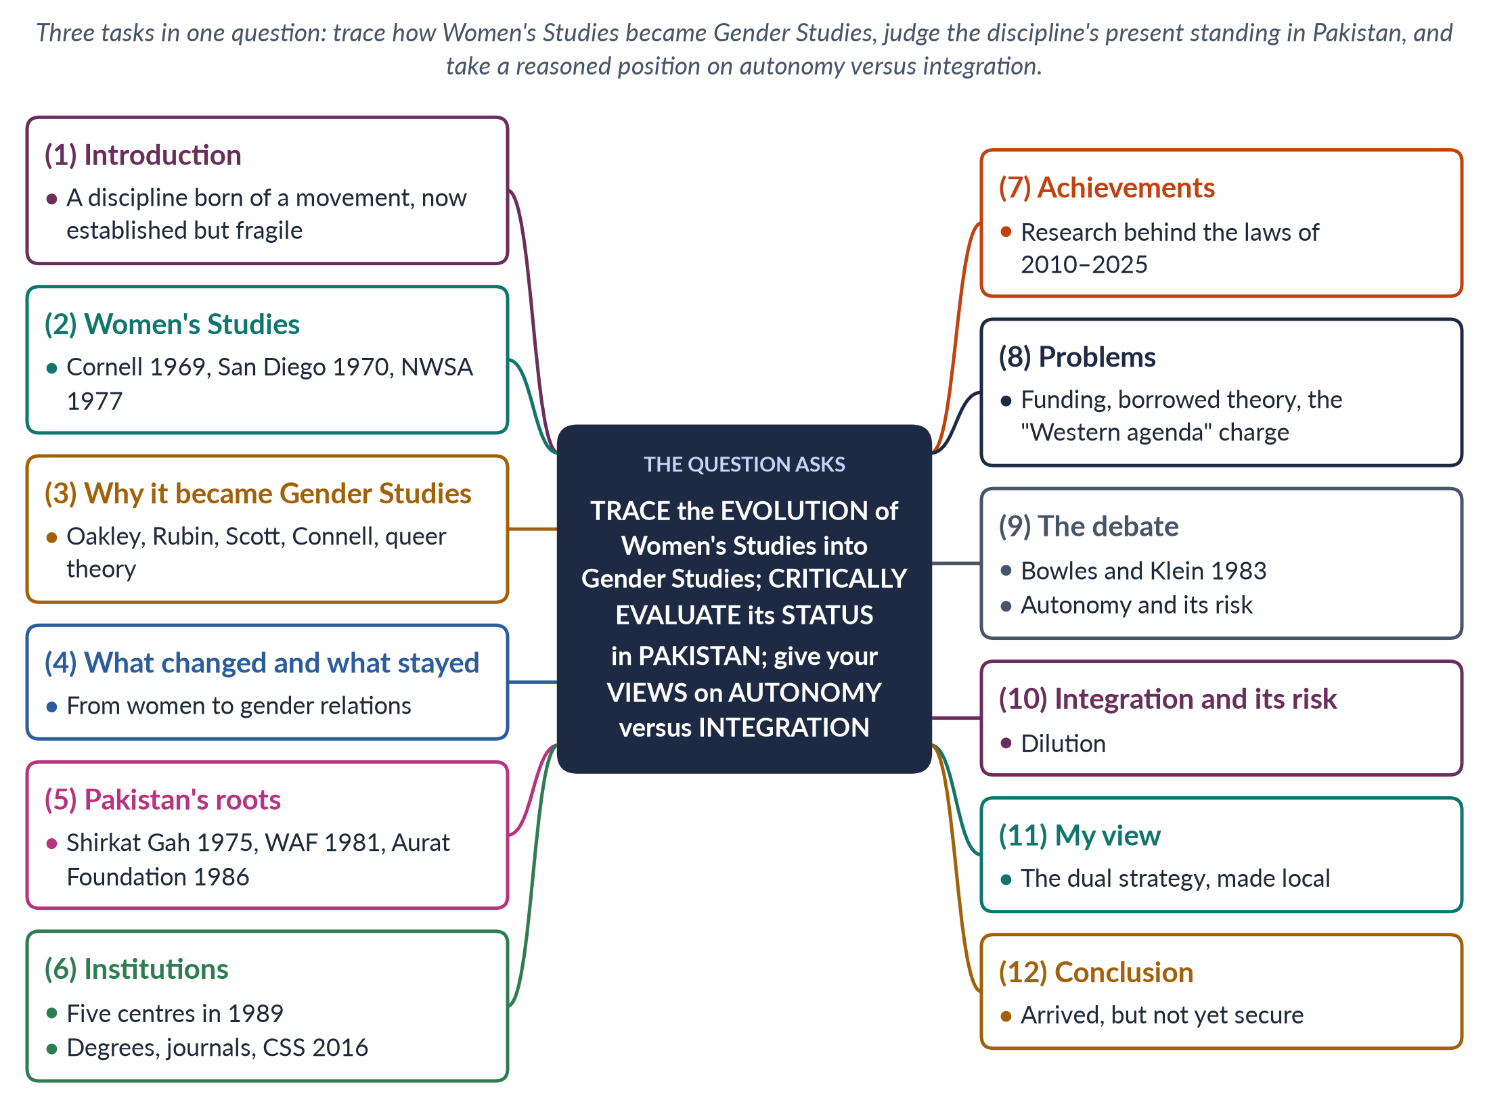
Figure 2 · The answer map: every branch is one numbered heading of the model answer below.

Decoding the question
The question has three limbs, and each needs its own headings. "Trace the evolution" asks for a dated history — from the first Women's Studies courses to Gender Studies — with the reasons for the change. "Critically evaluate the status … in Pakistan" asks for both achievements and weaknesses, ending in a judgement. "Give your views" on autonomy versus integration asks for an argued position, not just a summary of the two sides. Give each limb about a third of the answer.

The model answer

1. Introduction

i) Definition
Gender Studies is the multidisciplinary study of how society turns biological sex into gender — the roles, identities and relations of power between women and men — and how gender intersects with class, religion, region and other identities. It grew out of Women's Studies, "the academic arm of the women's movement".

ii) The argument
The discipline evolved from a woman-centred field into the study of gender relations. In Pakistan it has become established — with centres, degrees and a place in the CSS scheme — but remains fragile, short of funds, local theory and influence over other subjects. The way forward is a dual strategy: a strong autonomous base that drives integration across the university.

2. The birth of Women's Studies

i) The first courses
Women's Studies was born in the late 1960s in the United States, as second-wave feminists asked why universities taught history, economics and literature as if women did not exist. One of the first courses was taught at Cornell in 1969; the first full programme opened at San Diego State College in 1970; and the National Women's Studies Association was founded in 1977. In South Asia, India's report Towards Equality (1974) exposed women's declining status and sparked research.

ii) Its three aims

(a) Women as subject
To make women the subject of study, not a footnote to men's history.

(b) Women as knowers
To treat women as knowers whose experience counts as evidence.

(c) Research for women
To make research benefit women by informing law and policy.

3. Why Women's Studies became Gender Studies

i) The concept of gender
Ann Oakley (Sex, Gender and Society, 1972) separated biological sex from social gender; Gayle Rubin (1975) described the "sex/gender system"; and Joan Scott (1986) called gender "a primary way of signifying relationships of power".

ii) New subjects
R. W. Connell's Gender and Power (1987) founded the study of masculinities, and queer theory (around 1990) questioned fixed categories of sex and sexuality.

iii) Internal critique
bell hooks (1981) and Chandra Talpade Mohanty (1984) argued that "woman" in Women's Studies often meant only white, Western, middle-class women.

iv) The development agencies
Donors and governments moved from WID to GAD — from "women" to "gender relations" — and asked universities for gender expertise.
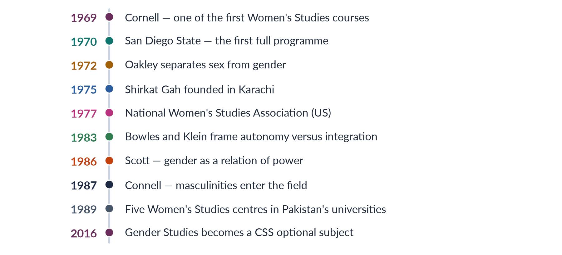
Figure 3 · From Women's Studies to Gender Studies — and to Pakistan.

4. What changed, and what stayed

i) What changed
The shift changed the subject — from women alone to gender relations among women, men and gender-diverse people — and the key idea, from women's oppression to gender as a social construction and a relation of power. It added men's studies, sexualities and intersectionality.

ii) What stayed
The feminist commitment to equality, the critique of male-centred knowledge, and the use of many disciplines.

iii) The risk, and the resolution
Critics such as Tania Modleski (Feminism Without Women, 1991) warned that "gender" could make women invisible again. The best reading is that the two are partners in one project, which is why many departments now call themselves "Women's and Gender Studies".

5. The Pakistani roots

i) Research outside the universities
In Pakistan, gender scholarship began outside the universities. Shirkat Gah (1975) and the Aurat Foundation (1986) researched women's rights, work and law.

ii) The movement as scholar
The Women's Action Forum (1981) challenged the Hudood Ordinances of 1979, producing legal and historical research. Khawar Mumtaz and Farida Shaheed's Women of Pakistan: Two Steps Forward, One Step Back? (1987) wrote the first history of the movement.

iii) Why this matters
The academic field grew from activism — a point that answers the charge that it is a foreign import.

6. Institutions: the status today

i) The 1989 centres
In 1989 the Ministry of Women's Development set up Women's Studies centres in five public universities — Quaid-i-Azam (Islamabad), Karachi, Punjab (Lahore), Peshawar and Balochistan (Quetta). The centre at Quaid-i-Azam University became the Centre of Excellence in Gender Studies.

ii) Degrees and journals
Most centres were later renamed Gender Studies and now offer degrees up to the PhD. Journals such as the Pakistan Journal of Gender Studies and Alam-e-Niswan publish local research.

iii) Official recognition
Gender Studies became a CSS optional subject from CE-2016.

7. Achievements

i) Evidence for the laws
The discipline's research on violence, law, work and health supplied the case for the workplace harassment law (2010), the acid and anti-women practices laws (2011), the honour-killing amendment (2016) and the domestic-violence laws from Sindh (2013) to Islamabad (2025).

ii) People for the state
Its graduates staff the National Commission on the Status of Women (2000) and provincial commissions, and it informed the National Policy for Development and Empowerment of Women (2002) and the Gender Reform Action Plan.

iii) Words for hidden harms
It gave the public words for hidden harms — harassment, economic abuse, the double burden.

8. Problems: a critical evaluation

i) Financial
Much research depends on short donor projects, so priorities follow funding rather than national needs.

ii) Intellectual
Teaching relies heavily on Western texts in English; local theory, Urdu and regional-language material and reliable data are thin. There are too few trained teachers, and libraries outside the big cities are poor.

iii) Political
The field faces resistance and the charge of a "Western" or "anti-family" agenda. It is often ghettoised — a small, mostly female department with little influence over law, medicine or economics.

iv) Weak impact on outcomes
The country's outcomes remain poor: Pakistan ranked 148th of 148 in the Global Gender Gap Report 2025 and 143rd of 145 in 2026.

9. The debate: autonomy and its risk

i) The source
The classic statement of the debate is Gloria Bowles and Renate Duelli Klein's Theories of Women's Studies (1983).

ii) What autonomy offers
Autonomy means a separate department with its own teachers, courses, degrees, budget and research — "a house of its own". It offers depth (from first degree to PhD), room for new theory, an independent critical voice and visibility.

iii) Its risk: ghettoisation
The field becomes a "women's corner", ignored by the rest of the university, costly to maintain and, in poorer countries, dependent on donors.

10. Integration and its risk

i) What integration offers
Integration (or mainstreaming) means carrying gender into every subject — gender in medicine's maternal health, in law's family and inheritance law, in economics' unpaid care, in planning's safe transport. It reaches every student, changes the disciplines themselves and involves men.

ii) Its risk: dilution
Gender is reduced to a single token lecture — "add a lecture and stir" — dependent on a few sympathetic teachers, with expertise and the feminist edge lost.
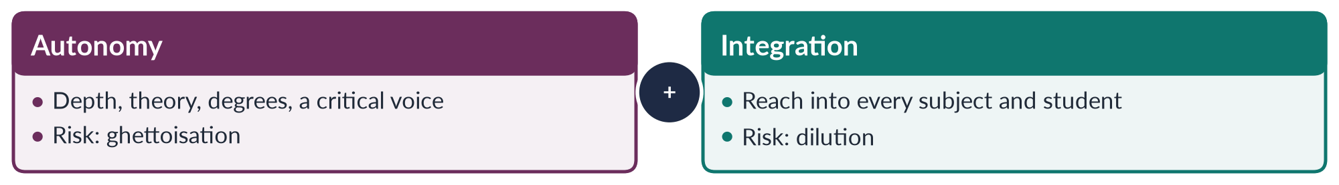
Figure 4 · Autonomy and integration — each needs the other.

11. My view: the dual strategy, made local

i) Both, not either
The debate is best resolved by a dual strategy: a strong autonomous centre that trains specialists and drives gender into other departments by training their teachers and co-teaching their courses. This mirrors the Beijing Platform's (1995) "twin track" of gender mainstreaming plus special measures.

ii) For Pakistan
Pakistan built autonomy first (1989) but integration remains weak.

(a) Integrate the core subjects
Gender modules in medicine, law, economics, education and civil-service training.

(b) Fund and localise
Steady HEC funding instead of donor cycles, and local research in Urdu and regional languages.

(c) Link to the state
Partnerships with the NCSW, the Bureau of Statistics and the Women's Parliamentary Caucus. Integration grounded in Pakistani data is also the best answer to the "Western agenda" charge.

12. Conclusion

i) The evolution in a sentence
Women's Studies became Gender Studies as the idea of gender, the study of men and masculinities, queer theory and intersectionality widened its gaze from women to the relations of power between the sexes.

ii) The verdict
In Pakistan the discipline, rooted in the women's movement and institutionalised in 1989, has arrived — it has degrees, research, influence on the laws of 2010–2025 and a CSS paper. But it is not yet secure. A dual strategy — autonomy as the engine, integration as the road — offers the surest way to move it from the margins to the mainstream.

Why this answer scores
- Answers all three limbs under separate headings: the evolution, the status and a clear view.
- The evolution is dated (1969, 1970, 1972, 1977, 1986, 1987) and explains why the shift happened.
- The status is evaluated, not described: achievements are matched by financial, intellectual and political problems.
- The view is argued — the dual strategy, adapted to Pakistan — and answers the "Western agenda" charge.
- A timeline and a compare figure show the argument at a glance.

Set 1 · Q. No. 3 · The Domestic-Violence Laws: Why Legislation Alone Has Not Been Enough
AT A GLANCE · PREDICTION PAPER SET 1 · Q. NO. 3 · 20 MARKS
Since 2013, every province and the Islamabad Capital Territory has enacted a law against domestic violence. Critically evaluate this legal framework. Why has legislation alone failed to reduce violence against women in Pakistan, and what workable strategies would you suggest?

The answer map
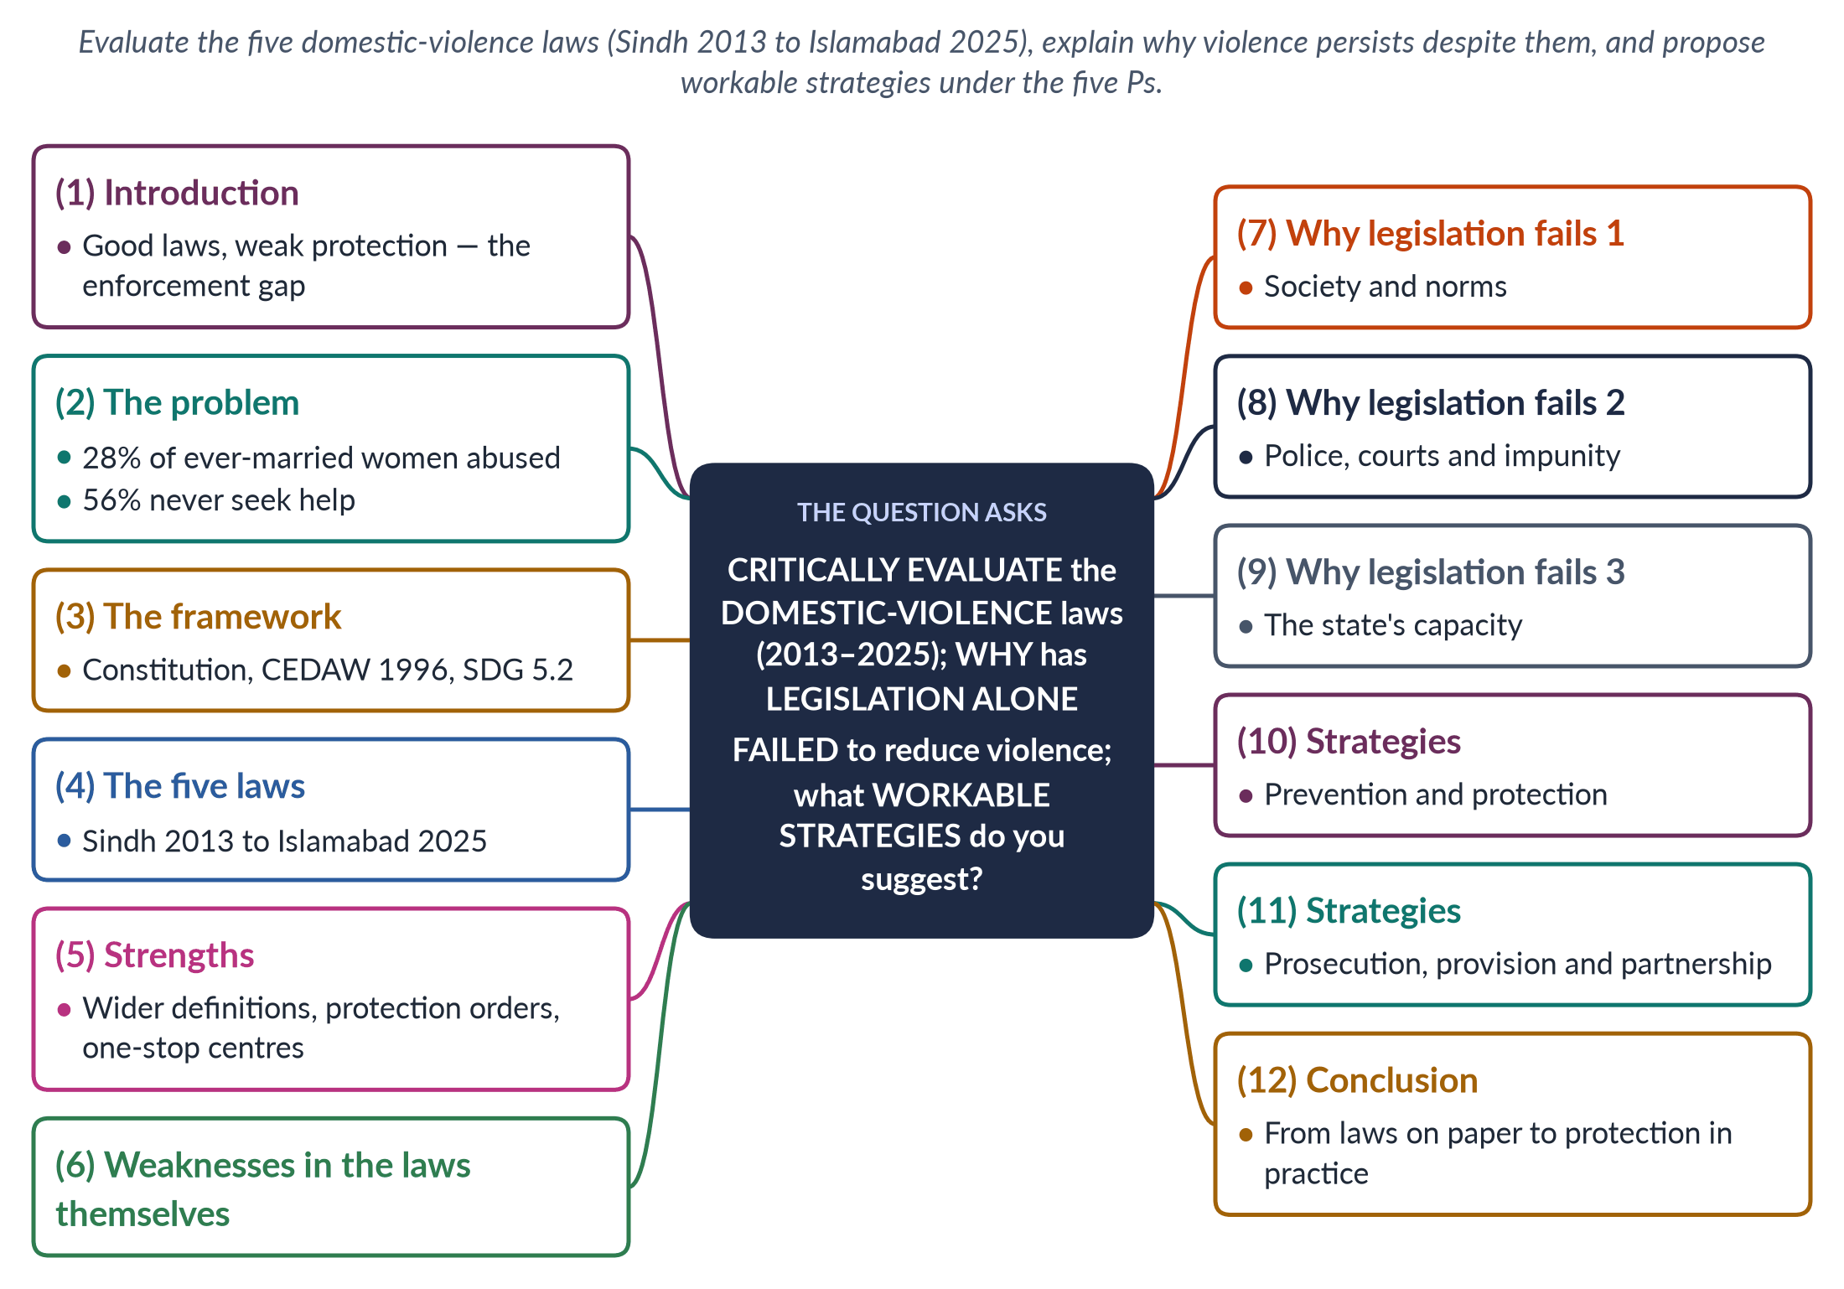
Figure 5 · The answer map: every branch is one numbered heading of the model answer below.

Decoding the question
The stem gives a fact — every province and Islamabad now has a domestic-violence law — and asks three things. "Critically evaluate" the legal framework: its strengths and weaknesses. "Why has legislation alone failed" asks for causes, best organised by level (society, institutions, state). "Workable strategies" means realistic measures, not slogans. Name each law with its year, and use dated data (PDHS 2017–18; SSDO 2024).

The model answer

1. Introduction

i) Definition
Domestic violence is physical, sexual, psychological or economic abuse by a person with whom a woman lives or has lived in a household — a husband, in-law, father or brother. The UN's Declaration on the Elimination of Violence against Women (1993) names the family as the first site of violence.

ii) The argument
Between 2013 and 2025 Pakistan filled a long legal gap: Sindh, Balochistan, Punjab, Khyber Pakhtunkhwa and the Islamabad Capital Territory all enacted domestic-violence laws. The laws are progressive in design but have had limited effect, because violence is rooted in patriarchal norms, sustained by weak enforcement and impunity, and met by a state with little capacity. Laws are necessary, but only a five-P strategy can turn them into protection.

2. The scale of the problem

i) The survey evidence
The Pakistan Demographic and Health Survey 2017–18 found that 28% of ever-married women had experienced physical violence since age 15, and 34% had experienced spousal physical, sexual or emotional violence.

ii) The silence
Most suffer in silence: 56% never sought help.

iii) The justice gap
The Sustainable Social Development Organization recorded 32,617 cases of gender-based violence in 2024, with conviction rates of about 0.5% for rape and honour killing. The gap between the scale of abuse and the response of the law is the core of the problem.

3. The legal framework

i) The Constitution
The Constitution guarantees security of person (Article 9), dignity (Article 14), equality and special measures for women (Article 25) and protection of the family (Article 35).

ii) International commitments
Pakistan acceded to CEDAW in 1996; its General Recommendations 19 (1992) and 35 (2017) treat gender-based violence as discrimination. Pakistan has also committed to SDG target 5.2 — eliminating all violence against women and girls — and its GSP+ trade status (2014) depends on implementing human-rights conventions.

4. The five laws

i) Why five laws
After the 18th Amendment (2010) made the subject provincial, each legislature acted separately.
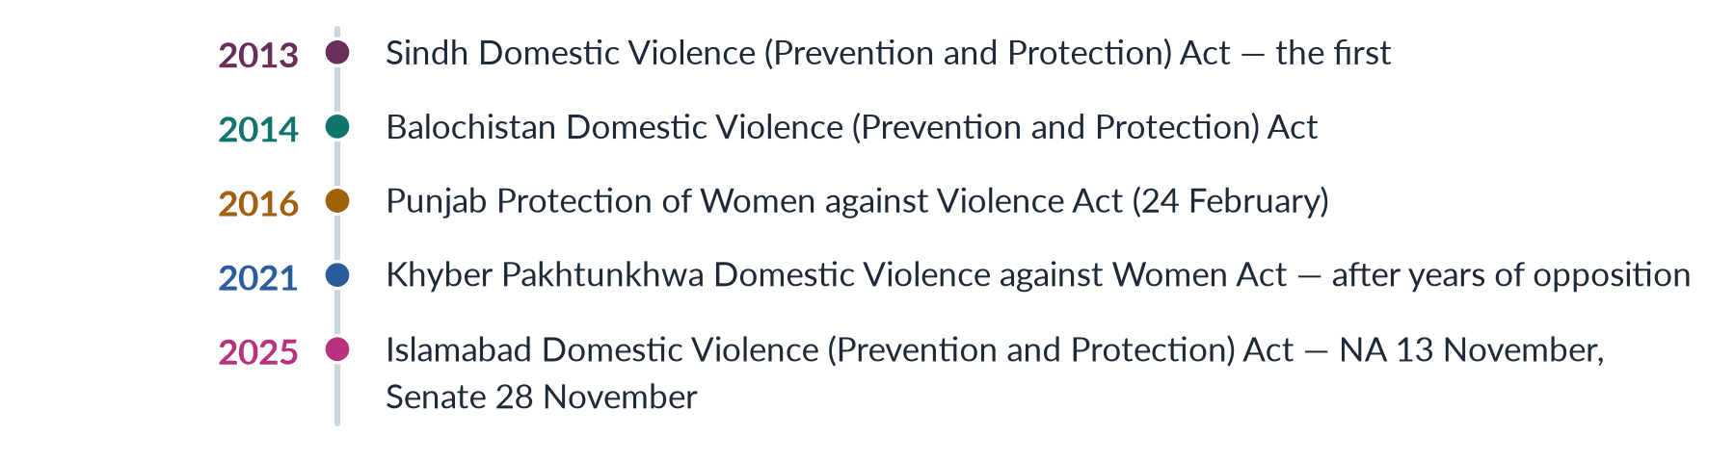
Figure 6 · Pakistan's domestic-violence laws, 2013–2025.

ii) The model law: Punjab 2016

(a) What counts as violence
Section 2(r) recognises domestic violence, sexual violence, psychological abuse, economic abuse, stalking and cybercrime.

(b) Procedure
Complaints go to the Family Court, which must decide within 90 days.

(c) Remedies
Interim, protection, residence and monetary orders, including a GPS bracelet for grave violence.

5. Strengths of the framework

i) Wider definitions
The laws recognise that violence is not only beating: economic abuse (denying food, clothing or a woman's own income) and psychological abuse are now named in law.

ii) Civil remedies
Protection and residence orders let a woman stay safely in her home rather than lose it — a practical relief that criminal law alone never offered.

iii) Institutions
The Punjab Act created District Women Protection Committees, Women Protection Officers and one-stop Violence against Women Centres — the first opened in Multan in 2017 — bringing police, doctors, prosecutors and counsellors under one roof.

6. Weaknesses in the laws themselves

i) Uneven protection
The laws differ from province to province in definitions and penalties, so a woman's protection depends on where she lives.

ii) Mediation and light penalties
Several rely on mediation and reconciliation, which can push women back into abusive homes. Penalties for breach are light — up to one year for a first breach in Punjab.

iii) Organised resistance
The Council of Islamic Ideology and religious parties called the Punjab Act a threat to the family, delaying its rules and centres, while the Khyber Pakhtunkhwa law took years to pass.

7. Why legislation fails: society and norms

i) Violence as "discipline"
Many men — and many women — still believe a husband may "discipline" his wife; the PDHS found wide acceptance of wife-beating for at least one reason.

ii) Honour and dependence
Ideas of izzat and ghairat make a complaint a family dishonour. Women's economic dependence — female labour-force participation is only 24.4% (LFS 2024–25) — and denial of inheritance leave them nowhere to go.

iii) Learned violence
Social learning theory (Bandura) explains how violence passes from parents to children.

8. Why legislation fails: police, courts and impunity

i) The police
Police refuse or delay FIRs, urge "compromise" and lack women officers. Investigation and forensics are weak.

ii) The courts
Courts are slow, witnesses turn hostile and families pressure women to withdraw.

iii) Impunity
The result is a conviction rate of about 0.5% — and impunity, which teaches abusers that violence is costless.
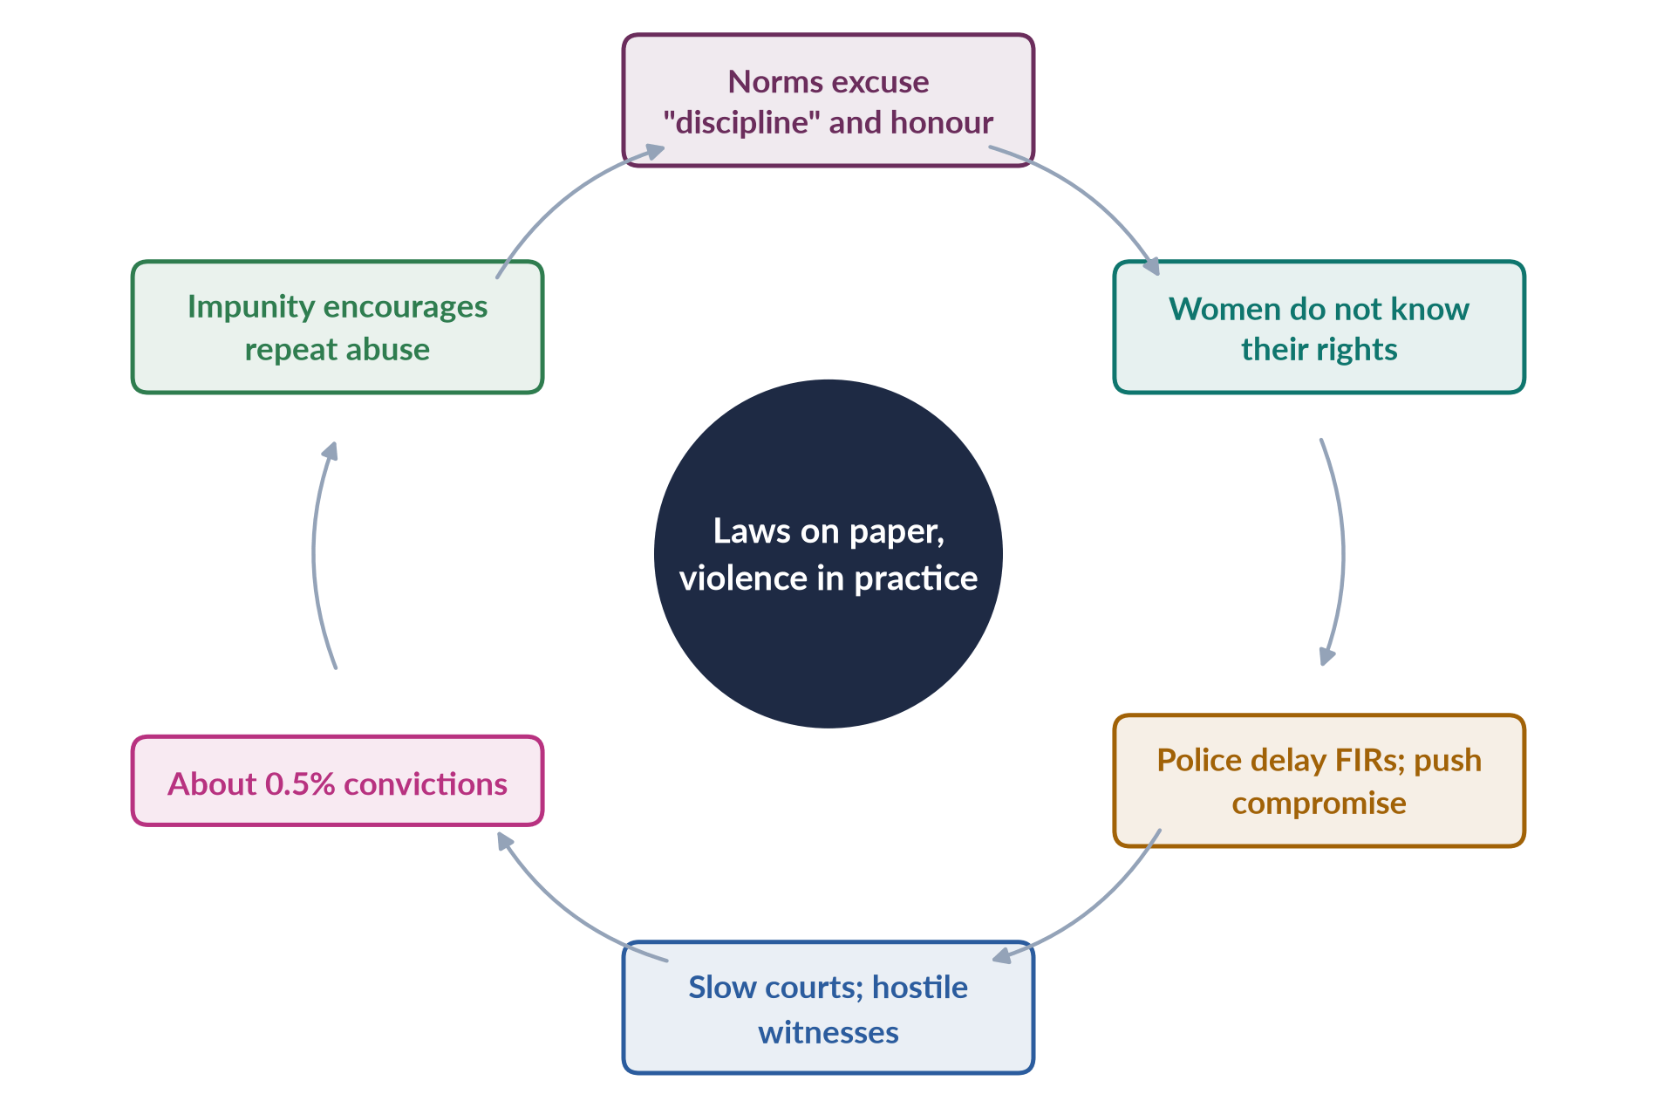
Figure 7 · Why domestic-violence laws have not stopped violence.

9. Why legislation fails: the state's capacity

i) Laws without money
Laws were passed without the money and staff to implement them. One-stop centres exist in few districts; Dar-ul-Aman shelters are scarce and often prison-like; helplines are unknown to rural women.

ii) No data, uneven provinces
There is no national database on domestic violence, and provincial capacity varies widely after the 18th Amendment.

iii) The theoretical explanation
Lori Heise's ecological model (1998) explains the overall failure: the laws act mainly at the society level, while violence is produced at the individual, relationship and community levels too.

10. Workable strategies: prevention and protection

i) Prevention

(a) Schools and men
Teach gender equality and consent in schools and keep girls in school; work with men and boys, as the Islamabad NGO Rozan does.

(b) Religion and economics
Enlist religious scholars and Friday sermons to reject violence as un-Islamic; support women's economic independence through jobs, inheritance enforcement and the Benazir Income Support Programme.

(c) Marriage law
Enforce the 18-year marriage age and marriage registration.

ii) Protection
Make protection orders quick and enforced; open a one-stop centre in every district; build dignified, well-run shelters; publicise 24-hour helplines such as the Punjab Women Helpline 1043 and the federal 1099; and train Lady Health Workers as first responders in villages.

11. Workable strategies: prosecution, provision and partnership

i) Prosecution
Make FIR registration compulsory, with penalties for police who refuse; recruit more women police; build forensic capacity; and assign domestic-violence cases to special courts with fast, in-camera trials, as the Anti-Rape Act 2021 did for sexual offences.

ii) Provision
Offer free legal aid, medical care, counselling and vocational training, in local languages, with outreach to rural, minority and disabled women.

iii) Partnership
Build a co-ordinated community response, on the Duluth model, linking police, courts, health, shelters and NGOs such as the Aurat Foundation and Shirkat Gah; harmonise the five laws through the Council of Common Interests; and create a national GBV database.

12. Conclusion

i) The achievement
Pakistan now has a domestic-violence law in every province and in Islamabad — a real achievement of the women's movement.

ii) The gap
Yet laws on paper have not become protection in practice, because norms, police and courts, and state capacity lag behind.

iii) The way forward
The workable path combines quick wins — compulsory FIRs, enforced protection orders, centres and helplines in every district — with long-term prevention that changes norms of masculinity and honour. Only then will the promise of Articles 9, 14 and 25 reach the women behind closed doors.

Why this answer scores
- Uses the stem's fact: names all five laws with their years and describes the Punjab Act 2016 in detail.
- Evaluates critically: strengths and weaknesses of the laws themselves come before the causes of failure.
- Organises the causes by level (norms, institutions, state capacity) and ties them to Heise's ecological model.
- Strategies are workable and organised by the five Ps, with Pakistani institutions named.
- A timeline and a cycle figure carry the argument; data are dated (PDHS 2017–18, SSDO 2024, LFS 2024–25).

Set 1 · Q. No. 4 · Gender Mainstreaming: Tools, Achievements and Limits of the GAD Strategy
AT A GLANCE · PREDICTION PAPER SET 1 · Q. NO. 4 · 20 MARKS
What is gender mainstreaming? Discuss its tools, and evaluate its achievements and limitations as the strategy of the Gender and Development (GAD) approach, with reference to Pakistan.

The answer map
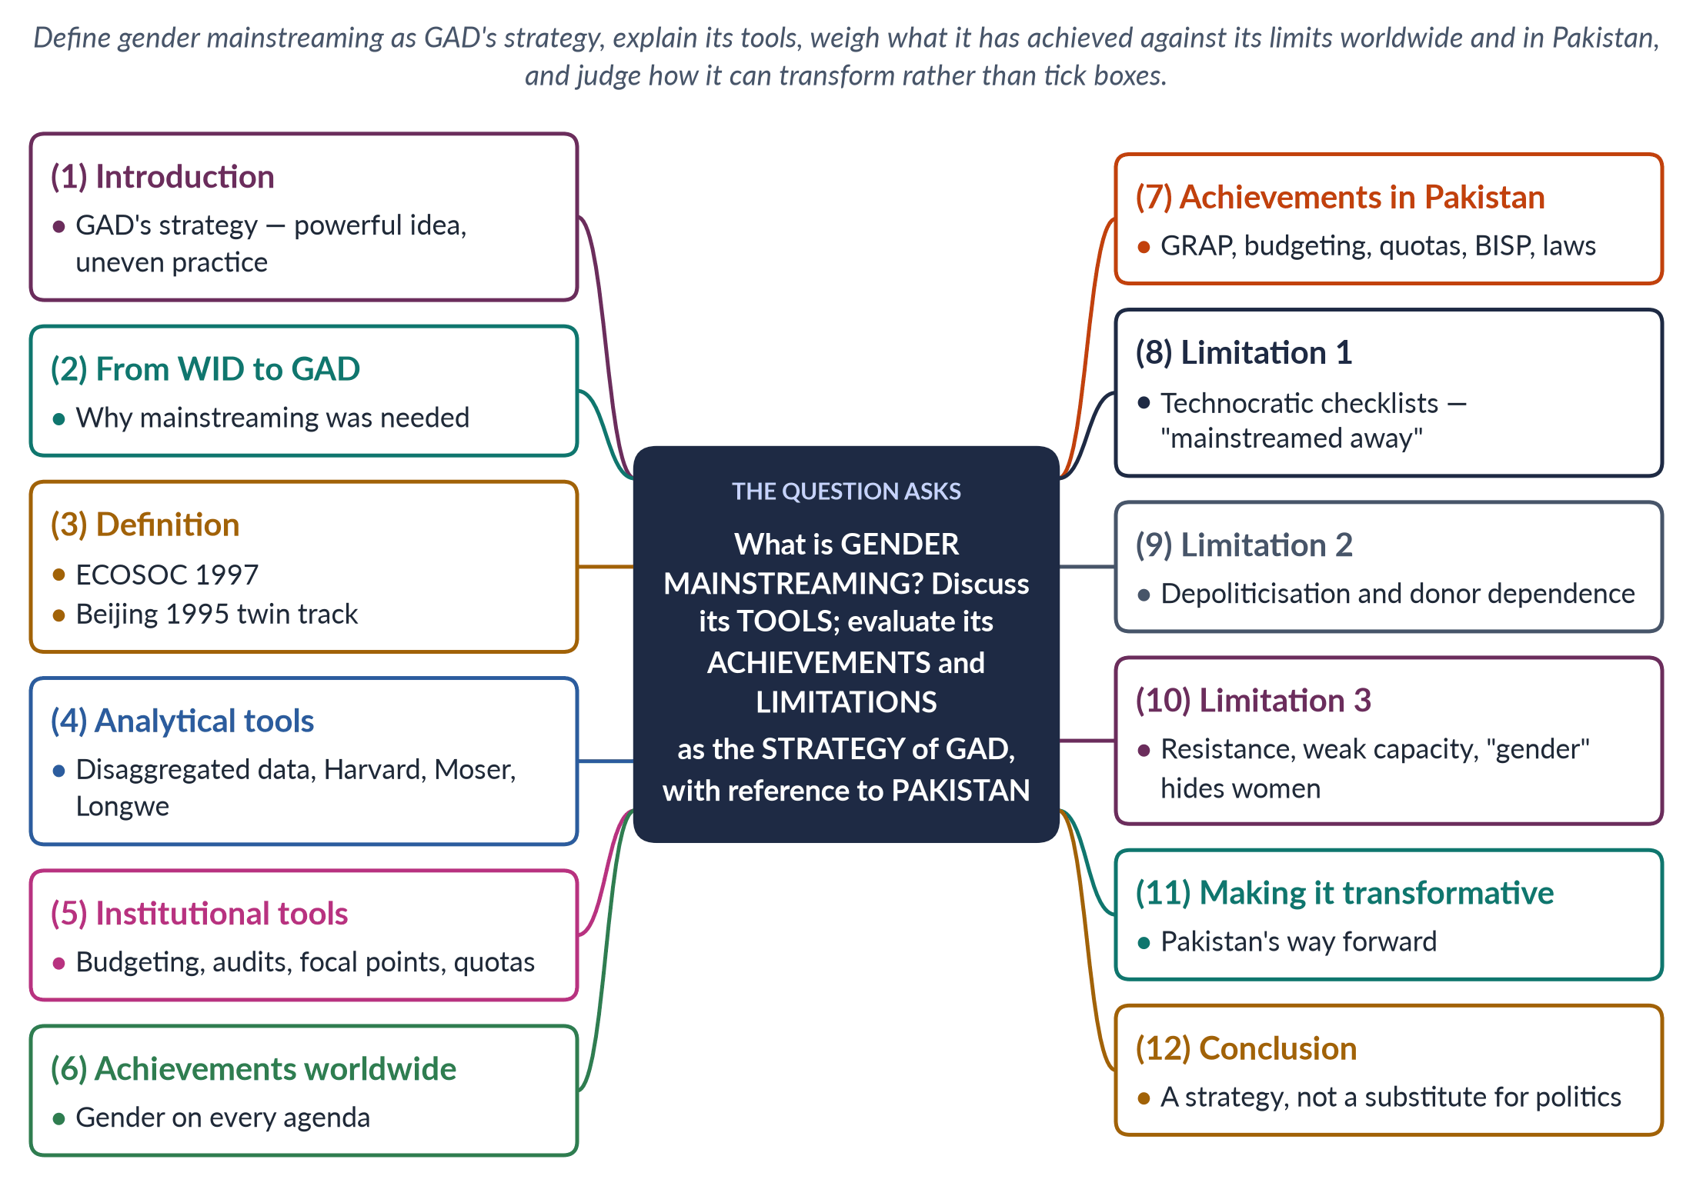
Figure 8 · The answer map: every branch is one numbered heading of the model answer below.

Decoding the question
Four tasks. "What is" — a precise definition, ideally the ECOSOC wording. "Discuss its tools" — name and explain the analytical and institutional tools. "Evaluate its achievements and limitations" — both sides, then a judgement. "As the strategy of GAD" — link mainstreaming to GAD's aim of transforming gender relations. "With reference to Pakistan" — Pakistani examples throughout, not only at the end.

The model answer

1. Introduction

i) Definition
Gender mainstreaming is the strategy of assessing the implications for women and men of every law, policy and programme, at every level, so that inequality is not reproduced. It is the main strategy of the Gender and Development (GAD) approach and was adopted worldwide by the Beijing Platform for Action (1995).

ii) The argument
Mainstreaming moved gender from the margins of development — small women's projects — to the centre of policy. It has put gender on every agenda, produced data, budgets and units, and in Pakistan helped create quotas, gender-responsive budgeting and cash transfers to women. But it has often become technocratic — checklists without power — and has been "mainstreamed away". It works only when tied to political will, resources and women's own organisations.

2. Why mainstreaming was needed

i) The failure of WID projects
The Women in Development (WID) approach of the 1970s, inspired by Ester Boserup (1970), added women to development through separate projects — sewing centres, credit, training. These projects were small and marginal, while the big decisions on roads, budgets, trade and agriculture remained gender-blind.

ii) The GAD insight
The GAD approach of the 1980s, shaped by socialist feminists and the Southern network DAWN (1984), argued that the problem was unequal power between women and men, embedded in every institution. If inequality is everywhere, the remedy must be everywhere too.

3. The definition and its origins

i) The ECOSOC definition
The UN Economic and Social Council defined mainstreaming in 1997 as "the process of assessing the implications for women and men of any planned action, including legislation, policies or programmes, in all areas and at all levels".

ii) Beijing's twin track
The Beijing Declaration and Platform for Action (1995) was the first global framework to adopt it, combining mainstreaming with special measures for women — the "twin track".

iii) Means, not end
Mainstreaming is meant not as an end but as a means to gender equality — today SDG 5.
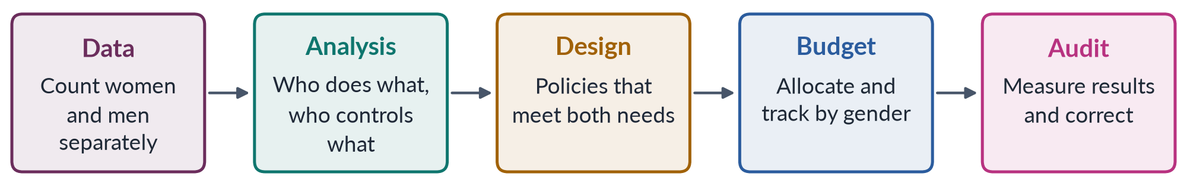
Figure 9 · How gender mainstreaming is meant to work in a policy cycle.

4. Analytical tools

i) Sex-disaggregated data
Statistics separated by sex reveal what averages hide — for example, Pakistan's female labour-force participation of 24.4% (LFS 2024–25) beside a far higher male rate.

ii) Gender analysis frameworks

(a) The Harvard Framework
The Harvard Framework (1985) maps activities, access and control of resources.

(b) Moser's framework
Caroline Moser (1989, 1993) identifies women's triple role — productive, reproductive and community-managing — and separates practical from strategic gender needs.

(c) Longwe and Kabeer
Sara Longwe's framework ranks interventions from welfare to control; Naila Kabeer (1999) defines empowerment through resources, agency and achievements.

5. Institutional tools

i) Gender-responsive budgeting
Analysing budgets by their effect on women and men, so that spending on maternal health, girls' schools or safe transport is visible and protected.

ii) Gender audits and impact assessment
Checking organisations and projects for bias before and after implementation.

iii) Focal points, units and quotas
Gender focal points in every ministry, women's machinery such as national commissions, and quotas that bring women into decision-making.

6. Achievements worldwide

i) Gender in every ministry
Mainstreaming made gender the business of every ministry, not only a women's ministry.

ii) A data revolution
It produced a revolution in sex-disaggregated data, so that indices like the Gender Development Index (1995) and Gender Inequality Index (2010) became possible. Gender-responsive budgeting spread to many countries.

iii) A new default question
It shaped the Millennium Development Goals and SDG 5, and made donors require gender analysis in projects. It changed the default question of policy from "what about women?" to "how does this affect women and men?"

7. Achievements in Pakistan

i) Plans and budgets
The Gender Reform Action Plan (early 2000s) sought to raise women's share of public jobs and create gender units in departments. The Ministry of Finance ran a Gender Responsive Budgeting Initiative.

ii) Women in the state
A 10% quota for women in federal jobs, 60 reserved seats in the National Assembly (2002) and 33% of local seats (2000–01) brought women into the state. The National Commission on the Status of Women (2000) reviews laws for their gender impact.

iii) Resources and rights
The Benazir Income Support Programme (2008) pays cash to women, giving them a resource in their own name. Strategic laws — the Enforcement of Women's Property Rights Act 2020 and the laws against violence — reflect GAD's aim of changing power, not only meeting needs.

8. Limitation 1: technocratic checklists

i) Box-ticking
In practice mainstreaming is often reduced to training workshops, checklists and reports. Officials tick a "gender box" without changing what they do.

ii) "Mainstreamed away"
When everyone is responsible for gender, no one is. Budgets labelled "gender-responsive" may simply relabel existing spending.

9. Limitation 2: depoliticisation and donor dependence

i) From politics to technique
GAD aimed to transform power relations — a political project. Mainstreaming, run by experts and consultants, can turn it into a technical exercise, stripped of the women's movement's demands.

ii) Projects that fade
In Pakistan much gender work depends on donor funding cycles, so units and pilots fade when projects end — the "NGO-isation" critique. Gender-responsive budgeting pilots did not become a permanent feature of every budget.

10. Limitation 3: resistance, capacity and "gender" hiding women

i) Resistance
Changing power provokes resistance from men and elites; governments avoid controversial strategic issues such as inheritance or marriage age.

ii) Weak capacity
Ministries lack trained staff and reliable data, and after the 18th Amendment (2010) provincial capacity varies widely.

iii) "Gender" can hide women
Talking of "gender" can let agencies cut women-specific programmes.

iv) The outcome test
Pakistan ranked 148th of 148 in the Global Gender Gap Report 2025, and 143rd of 145 in 2026 — a gap between process and result.
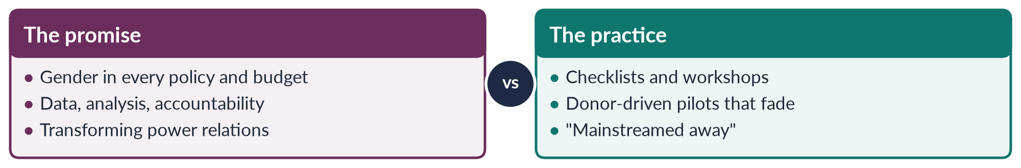
Figure 10 · Gender mainstreaming: what it promised and what it often became.

11. Making mainstreaming transformative in Pakistan

i) Institutionalise the tools
Make gender-responsive budgeting mandatory in federal and provincial budgets, with published gender statements; require gender impact assessment of major laws and projects; and fund the NCSW and provincial commissions from the public budget rather than donors.

ii) Combine the twin tracks
Keep special measures — quotas, BISP, women's police stations — alongside mainstreaming, because a gender-sensitive policy is no substitute for programmes that reach women directly.

iii) Link it to power and voice

(a) Women's organisations
Tie mainstreaming to women's organisations, the Women's Parliamentary Caucus and local women councillors, so that strategic needs — land, mobility, safety, political power — are on the agenda.

(b) Measure outcomes
Judge success by outcomes (girls' schooling, maternal mortality, labour participation), not by workshops held.

12. Conclusion

i) What mainstreaming is for
Gender mainstreaming is GAD's answer to the failure of marginal women's projects: if inequality runs through every institution, every institution must address it.

ii) The balance sheet
It has achieved much — data, budgets, units, quotas, a common language of equality — and in Pakistan it underlies the reserved seats, the 10% job quota, BISP and the property-rights law. But without political will, resources and women's voice it becomes a ritual of checklists.

iii) The verdict
Mainstreaming is a strategy, not a substitute for politics: it transforms only when it is backed by power.

Why this answer scores
- Gives the ECOSOC (1997) definition and the Beijing (1995) origin, and links mainstreaming to GAD explicitly.
- Separates analytical tools (data, Harvard, Moser, Longwe, Kabeer) from institutional tools (budgeting, audits, focal points, quotas).
- Evaluates both sides, with Pakistani examples (GRAP, GRBI, quotas, BISP, the 2020 property law) and outcome data.
- Ends with a way forward and a clear judgement.
- A flow figure shows the policy cycle; a compare figure shows promise versus practice.

Set 1 · Q. No. 5 · The Fourth Wave, Digital Activism and the Aurat March
AT A GLANCE · PREDICTION PAPER SET 1 · Q. NO. 5 · 20 MARKS
Discuss the key features of the fourth wave of feminism. How have digital activism, the #MeToo movement and the Aurat March reshaped feminist activism in Pakistan, and what backlash have they faced?

The answer map
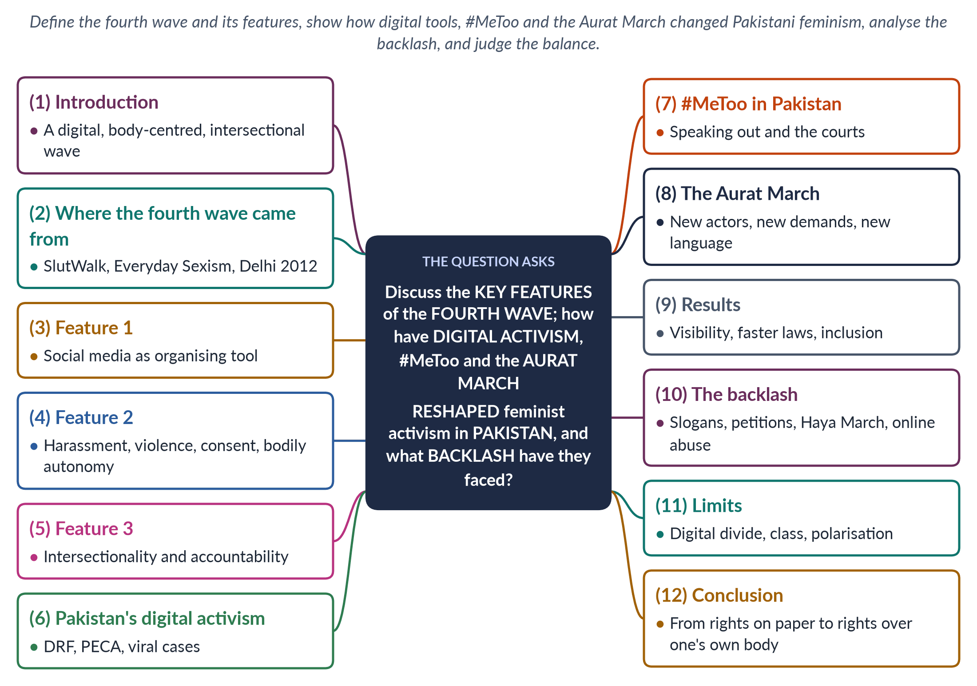
Figure 11 · The answer map: every branch is one numbered heading of the model answer below.

Decoding the question
Three limbs. "Key features of the fourth wave" — a definition, a date (about 2012 onwards), the global campaigns and four or five features. "How have digital activism, #MeToo and the Aurat March reshaped … Pakistan" — treat the three named items separately, then their effects. "What backlash" — the forms of backlash and why bodily autonomy provokes it. End with a judgement.

The model answer

1. Introduction

i) Definition
The fourth wave of feminism (from about 2012) is feminist activism that uses social media to share experience, expose harassment and violence, organise quickly and hold the powerful to account. Kira Cochrane described it in All the Rebel Women (2013).

ii) The argument
In Pakistan the fourth wave arrived through digital activism, #MeToo (2018) and the Aurat March (from 8 March 2018). It brought new actors (young, urban women, workers and khawaja siras), new demands (bodily autonomy, safety, consent) and new methods (hashtags, marches, art). It won visibility and faster laws, but provoked a fierce backlash and remains limited by the digital divide.

2. Where the fourth wave came from

i) The early campaigns
The wave grew from a series of campaigns: SlutWalk (Toronto, 2011), protesting the idea that women's dress invites rape; Laura Bates's Everyday Sexism Project (2012); and the protests after the Delhi gang rape of December 2012, which led to India's Criminal Law (Amendment) Act 2013.

ii) The global spread
#NiUnaMenos in Argentina (2015) and the Women's March of 21 January 2017 carried the wave across continents.

iii) The defining moment: #MeToo
The phrase was first used by Tarana Burke in 2006 and went global in October 2017 after the reports on Harvey Weinstein.

3. Feature 1: social media as the organising tool

i) A phone, not an organisation
Earlier waves needed organisations, newspapers and conferences. The fourth wave needs a phone. Hashtags, testimony threads and viral videos let women share private experience instantly and mobilise across borders in hours.

ii) Lower barriers, global reach
This lowers the cost of joining, gives voice to women outside formal organisations and makes campaigns global — the same hashtag trends in Los Angeles, Buenos Aires and Lahore.

iii) Networked leadership
Leadership is looser too: campaigns are run by networks and collectives rather than by a single organisation or leader.

4. Feature 2: harassment, violence, consent and the body

i) The issues
The fourth wave focuses on everyday sexism, sexual harassment, rape culture, consent and bodily autonomy — the right to decide about one's own body, marriage and movement.

ii) The personal made public
It extends the second wave's "the personal is political" into public space and online space: street harassment, workplace abuse and online blackmail become political issues.

5. Feature 3: intersectionality and accountability

i) Intersectionality
Influenced by Kimberlé Crenshaw's intersectionality (1989), the fourth wave insists that women's experience differs by class, race, religion, sexuality and disability, and includes trans people.

ii) Accountability
It also seeks accountability — "call-out culture" that names powerful abusers when institutions fail to act.
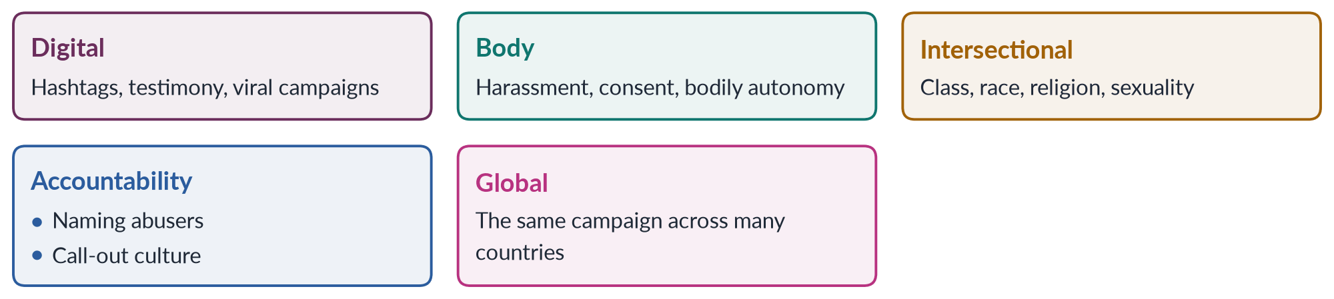
Figure 12 · Five features of the fourth wave.

6. Digital activism in Pakistan

i) Early institutions
The Digital Rights Foundation (2012) opened a cyber-harassment helpline in 2016, the year the Prevention of Electronic Crimes Act (PECA) created offences of online harassment and blackmail.

ii) Outrage that forced action
Online outrage after the murder of Qandeel Baloch (2016), the motorway gang rape (2020) and the murder of Noor Mukadam (2021) forced the state to respond.

iii) More women online
The mobile-internet gender gap fell from 38% to 25% (GSMA, 2024–25), widening this space.

7. #MeToo in Pakistan

i) Breaking the silence
#MeToo reached Pakistan in 2018, with allegations of harassment in the entertainment industry and on campuses. It broke the silence around workplace harassment, encouraged women to use the Protection against Harassment of Women at the Workplace Act 2010 (amended 2022 to widen "workplace" and "employee"), and prompted universities and firms to form inquiry committees.

ii) The cost of speaking
Accusers faced long defamation cases, online abuse and social stigma — a reminder that speaking out is costly where institutions are weak.

8. The Aurat March

i) Origins
The Aurat March, first held in Karachi on 8 March 2018 and then in Lahore, Islamabad and other cities, is Pakistan's fourth-wave movement.

ii) New actors
It is organised largely online by young, urban women, students and workers, with khawaja siras, home-based workers and domestic workers marching alongside.

iii) New demands
Violence and harassment, inheritance, forced and child marriage, workers' rights, khawaja sira rights, and bodily autonomy — symbolised by the slogan Mera Jism Meri Marzi ("my body, my choice").

iv) New language
Placards made for social media, humour, art and the language of consent, alongside the older language of the Constitution and Islam. The "locus of resistance" shifted from legal rights (WAF in the 1980s) to bodily autonomy.

9. Results

i) Visibility and faster laws
The fourth wave has made gender-based violence visible as never before and shortened the time between outrage and law: after the 2020 motorway case, the Anti-Rape (Investigation and Trial) Act received assent on 1 December 2021.

ii) Inclusion
It has brought new groups — trans people, workers, students — into feminism, and pushed debates on domestic violence and child marriage that ended in the Islamabad laws of 2025.

iii) New voices and a new debate
It has changed who speaks: survivors now tell their own stories in public rather than through lawyers or NGOs, and young men increasingly appear as allies. Even critics of the march now discuss harassment, consent and online safety — a sign that the fourth wave has shifted the terms of public debate, much as the Delhi protests of 2012 did in India.

10. The backlash

i) Forms of backlash

(a) In the media
Slogans on bodily autonomy were attacked on television and social media as immoral or "Western".

(b) In courts and streets
Petitions were filed in courts to stop the march; counter-events such as the "Haya March" were organised; posters were defaced.

(c) Online
Marchers faced online abuse, threats and doxxing.

ii) Why bodily autonomy provokes
The female body is tied to family izzat — critics hear a rejection of family and religion. Supporters reply that Islam forbids forced marriage and that Article 14 guarantees dignity; on the substance — ending violence and forced marriage — there is wide agreement.
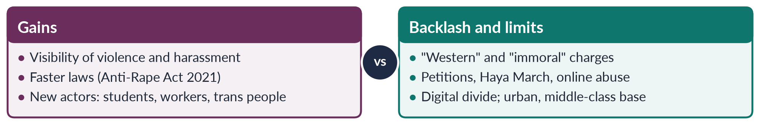
Figure 13 · The fourth wave in Pakistan: what it won and what it faced.

11. Limits

i) The digital divide
Digital feminism reaches mainly urban, educated women; millions of rural women lack phones, data or the safety to speak online.

ii) Online weaknesses
Online campaigns can become "slacktivism" without organisation; call-outs raise due-process concerns; and polarised debate can alienate potential allies.

iii) The challenge
The movement must join the energy of the march with the patient legal and grassroots work of WAF, rural women's movements and NGOs.

12. Conclusion

i) What changed
The fourth wave — digital, body-centred and intersectional — has reshaped Pakistani feminism: it moved the struggle from rights on paper to rights over one's own body, brought new actors into the movement and made the state respond faster to violence.

ii) The future
It has also provoked the strongest backlash since the 1980s. Its future depends on reaching beyond the cities, framing its demands in the language of the Constitution and Islam as well as consent, and turning online outrage into lasting institutions.

Why this answer scores
- Defines the fourth wave with dates and campaigns (2011–2017) and names five features.
- Treats the three named items — digital activism, #MeToo, the Aurat March — under separate headings.
- Explains why bodily autonomy provokes, and gives both sides of the backlash fairly.
- Uses current evidence: PECA 2016, the 2021 Anti-Rape Act, the GSMA's 38% to 25%.
- A grid and a compare figure organise the argument.

Set 1 · Q. No. 6 · Women's Education in Pakistan and Article 25A
AT A GLANCE · PREDICTION PAPER SET 1 · Q. NO. 6 · 20 MARKS
Discuss the status of women's education in Pakistan in the light of Article 25A of the Constitution. What are the causes of the gender gap in education, and what measures would you suggest to close it?

The answer map
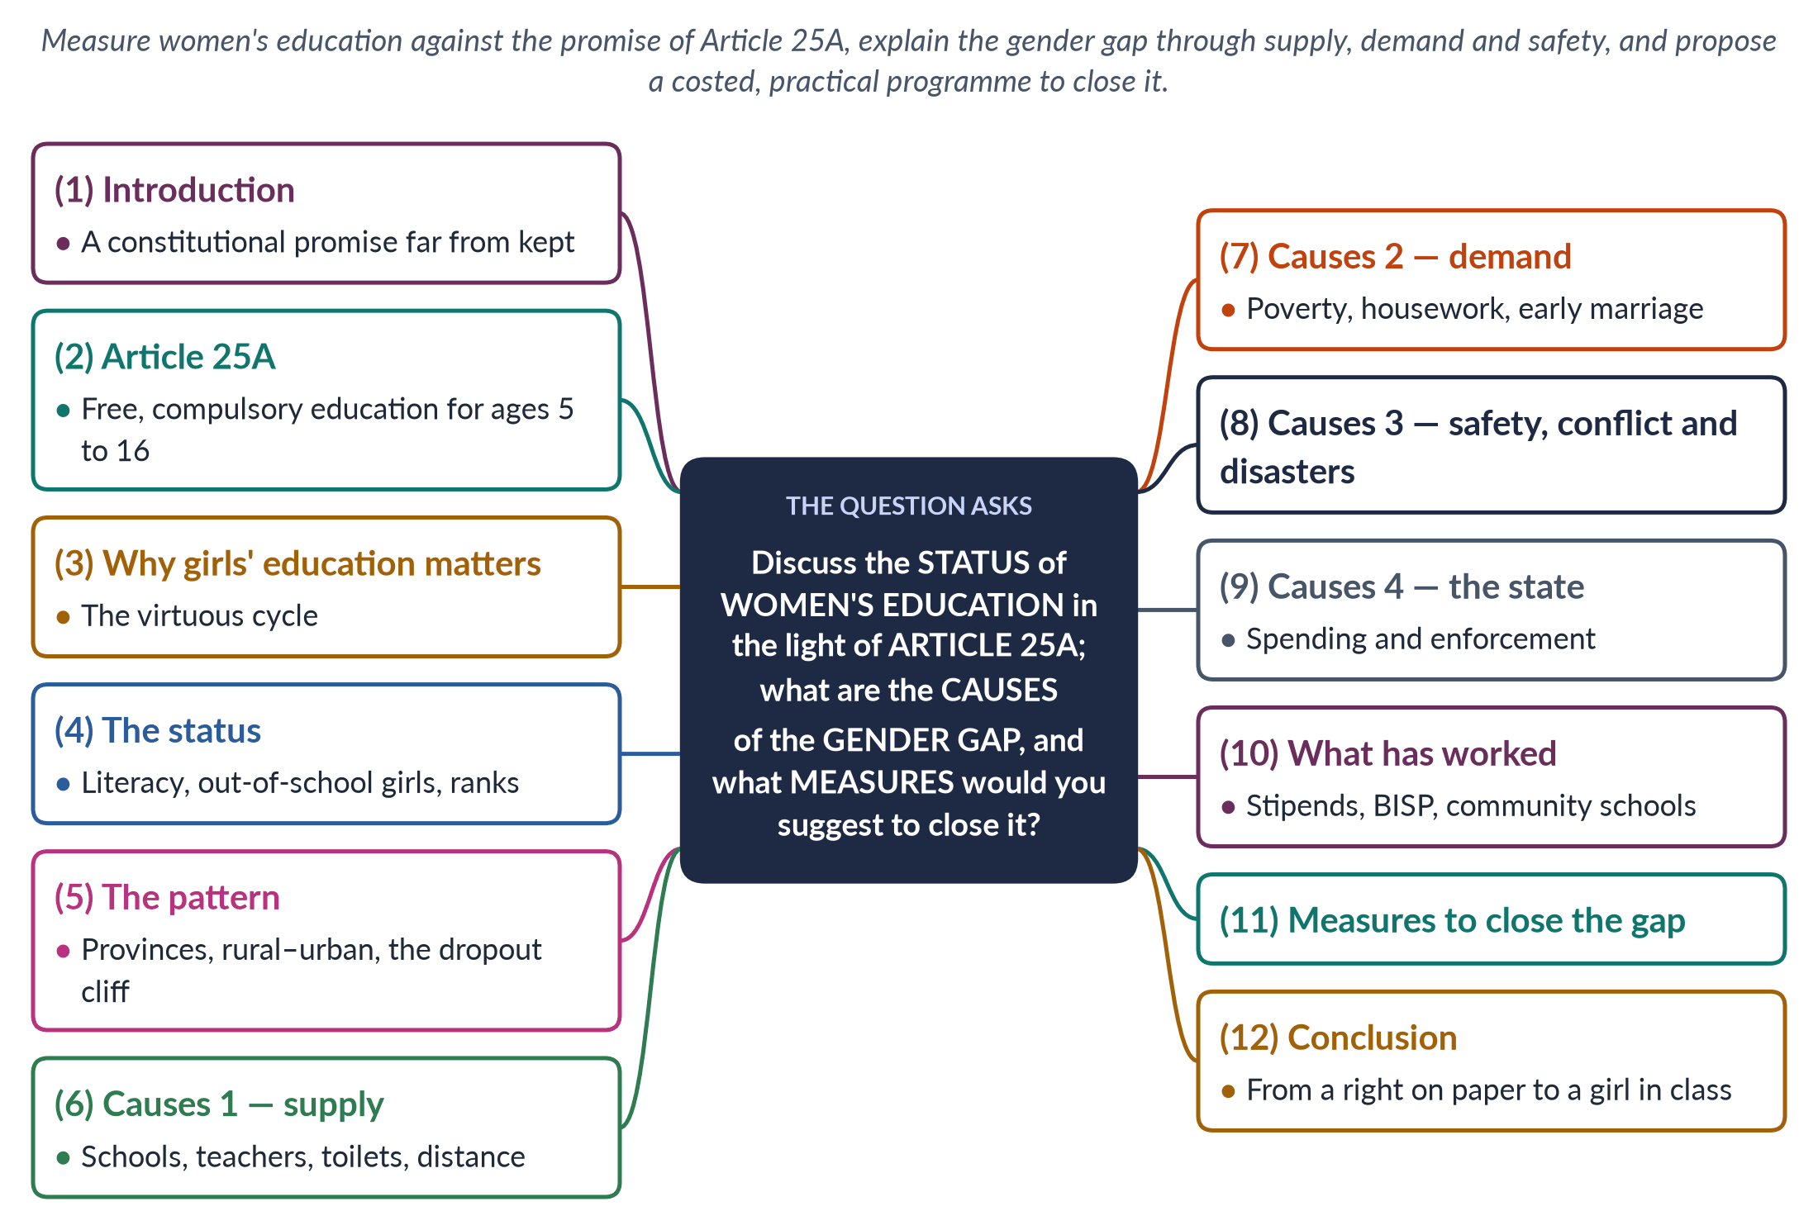
Figure 14 · The answer map: every branch is one numbered heading of the model answer below.

Decoding the question
Three limbs. "Status … in the light of Article 25A" — compare reality with the constitutional promise, using current data (Census 2023; Global Gender Gap 2026). "Causes of the gender gap" — organise them (supply, demand, safety, state) rather than listing. "Measures" — specific, practical and Pakistani. Mention Malala as evidence, but this is a status question, not a case study.

The model answer

1. Introduction

i) Definition
Women's education means girls' and women's access to, participation in and completion of schooling and higher education, and the quality of what they learn. The gender gap in education is the difference between boys' and girls' enrolment, completion, literacy and learning.

ii) The argument
The 18th Amendment (2010) made education a fundamental right under Article 25A, but the promise remains far from kept for girls. Female literacy is only about 53% (Census 2023), and more than 25 million children are out of school, most of them girls. The gap is caused by a shortage of schools and female teachers, by poverty and norms that keep girls at home, by insecurity, and by a state that spends too little. It can be closed — the stipend and cash-transfer programmes show how.

2. Article 25A

i) The text
Article 25A states that "the State shall provide free and compulsory education to all children of the age of five to sixteen years in such manner as may be determined by law". It made education a justiciable right and placed responsibility on the provinces, which passed their own compulsory-education laws.

ii) Its foundations
Article 25A builds on Article 37(b), a Principle of Policy calling for the removal of illiteracy, and on Pakistan's commitments under CEDAW (Article 10, equal access to education) and SDG 4.

iii) The enforcement gap
Fifteen years on, enforcement is weak: few parents are ever penalised, and the schools needed to make attendance possible do not exist in many places.

3. Why girls' education matters

i) Health and family
Educated women marry later, have fewer and healthier children, seek antenatal care and immunise their children — vital in a country with a maternal mortality ratio of 186 per 100,000 live births (PMMS 2019).

ii) Income and voice
They earn more, know their rights, are better able to resist violence and take part in public life.

iii) The next generation
Their daughters are more likely to go to school — a virtuous cycle.
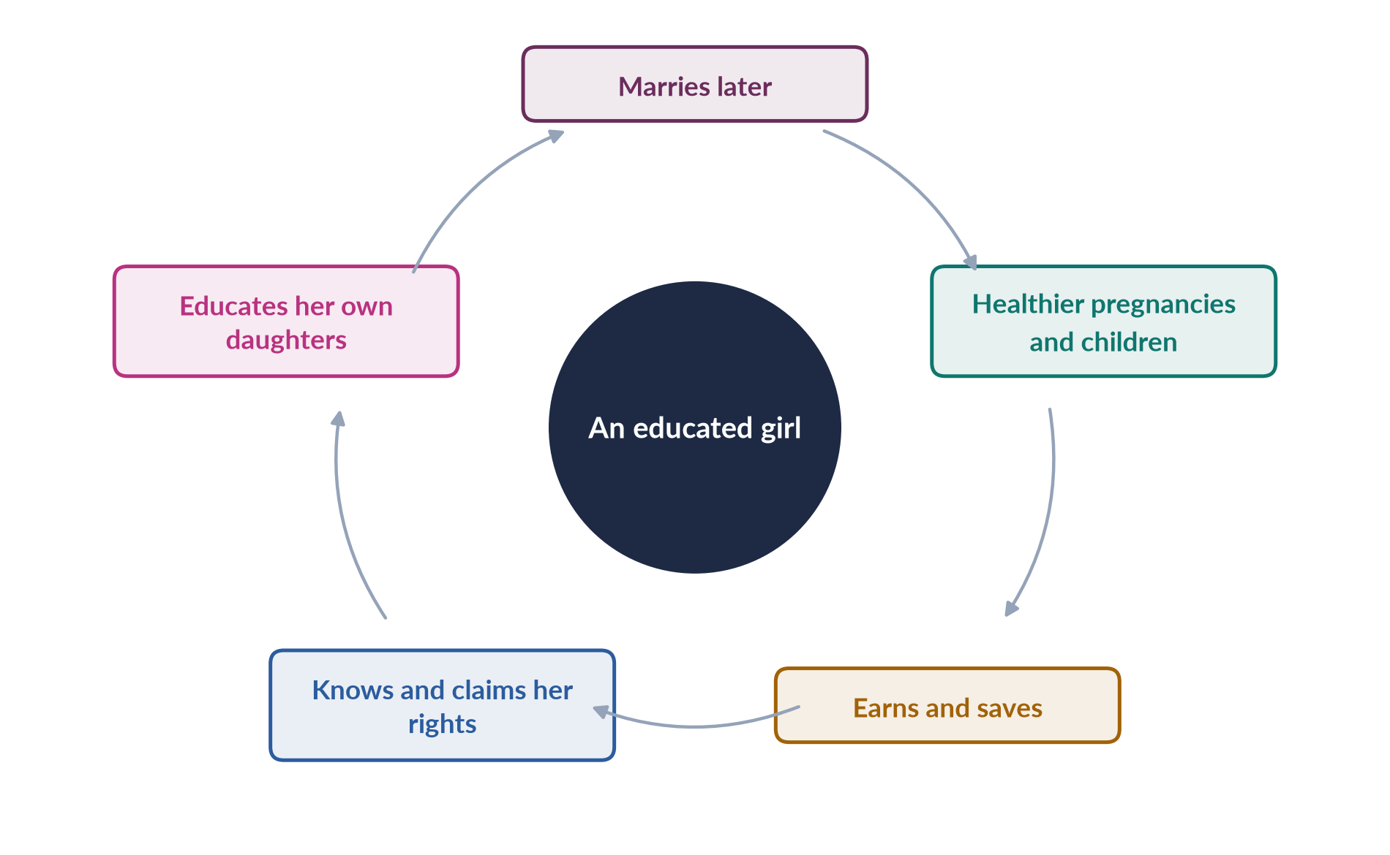
Figure 15 · The virtuous cycle of girls' education.

4. The status today

i) Literacy
The Census 2023 put literacy at 60.65%: about 68% for men and 53% for women.

ii) Out-of-school children
More than 25 million children aged 5–16 are out of school, the majority of them girls.

iii) The global comparison
In the World Economic Forum's Global Gender Gap Report 2026, Pakistan ranked 130th on educational attainment, part of an overall rank of 143rd of 145.

iv) Real but uneven progress
Female literacy was 48% in the figure used by the 2019 CSS paper, and women are now about half of university students and a majority in medical colleges — but learning levels are low and many schools lack basic facilities.

5. The pattern of the gap

i) By province
Punjab and Islamabad lead; rural Sindh lags; the former tribal areas of Khyber Pakhtunkhwa are recovering after conflict; and Balochistan has the lowest female literacy in the country.

ii) By place and class
The gap is widest in rural areas and among the poor — a poor rural girl in Balochistan and an urban girl in Lahore live in two different educational worlds, an example of intersectionality.

iii) By age: the dropout cliff
Many girls finish primary school but never reach a middle or secondary school — the "dropout cliff" at about age ten to twelve.

6. Causes 1 — supply

i) Too few secondary schools
There are far fewer girls' middle and secondary schools than primary schools, so a girl who finishes primary must often travel far. Parents will not send adolescent daughters long distances without safe transport.

ii) Missing teachers and facilities
Many schools lack female teachers, toilets and boundary walls, which conservative families regard as essential.

iii) Poor quality
Absent teachers, rote learning and overcrowding reduce the value parents see in keeping girls enrolled.

7. Causes 2 — demand

i) Poverty and housework
Poor families face direct costs (uniforms, books, transport) and opportunity costs: girls do housework, fetch water and care for siblings.

ii) Early marriage
Early marriage ends schooling; the federal law still sets 16 as the minimum age for girls outside Sindh (18 since 2013) and Islamabad (18 since 2025).

iii) Norms
The belief that a daughter "belongs to another household" makes investment in her education seem wasted, and limited jobs for educated women in rural areas reinforce that belief.
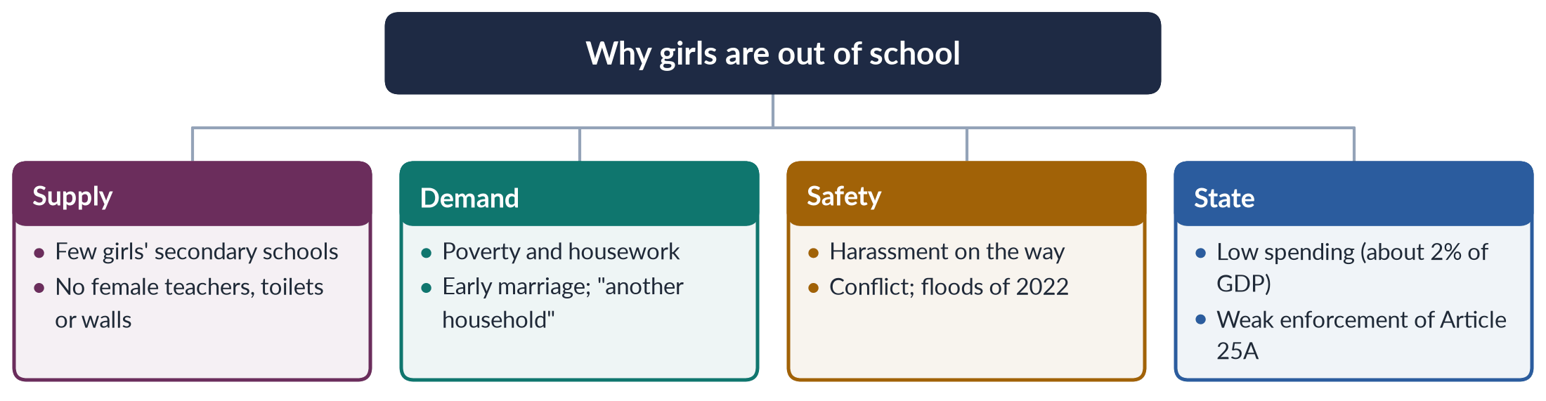
Figure 16 · The causes of the gender gap in education.

8. Causes 3 — safety, conflict and disasters

i) Harassment
Harassment on the way to school is a common reason for withdrawal.

ii) Conflict: Swat and Malala
In Swat, militants banned girls' education in 2007–2009 and destroyed schools; Malala Yousafzai, who wrote a BBC Urdu diary as "Gul Makai", was shot on 9 October 2012 for defending girls' right to learn, and won the Nobel Peace Prize in 2014. Girls' schools were also destroyed in the former tribal areas.

iii) Disasters
The 2022 floods damaged thousands of schools, and girls are usually the last to return after a disaster.

9. Causes 4 — the state

i) Low spending
Public spending on education has long been about 2% of GDP — among the lowest in the region.

ii) Uneven capacity and enforcement
After the 18th Amendment, provinces vary greatly in capacity, and compulsory-education laws are rarely enforced.

iii) Gaps in the system
Madrassas, free and close by, absorb many poor children but teach few modern subjects, and policies have neglected adult literacy for the millions of women who missed school.

10. What has worked

i) Stipends
Punjab's female school stipend (from 2004), paid to girls who attend secondary school, raised enrolment.

ii) Conditional cash transfers
The Benazir Income Support Programme's education conditional cash transfer (Waseela-e-Taleem) pays mothers when children attend.

iii) Community schools and local teachers
Community and home schools, staffed by local women, bring schooling to villages without government schools; recruiting local female teachers and building missing facilities raised attendance where tried.

11. Measures to close the gap

i) Bring schools to girls
Upgrade primary schools to middle and secondary level in rural areas, or provide safe school transport; build toilets and boundary walls; recruit and train local female teachers.

ii) Make schooling affordable
Extend stipends and conditional cash transfers to all provinces, with higher amounts for secondary school; provide free books and uniforms.

iii) Remove the barriers of law and norms

(a) Marriage law
Raise the minimum marriage age to 18 in every province and enforce marriage registration.

(b) Norms and safety
Run campaigns with religious scholars on Islam's emphasis on seeking knowledge; protect schools in conflict areas and rebuild after floods.

iv) Fund and enforce Article 25A
Raise education spending towards 4% of GDP, enforce the provincial compulsory-education laws, mainstream madrassas with modern subjects, and link education to jobs and digital skills so that families see a return.

12. Conclusion

i) The promise and the reality
Article 25A promised every child aged five to sixteen a free education, but for millions of Pakistani girls it remains a right on paper: female literacy of about 53%, more than 25 million children out of school and a rank of 130th on education show the size of the gap.

ii) The way forward
Its causes — too few schools and female teachers, poverty and early marriage, insecurity and low spending — are known, and so are the remedies that work. Closing the gap is the surest investment Pakistan can make in health, prosperity and democracy.

Why this answer scores
- Quotes Article 25A and links it to Article 37(b), CEDAW Article 10 and SDG 4.
- Uses current, dated data: Census 2023, Global Gender Gap 2026 (130th), PMMS 2019.
- Organises the causes into supply, demand, safety and the state, with a tree figure.
- Shows that policy works (Punjab stipend, Waseela-e-Taleem) before proposing measures.
- Measures are specific and practical, ending with a clear judgement.

Set 1 · Q. No. 7 · Women as Voters and Candidates: The Elections Act 2017 and the 2024 Elections
AT A GLANCE · PREDICTION PAPER SET 1 · Q. NO. 7 · 20 MARKS
Discuss the gender issues faced by women as voters and as candidates in Pakistan. How far have the provisions of the Elections Act 2017 addressed these issues? Refer to the General Elections 2024 in your answer.

The answer map
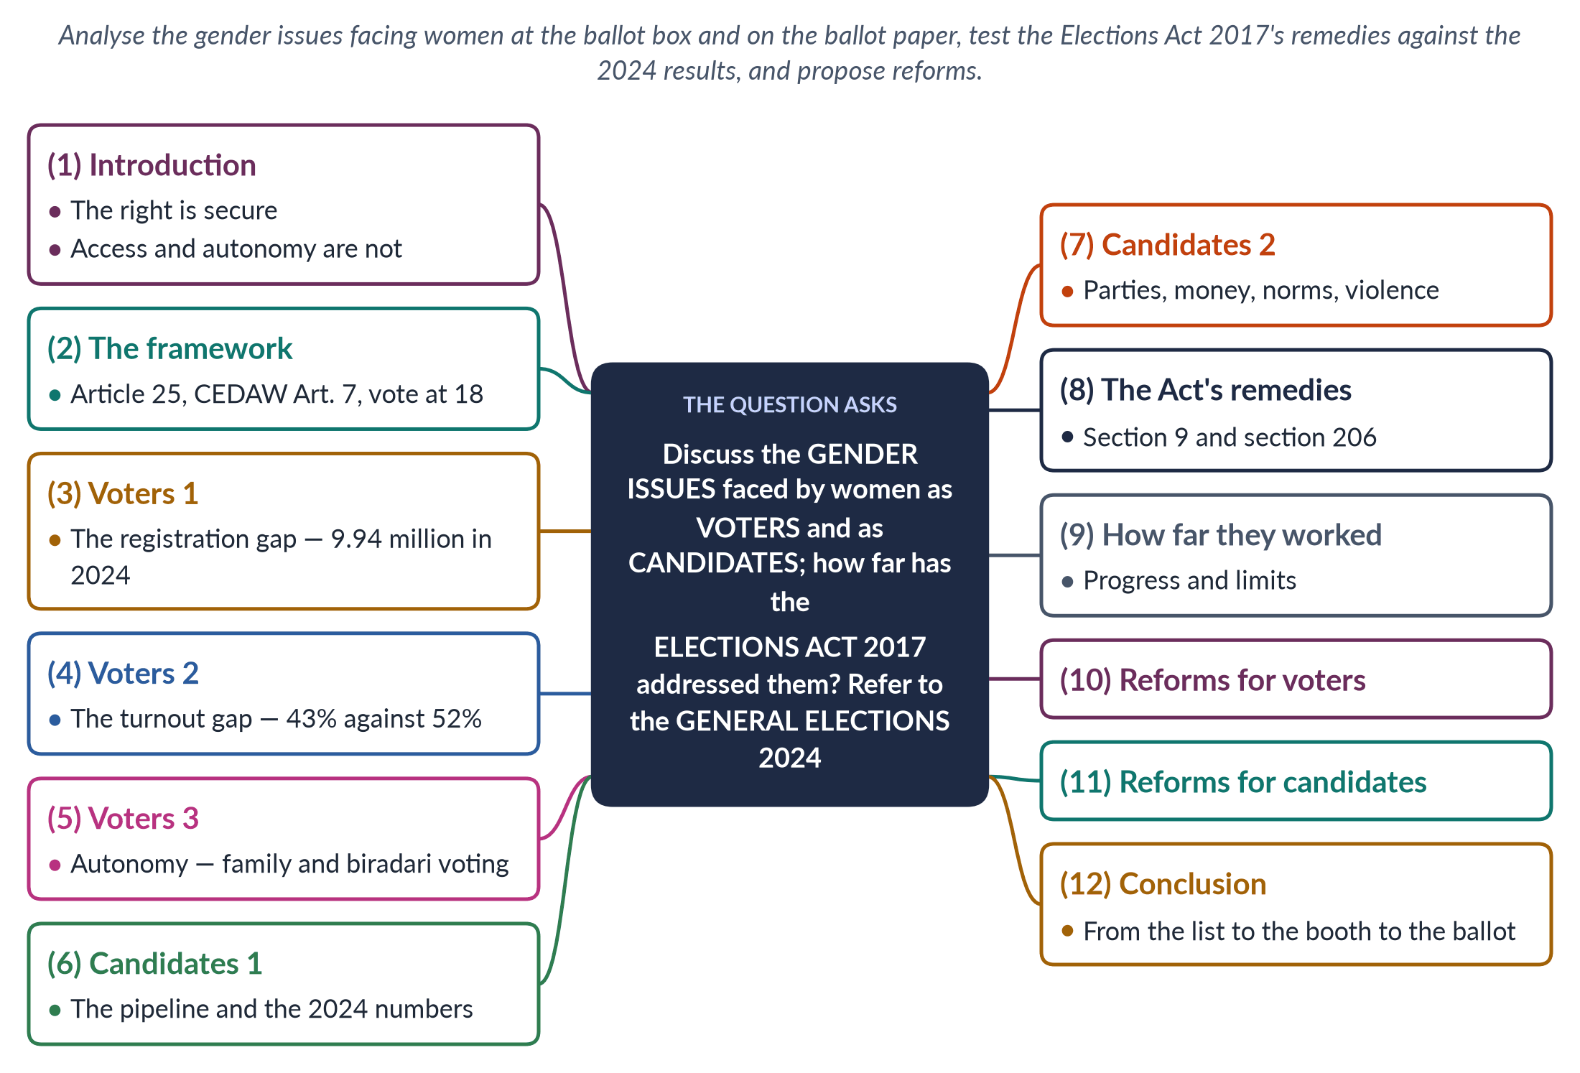
Figure 17 · The answer map: every branch is one numbered heading of the model answer below.

Decoding the question
Two groups and three tasks. "Gender issues faced by women as voters" and "as candidates" — treat them separately; they have different barriers. "How far have the provisions of the Elections Act 2017 addressed these issues" — name the provisions (sections 9 and 206, plus measures on registration) and evaluate them: "how far" demands a balanced judgement. "Refer to the General Elections 2024" — use the 2024 data throughout.

The model answer

1. Introduction

i) Definition
Women's electoral participation has three stages: being on the electoral roll, casting a vote at the polling station, and choosing freely; and, as candidates, seeking a party ticket, contesting and winning.

ii) The argument
Pakistani women have had the vote since independence, and the Elections Act 2017 added important safeguards. The 2024 elections showed real progress — the registration gap fell to 7.7% and women cast 2.7 million more votes than in 2018. But 9.94 million fewer women than men were registered, women's turnout trailed men's by nine points, and only 11 women won general National Assembly seats. The Act addressed the most visible barriers; it has not touched family control, party gatekeeping or money.

2. The framework

i) The Constitution
Article 25 of the Constitution forbids discrimination on the basis of sex, and Article 34 calls for women's full participation in national life.

ii) International commitments
CEDAW Article 7, which Pakistan accepted in 1996, requires equality in voting and standing for election, and SDG target 5.5 calls for women's full participation in decision-making.

iii) The electoral law
The voting age is 18, lowered from 21 in 2002; a voter needs a CNIC from NADRA, and the Election Commission of Pakistan (ECP) prepares the roll.

3. Voters: the registration gap

i) The numbers
In 2024 Pakistan had 128.58 million registered voters: 69.26 million men and 59.32 million women — a gap of 9.94 million, or 7.7%, down from 12.8% in 2013.

ii) Why women are missing
Many lack a CNIC: the documents, travel, cost and family permission needed are barriers, and some families see no reason for a woman to hold one.

iii) Why the CNIC matters
Without it a woman cannot open a bank account, receive BISP payments, claim inheritance or buy a SIM card. BISP (2008), paid only to women with CNICs, was a major driver of registration.

4. Voters: the turnout gap

i) The numbers
In 2024 about 43% of registered women voted, against about 52% of men. The gap was widest in Khyber Pakhtunkhwa.

ii) Why women stay home

(a) Family and distance
Families decide; polling stations are far away; insecurity deters travel.

(b) The polling system
There are too few female polling stations and staff, and care work leaves little time.

(c) Local agreements
In some constituencies elders and candidates have made local agreements to bar women from voting altogether.
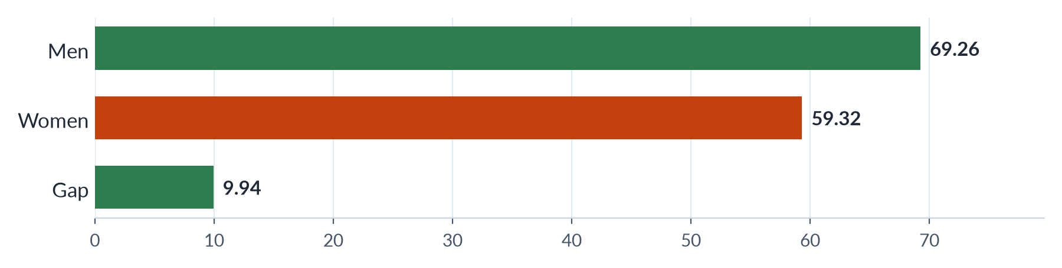
Figure 18 · The gender gap on Pakistan's electoral roll, 2024 (millions of registered voters).

5. Voters: autonomy

i) Family and clan voting
Even when women vote, the choice is often made by husbands, fathers or the biradari (clan), so women's votes may simply multiply men's preferences.

ii) Parties court women
Parties have begun to court women directly — through BISP and provincial cash or health schemes — but a free and secret choice remains the hardest stage to secure.

6. Candidates: the pipeline and the numbers

i) The leaking pipeline
Women leak out at every stage of the candidate pipeline: fewer aspire, fewer receive tickets, fewer win.

ii) The 2024 results
In 2024, 306 women contested general National Assembly seats, but only 11 won — about 4% of the 266 general seats — up from 8 in 2018. Women's presence in the Assembly rests mainly on the 60 reserved seats, filled by party lists.

iii) Firsts and absences
Maryam Nawaz became Pakistan's first woman chief minister (Punjab) in 2024, yet the Global Gender Gap Report 2025 recorded no women federal ministers.

7. Candidates: the barriers

i) Parties
Party leaders control tickets and prefer "electables" — candidates with land, clan and money networks — who are almost always men.

ii) Money and norms
Campaigns are costly and women own little property. Norms of purdah, honour and care make campaigning hard, and "politics is dirty" discourages aspiration.

iii) Violence and harassment
Women candidates face threats and online abuse — doctored images and sexual slurs. Benazir Bhutto's assassination on 27 December 2007 is a reminder of the danger.

iv) The dynastic route
Many women who succeed come through political families — a route, but almost the only one.

8. The Elections Act's remedies

i) Section 9 — the 10% rule
The ECP may declare a poll void in a constituency where women's turnout is below 10% of the votes cast, presuming that women were prevented from voting. In 2015 the ECP had annulled a by-election in Lower Dir where women were kept away — a precedent the Act wrote into law.

ii) Registration measures
The ECP must take special measures where the gap between men and women on the roll exceeds 10%, with NADRA mobile vans, women's counters and campaigns with NGOs such as the Aurat Foundation and FAFEN.

iii) Section 206 — the 5% ticket rule
Parties must give at least 5% of their general-seat tickets to women.
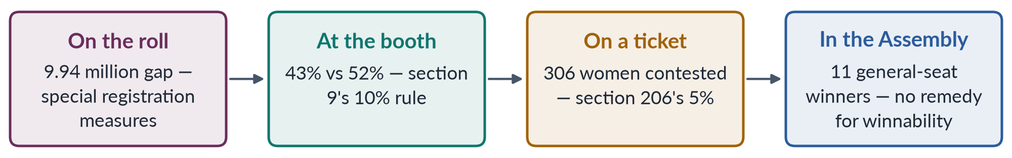
Figure 19 · Where women leak out of the electoral process — and the Act's remedy at each stage.

9. How far the remedies worked

i) What worked
The Act has worked against open exclusion. The threat of annulment deters agreements to bar women, and the registration gap has narrowed from 12.8% to 7.7%, with 2.7 million more votes cast by women than in 2018.

ii) What did not

(a) A low threshold
The 10% threshold is very low — a constituency where nine in ten voters are men passes.

(b) Registration depends on others
The registration measures depend on NADRA's reach and families' consent.

(c) Tickets without winnable seats
The 5% rule says nothing about winnable seats: parties meet it by fielding women where they expect to lose, so 306 candidates produced 11 winners.

iii) The verdict
The Act addresses access, not autonomy or power.

10. Reforms for voters

i) A stronger turnout rule
Raise the section 9 threshold progressively, for example to 20%, and apply it to polling stations as well as constituencies.

ii) Easier registration
Make CNIC registration free and mobile, linked to BISP, health cards and school enrolment.

iii) Safer, freer voting
Open more women's polling stations with women staff and police close to homes; run voter-education campaigns on the secret ballot, with religious scholars confirming that women's voting is a right; prosecute anyone who makes agreements to bar women.

11. Reforms for candidates

i) A real ticket quota
Raise the ticket quota (for example to 10%) and require that a share be in winnable constituencies, with penalties such as loss of reserved-seat allocation for parties that fail.

ii) Money and parties
Introduce campaign-finance support and spending limits; require women in party executives and ticket committees.

iii) Safety and the pipeline
Strengthen protection against harassment under PECA 2016, and revive local government — where 33% quotas in 2000–01 elected about 36,000 women — as a training ground.

12. Conclusion

i) Progress
Pakistani women's right to vote and stand is secure in law, and the Elections Act 2017 has narrowed the gaps at the roll and the booth.

ii) The distance remaining
The 2024 elections show nearly ten million women unregistered, a nine-point turnout gap and only 11 women winning general seats.

iii) The next reforms
The Act tackled the most visible exclusion; the next reforms must tackle family control, party gatekeeping and money, so that women move from the list, to the booth, to a free choice — and to power.

Why this answer scores
- Separates voters and candidates, and three stages of each (roll, booth, choice; ticket, contest, win).
- Names the Act's specific provisions — sections 9 and 206 and the registration measures — and the Lower Dir 2015 precedent.
- Uses the 2024 data throughout (9.94 million gap; 43% vs 52%; 306 contested, 11 won).
- Answers "how far" with a balanced verdict: access improved, autonomy and power untouched.
- A bars figure and a flow figure match each barrier to its remedy.

Set 1 · Q. No. 8(a) · Short Note: Liberal Feminism
AT A GLANCE · PREDICTION PAPER SET 1 · Q. NO. 8(A) · SHORT NOTE · 10 MARKS
Write short notes on the following: Liberal Feminism.

The answer map
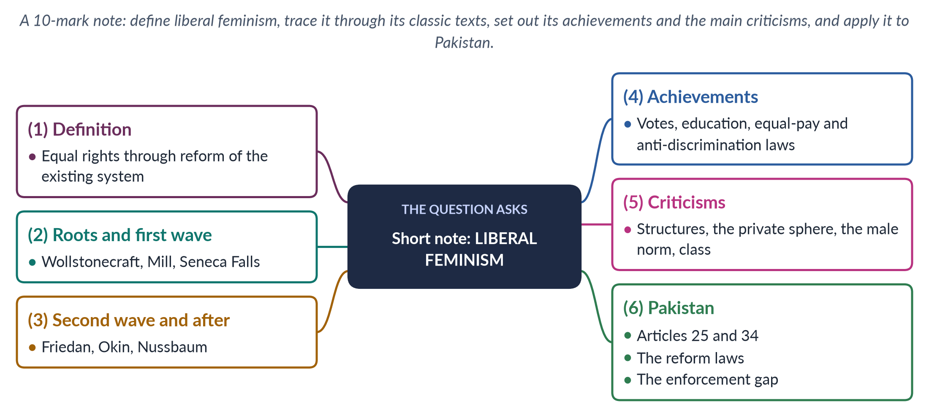
Figure 20 · The answer map for the short note: every branch is one headed point.

Decoding the question
A short note of 10 marks: about 550–650 words, in five or six headed points. Liberal feminism is the most famous school yet has never been asked on its own — so give a precise definition, its thinkers with dates, a balanced evaluation and a Pakistan paragraph.

The model answer

1. Definition

i) The core claim
Liberal feminism holds that women are as rational as men and that their disadvantage comes from unequal laws, customs and opportunities.

ii) The remedy
Reform within the existing system — equal rights in law, education, work and politics — rather than revolution. It grew from Enlightenment liberalism, with its belief in the individual, reason and natural rights. A 2023 CSS MCQ described it simply: the theory that men and women should be treated equally.

2. Roots and the first wave

i) Wollstonecraft and de Gouges
Mary Wollstonecraft's A Vindication of the Rights of Woman (1792) answered Rousseau's Émile, which said girls should be educated to please men: women only seemed weak because they were denied a rational education. Olympe de Gouges wrote the Declaration of the Rights of Woman and of the Female Citizen (1791).

ii) Seneca Falls
At Seneca Falls (1848), Elizabeth Cady Stanton and Lucretia Mott's Declaration of Sentiments declared that "all men and women are created equal".

iii) The Mills
John Stuart Mill's The Subjection of Women (1869), written with Harriet Taylor Mill's influence, called women's legal subordination wrong and a barrier to progress, and women's "nature" "an eminently artificial thing". In 1867 Mill moved in Parliament to replace "man" with "person" in the Reform Bill — the first such motion.

3. The second wave and after

i) Friedan
Betty Friedan's The Feminine Mystique (1963) named "the problem that has no name" — the frustration of educated housewives told that fulfilment lay only in home and family — and she co-founded the National Organization for Women (1966). The US Equal Pay Act (1963) and Title VII of the Civil Rights Act (1964) followed.

ii) Okin and Nussbaum
Susan Moller Okin (1989) argued that justice must extend into the family, and Martha Nussbaum (2000) developed the capabilities approach — women's real freedom to be and do.
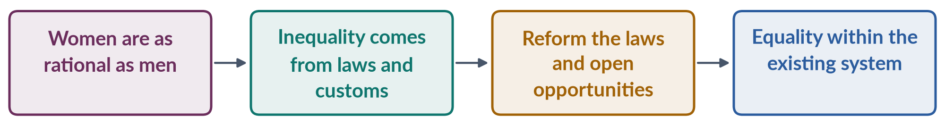
Figure 21 · The liberal feminist chain of reasoning.

4. Achievements

i) Rights won
The vote (New Zealand 1893; the United States 1920; equal suffrage in Britain 1928), access to education and the professions, and equal-pay and anti-discrimination laws.

ii) The global language of rights
Its language shaped CEDAW (1979) and SDG 5. It is practical, persuasive and works through courts and parliaments — which is why most states, including Pakistan, frame gender policy in its terms.

5. Criticisms

i) Radical and socialist critiques
Radical feminists say it ignores the structures of patriarchy and leaves the "private" family untouched. Socialist feminists say legal equality means little without economic change and recognition of unpaid care.

ii) The male norm and class bias
It measures equality against a male norm — women must become like men to succeed. bell hooks criticised Friedan's focus on white, middle-class housewives, ignoring poor and Black women who already worked.

iii) Individualism
Its individualism can neglect collective action, and postcolonial feminists add that it universalises Western ideas of individual rights, overlooking women for whom family and community are sources of strength as well as constraint.

6. Pakistan

i) A liberal Constitution
Article 25 bans sex discrimination and allows special provision for women, Article 27 bars discrimination in public service, and Article 34 calls for women's full participation.

ii) The reform laws
The Protection of Women Act 2006, the workplace harassment law 2010, the honour-killing amendment 2016, the Anti-Rape Act 2021 and the Islamabad Child Marriage Restraint Act 2025 (age 18) follow the liberal strategy, as do the 60 reserved seats and the NCSW (2000). Such reforms are often defended in Islamic terms as well — the MFLO (1961) and the 2025 child-marriage law were argued as consistent with Islam.

iii) The limit
Their limited effect shows the school's weakness: laws are blunted by poverty, custom and weak enforcement. Liberal feminism is necessary, but not sufficient.

Why this answer scores
- A precise definition, then the classic texts with dates (1791, 1792, 1848, 1869, 1963).
- Balanced: achievements and criticisms from radical, socialist and Black feminists.
- A Pakistan paragraph that uses the Constitution and the reform laws, ending with a judgement.
- A flow figure shows the school's logic in one line.

Set 1 · Q. No. 8(b) · Short Note: The UN World Conferences on Women and Beijing+30
AT A GLANCE · PREDICTION PAPER SET 1 · Q. NO. 8(B) · SHORT NOTE · 10 MARKS
Write short notes on the following: The United Nations World Conferences on Women and Beijing+30.

The answer map
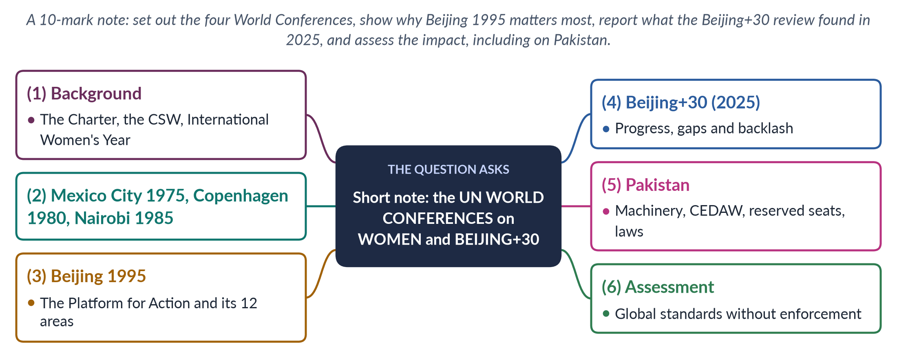
Figure 22 · The answer map for the short note: every branch is one headed point.

Decoding the question
A 10-mark note (about 550–650 words). The UN conferences have never been a descriptive question, though they are an MCQ favourite, and the thirtieth review of Beijing in 2025 makes them topical. Cover all four conferences briefly, Beijing in detail, Beijing+30, Pakistan and a short assessment.

The model answer

1. Background

i) The UN's founding commitments
The UN Charter (1945) affirmed "equal rights of men and women", and the Commission on the Status of Women was set up on 21 June 1946. The UN adopted the Convention on the Political Rights of Women (1952) and the Declaration on the Elimination of Discrimination against Women (1967).

ii) The Year and the Decade
The UN declared 1975 International Women's Year and 1976–1985 the UN Decade for Women, with the themes "Equality, Development and Peace". Four World Conferences on Women gave this agenda its milestones.

2. The first three conferences

i) Mexico City (1975)
The first conference adopted a World Plan of Action and led to UNIFEM and INSTRAW; it exposed tensions between Northern women's focus on equality and Southern women's focus on development and poverty.

ii) Copenhagen (1980)
At mid-decade it held a signing ceremony for CEDAW (adopted 1979) and stressed employment, health and education.

iii) Nairobi (1985)
It adopted the Forward-Looking Strategies to the year 2000 and hosted a large NGO forum, where the Southern network DAWN presented its vision of development led by poor women.
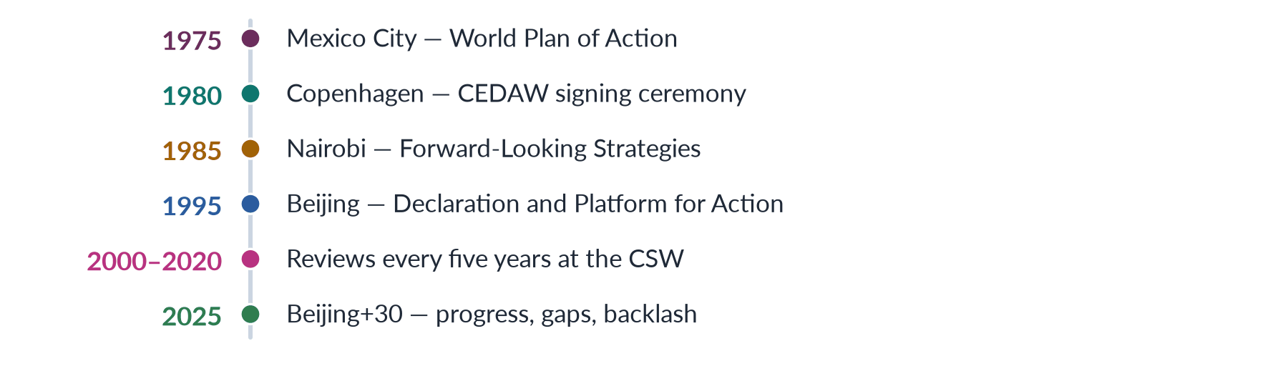
Figure 23 · The UN World Conferences on Women and the Beijing reviews.

3. Beijing 1995

i) The conference
The Fourth World Conference, held in Beijing from 4 to 15 September 1995 with 189 governments, adopted the Beijing Declaration and Platform for Action — still the most comprehensive global agenda for women. About 30,000 activists attended the parallel NGO forum at Huairou, and Benazir Bhutto addressed the conference.

ii) The 12 critical areas
Poverty, education, health, violence, armed conflict, the economy, power and decision-making, institutional mechanisms, human rights, the media, the environment and the girl child.

iii) Its strategy and context
It adopted gender mainstreaming as a global strategy and declared that "women's rights are human rights", building on the Vienna human-rights conference (1993) and the Cairo population conference (1994); Security Council Resolution 1325 (2000) later carried the critical area on armed conflict into peace and security.

4. Beijing+30 (2025)

i) What the review found
The Beijing+30 review at the CSW in March 2025 found real progress in girls' education and in laws against discrimination and violence, but warned of slow change in power and pay, persistent violence, and a growing backlash against women's rights; no country had achieved full equality.

ii) Where Beijing lives now
The commitments now run through SDG 5 (2015), with targets for 2030, and the Generation Equality Forum (2021) sought fresh pledges from governments and donors.

5. Pakistan

i) The machinery
The conferences shaped the Women's Division (1979), the National Plan of Action (1998) after Beijing, accession to CEDAW (1996), the National Commission on the Status of Women (2000), the National Policy for Development and Empowerment of Women (2002) and the 60 reserved seats (2002), which echo Critical Area G on power and decision-making.

ii) A platform for activists
Pakistan reports periodically to the CEDAW Committee, NGOs submit shadow reports, and the Committee has urged the repeal of discriminatory laws and stronger action against violence and child marriage.

6. Assessment

i) Achievements
The conferences set global standards, put violence against women on the human-rights agenda, created national machineries and gave NGOs a voice; UN Women (2010), first led by Michelle Bachelet, gave the agenda a stronger institutional home.

ii) Limits
Their outcomes are not binding: implementation depends on governments, reservations weaken commitments, and critics call them "Western".

iii) The verdict
Beijing+30 shows both sides — a framework that changed the world's language on women, and a promise still far from kept.

Why this answer scores
- Covers all four conferences with dates and one outcome each, and Beijing in detail (189 governments, 12 areas, mainstreaming).
- Reports what the Beijing+30 review found — the topical hook.
- Links the conferences to Pakistan's machinery (1979, 1996, 1998, 2000, 2002).
- Ends with a balanced assessment; a timeline figure shows the sequence.

Set 2 · The Difficult Paper
About 70% difficult and 30% medium: theory-heavy, cross-topic questions that reward depth.
Five of the seven Part II questions are difficult — historicizing constructionism, men's feminism, the gendered political economy of adjustment, honour killing through Galtung, and the "Western import" debate — and two are medium (family law; the notes on governance and world-system theory). Of the twenty MCQs, fourteen are difficult and six medium: lesser-known thinkers, "which is NOT" items and keys of "None of these".

Roll Number
FEDERAL PUBLIC SERVICE COMMISSION
COMPETITIVE EXAMINATION-2027
FOR RECRUITMENT TO POSTS IN BS-17
UNDER THE FEDERAL GOVERNMENT
GENDER STUDIES

TIME ALLOWED: THREE HOURS TOTAL MARKS: 100
PART-I (MCQS): MAXIMUM 30 MINUTES PART-I (MCQS): MAXIMUM MARKS = 20
PART-II PART-II: MAXIMUM MARKS = 80

NOTE: | (i) First attempt PART-I (MCQS) on separate Answer Sheet which shall be taken back after 30 minutes.
 | (ii) Overwriting/cutting of the options/answers will not be given credit.

PART-I (MCQS) (COMPULSORY)
Q. No. 1. (i) Select the best option/answer and fill in the appropriate box on the Answer Sheet.
(ii) Answers given anywhere else, other than Answer Sheet, will not be considered. (20×1=20)
1. Thomas Laqueur's "one-sex model" holds that before the eighteenth century:
(a) Women were seen as a separate species
(b) Women were seen as inverted, lesser versions of men
(c) Sex was considered irrelevant to social roles
(d) None of these
2. Barbara Risman (2004) described gender as:
(a) A performance without an actor
(b) A social structure working at individual, interactional and institutional levels
(c) A hormonal trait
(d) None of these
3. In Berger and Luckmann's The Social Construction of Reality (1966), the stage at which human-made arrangements come to look like solid facts is called:
(a) Objectivation | (b) Externalisation | (c) Internalisation | (d) None of these
4. Which of the following is a "marked" term?
(a) Doctor | (b) Lady doctor | (c) Chairperson | (d) Teacher
5. Which of the following is NOT one of Sylvia Walby's six structures of patriarchy (1990)?
(a) Paid work | (b) The state | (c) Religion | (d) Male violence
6. "Under Western Eyes" (1984), a critique of Western feminist portrayals of "Third World women", was written by:
(a) Gayatri Chakravorty Spivak | (b) Uma Narayan
(c) Chandra Talpade Mohanty | (d) None of these
7. The "patriarchal dividend" — the advantage all men gain from women's subordination — is a concept of:
(a) R. W. Connell | (b) Michael Kimmel | (c) Michael Kaufman | (d) None of these
8. Qur'an and Woman (1992), a founding text of Islamic feminism, was written by:
(a) Fatima Mernissi | (b) Asma Barlas | (c) Riffat Hassan | (d) None of these
9. The Optional Protocol to CEDAW (1999):
(a) Allows individual complaints to the CEDAW Committee
(b) Has been ratified by Pakistan
(c) Created UN Women
(d) None of these
10. Pakistan's reservation to CEDAW concerns:
(a) Article 2 | (b) Article 16 | (c) Article 29(1) | (d) None of these
11. The Sindhiani Tehreek, a mass movement of rural Sindhi women, began in:
(a) 1975 | (b) 1979 | (c) 1981 | (d) 1982
12. Diane Elson argued that structural adjustment programmes treat women's labour as:
(a) Infinitely elastic | (b) Fully remunerated | (c) Highly mechanised | (d) None of these
13. In Wallerstein's world-system theory, the zone that both exploits the periphery and is exploited by the core is:
(a) The hinterland | (b) The semi-periphery | (c) The metropole | (d) None of these
14. Naila Kabeer (1999) defined empowerment through three interrelated dimensions:
(a) Access, control and participation | (b) Welfare, equity and efficiency
(c) Resources, agency and achievements | (d) None of these
15. The concept of "global care chains" (2000) was developed by:
(a) Arlie Hochschild | (b) Saskia Sassen | (c) Guy Standing | (d) Maria Mies
16. Under the Muslim Family Laws Ordinance 1961, a talaq takes effect:
(a) Immediately on pronouncement | (b) On a decree of the Family Court
(c) On the Arbitration Council's permission | (d) None of these
17. A wife's right to khula was recognised by the superior courts in:
(a) The Saima Waheed case (2004) | (b) The Safia Bibi case (1983)
(c) The Shah Bano case (1985) | (d) None of these
18. In Hanna Pitkin's typology, representatives who act in the interests of those they represent illustrate which type of representation?
(a) Formal | (b) Descriptive | (c) Symbolic | (d) None of these
19. The World Bank's 1989 report that spoke of a "crisis of governance" concerned:
(a) South Asia | (b) Latin America | (c) Sub-Saharan Africa | (d) Eastern Europe
20. Johan Galtung's "cultural violence" (1990) refers to:
(a) Violence committed by cultural groups
(b) Aspects of culture that legitimise direct and structural violence
(c) Violence portrayed in films
(d) None of these
**********

Roll Number
FEDERAL PUBLIC SERVICE COMMISSION
COMPETITIVE EXAMINATION-2027
FOR RECRUITMENT TO POSTS IN BS-17
UNDER THE FEDERAL GOVERNMENT
GENDER STUDIES

TIME ALLOWED: THREE HOURS TOTAL MARKS: 100
PART-I (MCQS): MAXIMUM 30 MINUTES PART-I (MCQS): MAXIMUM MARKS = 20
PART-II PART-II: MAXIMUM MARKS = 80

NOTE: | (i) Part-II is to be attempted on the separate Answer Book.
 | (ii) Attempt ONLY FOUR questions from PART-II. ALL questions carry EQUAL marks.
 | (iii) All the parts (if any) of each Question must be attempted at one place instead of at different places.
 | (iv) Write Q. No. in the Answer Book in accordance with Q. No. in the Q. Paper.
 | (v) No Page/Space be left blank between the answers. All the blank pages of Answer Book must be crossed.
 | (vi) Extra attempt of any question or any part of the question will not be considered.

PART-II
Q. No. 2. "Constructionism itself has a history." Historicize social constructionism from Wollstonecraft and Mill to Beauvoir, Berger and Luckmann, Foucault and Butler. In the light of Thomas Laqueur's "one-sex model" and research on intersex variation, is the distinction between sex and gender itself a social construction? (20)
Q. No. 3. Can men be feminists? Critically evaluate men's feminism with reference to R. W. Connell's theory of masculinities, pro-feminist men's movements and the rise of the online "manosphere". What role can men play in advancing gender equality in Pakistan? (20)
Q. No. 4. "Structural adjustment treats women's labour as infinitely elastic" (Diane Elson). Critically analyse the gendered impact of structural adjustment and IMF stabilisation programmes on women in developing countries, with particular reference to Pakistan's programmes of 2023–2024 and the care economy. (20)
Q. No. 5. Using Johan Galtung's typology of direct, structural and cultural violence, critically analyse honour killing in Pakistan. Why have legal reforms such as the Criminal Law (Amendment) Acts of 2004 and 2016 failed to eliminate the practice? (20)
Q. No. 6. "Feminism is a Western import." Critically evaluate this claim with reference to the history of women's activism in South Asia, postcolonial feminist critiques of Western feminism and the work of Muslim feminist scholars. (20)
Q. No. 7. Critically evaluate the family laws of Pakistan — on marriage, divorce, dower, maintenance, inheritance and the minimum age of marriage — from a gender perspective, with reference to the Muslim Family Laws Ordinance 1961 and the recent child-marriage laws. (20)
Q. No. 8. Write short notes on the following: (10+10)
(a) Gender and good governance: why gender equality is essential to good governance.
(b) World-system theory and the international sexual division of labour.
**********

Set 2 · Part I Explained
Each MCQ of Set 2 with its options. The correct answer is printed in bold straight after each question, with a one-line reason.
1. Thomas Laqueur's "one-sex model" holds that before the eighteenth century:
(a) Women were seen as a separate species (b) Women were seen as inverted, lesser versions of men (c) Sex was considered irrelevant to social roles (d) None of these
Answer: (b) Women were seen as inverted, lesser versions of men — In Making Sex (1990) Laqueur argued that Europe saw the female body as an inverted male body until a "two-sex" model emerged in the 18th century.
2. Barbara Risman (2004) described gender as:
(a) A performance without an actor (b) A social structure working at individual, interactional and institutional levels (c) A hormonal trait (d) None of these
Answer: (b) A social structure working at individual, interactional and institutional levels — Risman: gender as a social structure at three levels — the individual, everyday interaction and institutions.
3. In Berger and Luckmann's The Social Construction of Reality (1966), the stage at which human-made arrangements come to look like solid facts is called:
(a) Objectivation (b) Externalisation (c) Internalisation (d) None of these
Answer: (a) Objectivation — Externalisation (people create arrangements) → objectivation (they look like facts) → internalisation (new generations learn them as natural).
4. Which of the following is a "marked" term?
(a) Doctor (b) Lady doctor (c) Chairperson (d) Teacher
Answer: (b) Lady doctor — A marked term singles a woman out as the exception to a male norm ("lady doctor").
5. Which of the following is NOT one of Sylvia Walby's six structures of patriarchy (1990)?
(a) Paid work (b) The state (c) Religion (d) Male violence
Answer: (c) Religion — Walby's six: paid work, household production, culture, sexuality, violence and the state.
6. "Under Western Eyes" (1984), a critique of Western feminist portrayals of "Third World women", was written by:
(a) Gayatri Chakravorty Spivak (b) Uma Narayan (c) Chandra Talpade Mohanty (d) None of these
Answer: (c) Chandra Talpade Mohanty — Chandra Talpade Mohanty (1984).
7. The "patriarchal dividend" — the advantage all men gain from women's subordination — is a concept of:
(a) R. W. Connell (b) Michael Kimmel (c) Michael Kaufman (d) None of these
Answer: (a) R. W. Connell — R. W. Connell, Masculinities (1995).
8. Qur'an and Woman (1992), a founding text of Islamic feminism, was written by:
(a) Fatima Mernissi (b) Asma Barlas (c) Riffat Hassan (d) None of these
Answer: (d) None of these — Amina Wadud (1992). Mernissi wrote The Veil and the Male Elite (1987).
9. The Optional Protocol to CEDAW (1999):
(a) Allows individual complaints to the CEDAW Committee (b) Has been ratified by Pakistan (c) Created UN Women (d) None of these
Answer: (a) Allows individual complaints to the CEDAW Committee — It allows individual complaints and inquiries; Pakistan is not a party.
10. Pakistan's reservation to CEDAW concerns:
(a) Article 2 (b) Article 16 (c) Article 29(1) (d) None of these
Answer: (c) Article 29(1) — A reservation to Article 29(1) (disputes to the International Court of Justice), plus a general declaration subject to the Constitution.
11. The Sindhiani Tehreek, a mass movement of rural Sindhi women, began in:
(a) 1975 (b) 1979 (c) 1981 (d) 1982
Answer: (d) 1982 — 1982, joining women's rights to struggles over land and democracy.
12. Diane Elson argued that structural adjustment programmes treat women's labour as:
(a) Infinitely elastic (b) Fully remunerated (c) Highly mechanised (d) None of these
Answer: (a) Infinitely elastic — Male Bias in the Development Process (1991): SAPs assume women's unpaid work can stretch without limit to absorb cuts.
13. In Wallerstein's world-system theory, the zone that both exploits the periphery and is exploited by the core is:
(a) The hinterland (b) The semi-periphery (c) The metropole (d) None of these
Answer: (b) The semi-periphery — The semi-periphery (core, semi-periphery, periphery — Wallerstein, 1974).
14. Naila Kabeer (1999) defined empowerment through three interrelated dimensions:
(a) Access, control and participation (b) Welfare, equity and efficiency (c) Resources, agency and achievements (d) None of these
Answer: (c) Resources, agency and achievements — Resources, agency and achievements — the ability to make strategic life choices previously denied.
15. The concept of "global care chains" (2000) was developed by:
(a) Arlie Hochschild (b) Saskia Sassen (c) Guy Standing (d) Maria Mies
Answer: (a) Arlie Hochschild — Arlie Hochschild: poor women migrate to care for richer families' children, leaving their own children with others.
16. Under the Muslim Family Laws Ordinance 1961, a talaq takes effect:
(a) Immediately on pronouncement (b) On a decree of the Family Court (c) On the Arbitration Council's permission (d) None of these
Answer: (d) None of these — 90 days after written notice to the chairman of the Union Council.
17. A wife's right to khula was recognised by the superior courts in:
(a) The Saima Waheed case (2004) (b) The Safia Bibi case (1983) (c) The Shah Bano case (1985) (d) None of these
Answer: (d) None of these — Khurshid Bibi v. Muhammad Amin (1967). Saima Waheed concerned marriage without a wali.
18. In Hanna Pitkin's typology, representatives who act in the interests of those they represent illustrate which type of representation?
(a) Formal (b) Descriptive (c) Symbolic (d) None of these
Answer: (d) None of these — Substantive representation (Pitkin, 1967).
19. The World Bank's 1989 report that spoke of a "crisis of governance" concerned:
(a) South Asia (b) Latin America (c) Sub-Saharan Africa (d) Eastern Europe
Answer: (c) Sub-Saharan Africa — Sub-Saharan Africa (1989); the Bank defined governance in 1992.
20. Johan Galtung's "cultural violence" (1990) refers to:
(a) Violence committed by cultural groups (b) Aspects of culture that legitimise direct and structural violence (c) Violence portrayed in films (d) None of these
Answer: (b) Aspects of culture that legitimise direct and structural violence — Cultural violence: beliefs and symbols that make direct and structural violence look right or acceptable.

Set 2 · Q. No. 2 · Historicizing Constructionism: Is the Sex/Gender Distinction Itself Constructed?
AT A GLANCE · PREDICTION PAPER SET 2 · Q. NO. 2 · 20 MARKS
"Constructionism itself has a history." Historicize social constructionism from Wollstonecraft and Mill to Beauvoir, Berger and Luckmann, Foucault and Butler. In the light of Thomas Laqueur's "one-sex model" and research on intersex variation, is the distinction between sex and gender itself a social construction?

The answer map
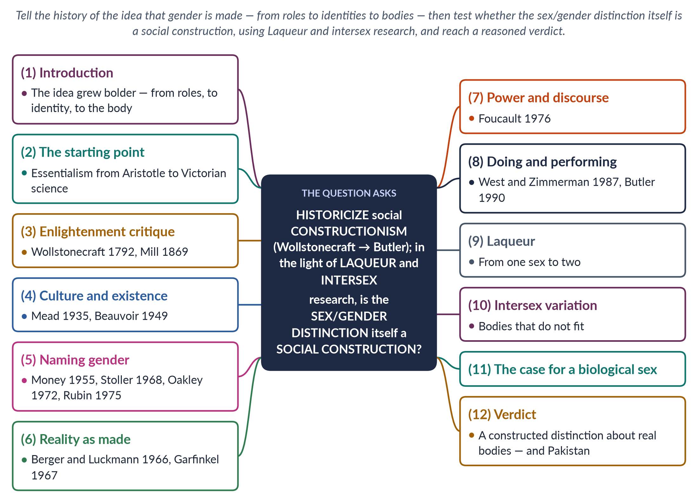
Figure 24 · The answer map: every branch is one numbered heading of the model answer below.

Decoding the question
"Historicize" means tell the idea's history: when each stage appeared, who developed it and how it grew bolder — not just list theories. The question names six thinkers; use them all, in order, with dates. The second limb asks a critical question — is the sex/gender distinction itself constructed? — and names the evidence to use (Laqueur, intersex research). It requires a verdict, with the case on both sides.

The model answer

1. Introduction

i) Definition
Social constructionism holds that gender — and perhaps sex — is made by society through upbringing, language, institutions and daily life, rather than given by nature. To historicize constructionism is to show that this idea itself has a history.

ii) The argument
Constructionism grew bolder in three steps: first it claimed that women's roles and character are social (Wollstonecraft to Beauvoir); then that gender identity is learned and performed (Money to West and Zimmerman); and finally that the very category of sex is shaped by society (Foucault, Laqueur, Butler). On the final claim my verdict is partial: bodies and their differences are real, but how we divide them into two, and what we make those divisions mean, are social. The sex/gender distinction is a useful construction about real bodies.

2. The starting point: essentialism

i) What essentialism claimed
Constructionism began as a revolt against essentialism — the belief that women and men have fixed natural essences.

ii) Its forms

(a) Classical
Aristotle described the female as an incomplete male.

(b) Victorian science
Scientists claimed women's smaller brains and reproductive organs made them emotional and unfit for higher education or the vote.

iii) Its effect
Essentialism made inequality look natural, and therefore unchangeable.

3. The Enlightenment critique

i) Wollstonecraft (1792)
Mary Wollstonecraft (A Vindication of the Rights of Woman) made the first great constructionist move: women seemed weak and silly not by nature but because they were denied education and trained to please men.

ii) Mill (1869)
John Stuart Mill (The Subjection of Women) went further: what is called women's "nature" is "an eminently artificial thing" — the product of forced repression in some directions and unnatural stimulation in others.

iii) Their limit
Both still assumed two natural sexes; their target was the character and roles built on them.

4. Culture and existence

i) Mead (1935)
Margaret Mead's Sex and Temperament found that among the Arapesh both sexes were gentle, among the Mundugumor both were fierce, and among the Tchambuli women dominated — so temperament varies with culture.

ii) Beauvoir (1949)
Simone de Beauvoir's The Second Sex gave constructionism its motto: "One is not born, but rather becomes, a woman." Society defines man as the human norm and woman as "the Other", and makes girls into that Other through upbringing, marriage, religion and law.

5. Naming gender

i) From medicine
John Money coined "gender role" in 1955; Robert Stoller (Sex and Gender, 1968) separated biological sex from gender identity.

ii) Into sociology
Ann Oakley (Sex, Gender and Society, 1972) brought the distinction into sociology — sex is biological, gender cultural; Gayle Rubin (1975) described the "sex/gender system" by which societies turn biological sex into social roles.

iii) A feminist weapon
If inequality lies in gender, not sex, it can be changed.

6. Reality as made

i) Berger and Luckmann (1966)
The Social Construction of Reality showed how people externalise arrangements, which then undergo objectivation — they come to look like solid facts — and are internalised by each new generation as natural.

ii) Garfinkel, Kessler and McKenna
Harold Garfinkel (1967) studied "Agnes", who had to work constantly to be seen as a woman, showing gender as a daily accomplishment; Kessler and McKenna (1978) showed that we assign gender to others from social clues, not from seeing bodies.

7. Power and discourse

i) Foucault's claim
Michel Foucault's The History of Sexuality (1976) argued that power does not only silence sex; it produces talk about it — medicine, psychiatry and law created new types of person, such as "the homosexual" of nineteenth-century medicine.

ii) The consequence
Construction moved from roles to categories: if sexual categories have a history, perhaps sexual bodies are read through categories too.
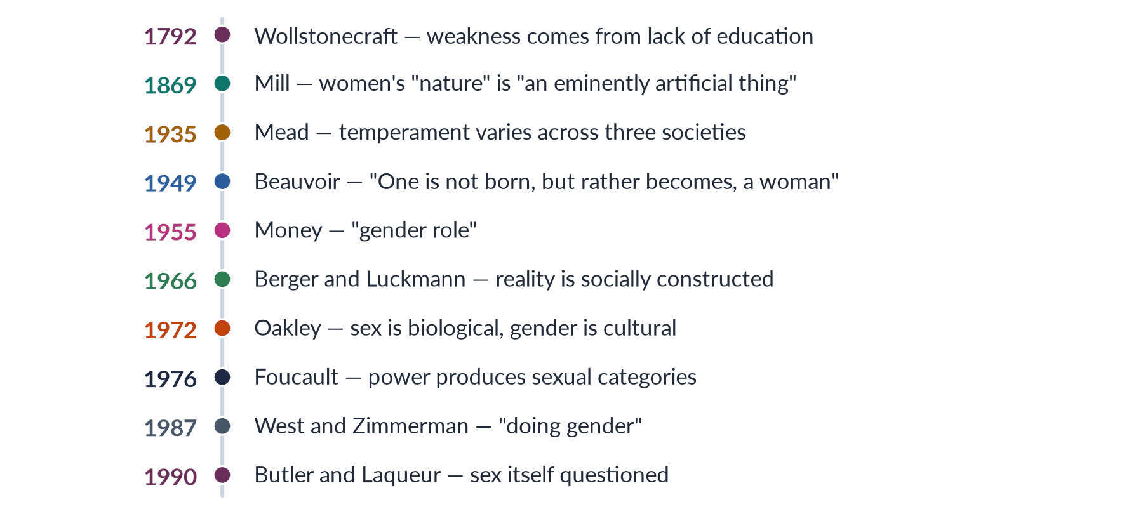
Figure 25 · Historicizing constructionism: how the idea that gender is made grew bolder.

8. Doing and performing gender

i) Doing gender (1987)
Candace West and Don Zimmerman argued that gender is something we do in interaction and are held accountable for.

ii) Performativity (1990)
Judith Butler's Gender Trouble made the boldest claim: gender is performative — repeated, stylised acts create the appearance of an inner gender — and "sex" may be "always already gender", because we see bodies through gender categories.

iii) Gender as institution (1994)
Judith Lorber treated gender as a social institution. Constructionism had reached the body.

9. Laqueur: from one sex to two

i) The one-sex model
Thomas Laqueur's Making Sex (1990) showed that for centuries European medicine saw the female body as an inverted, lesser version of the male body, with the same organs turned inward.

ii) The two-sex model
Only in the eighteenth century did a "two-sex model" of opposite bodies take hold — partly for social and political reasons, as new ideas of equality required new grounds for women's exclusion.

iii) What it proves
If the way science sees sexed bodies has changed, our two-sex framework is, at least in part, a historical product.

10. Intersex variation

i) Bodies that do not fit
Intersex people — whose chromosomes, gonads or anatomy do not fit the usual male or female pattern — show that bodies vary more than a strict binary allows.

ii) Where the line is drawn
Estimates range from about 0.018% of births (Leonard Sax, 2002) to 1.7% (Anne Fausto-Sterling, "The Five Sexes", 1993), depending on the definition — itself a sign that drawing the line is a social decision. Doctors long assigned intersex babies a sex by social criteria, and sports bodies keep revising their sex tests.

iii) In Islamic law
Classical Islamic law recognised the intersex person as khuntha, with detailed rules — variation acknowledged within a two-sex framework.
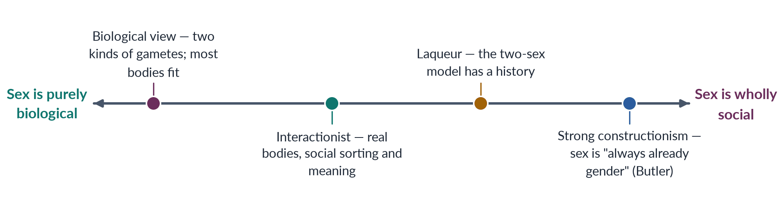
Figure 26 · Positions on the question "Is the sex/gender distinction itself socially constructed?"

11. The case for a biological sex

i) Gametes and bodies
Reproduction requires two kinds of gametes — eggs and sperm — and the great majority of people fit clearly into one sex. Sorting bodies is not creating them.

ii) Real consequences
Sex has consequences — pregnancy, maternal health, women's sport, women-only spaces — that a purely discursive account cannot handle.

iii) The political danger
Martha Nussbaum (1999) attacked Butler's work as too abstract to help real women facing hunger and violence; strong constructionism also risks dissolving "women" as a political category just when women need it.

12. Verdict, and the Pakistani debate

i) My verdict
The sex/gender distinction is partly constructed. The bodies are real, and so are differences in reproduction. But the decision to sort all bodies into exactly two boxes, where to draw the line for intersex people, and what the boxes mean for rights, work and dress are social and historical. The distinction is best seen as a powerful tool — invented in 1955–1972, used to free women from "biology is destiny" — that remains useful as long as we remember that both terms carry social meaning.

ii) Why it matters in Pakistan
The debate is not abstract. The Transgender Persons (Protection of Rights) Act 2018 based identity on self-perception; the Federal Shariat Court on 19 May 2023 held key sections against Islamic injunctions, distinguishing biological intersex variation (recognised) from identity separate from sex (not recognised); the appeal was still pending in 2026. The court, in effect, drew a line between sex and gender — showing that where we place that line is a legal and social choice.

13. Conclusion

i) The history in brief
Constructionism began by freeing women's character from nature (Wollstonecraft, Mill), named gender as distinct from sex (Money, Oakley), explained how social reality hardens into fact (Berger and Luckmann) and finally questioned sex itself (Foucault, Laqueur, Butler). The history shows the idea growing bolder at each step.

ii) The answer
The final step is only half right: bodies are not invented, but the sex/gender distinction is a social construction about real bodies — and that is precisely why societies, courts and legislatures argue about where to draw it.

Why this answer scores
- Historicizes rather than lists: the idea moves from roles, to identity, to the body, with every stage dated.
- Uses all six named thinkers in order, adding Mead, Money, Oakley and Garfinkel where they fill the story.
- Uses the named evidence — Laqueur's one-sex model and intersex estimates — and states the opposing case fairly.
- Gives a clear, defended verdict and applies it to the Transgender Persons Act and the FSC judgment of 2023.
- A timeline and a spectrum figure show the history and the range of positions.

Set 2 · Q. No. 3 · Can Men Be Feminists? Masculinities, Pro-Feminism and the Manosphere
AT A GLANCE · PREDICTION PAPER SET 2 · Q. NO. 3 · 20 MARKS
Can men be feminists? Critically evaluate men's feminism with reference to R. W. Connell's theory of masculinities, pro-feminist men's movements and the rise of the online "manosphere". What role can men play in advancing gender equality in Pakistan?

The answer map
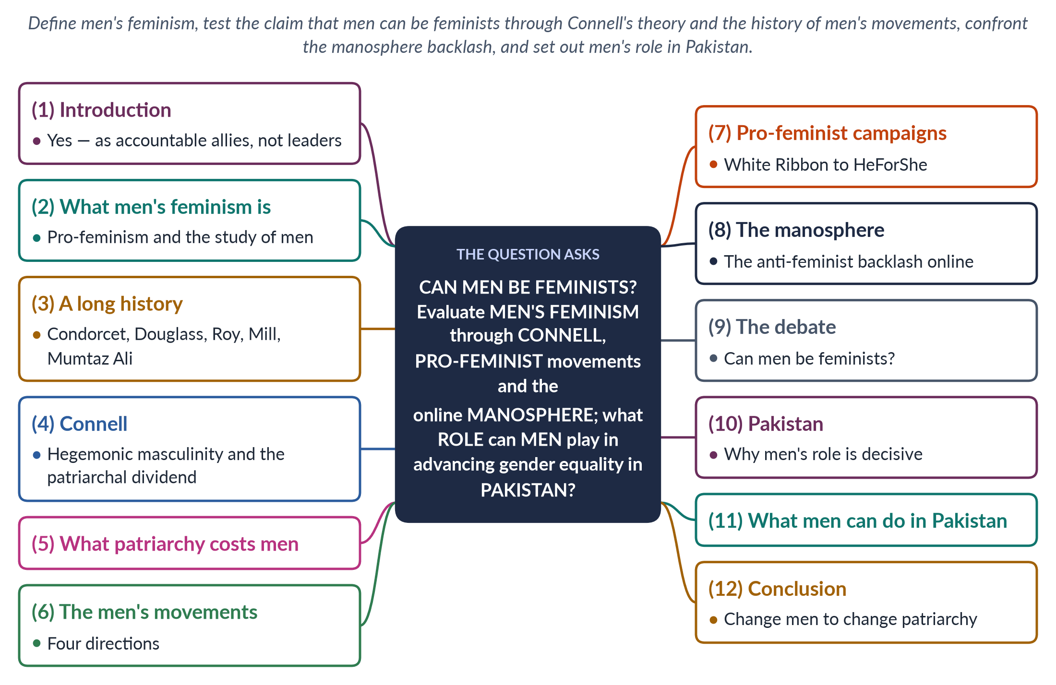
Figure 27 · The answer map: every branch is one numbered heading of the model answer below.

Decoding the question
The question is evaluative and applied. "Can men be feminists?" demands a position, argued both ways. "Critically evaluate men's feminism" names three lenses to use — Connell's theory, pro-feminist men's movements and the manosphere (the anti-feminist backlash) — so each needs its own heading. "What role can men play … in Pakistan" asks for practical roles, grounded in Pakistani institutions and examples. Men's feminism has never been asked in either part of the paper — a blind spot.

The model answer

1. Introduction

i) Definition
Men's feminism (or pro-feminism) is men's support for gender equality, combined with the study of how patriarchy shapes men — the masculinities it rewards and the harm it does. It aims to change both men and the male-run institutions of society.

ii) The argument
Men can be feminists — as allies accountable to women, not as leaders who displace them. R. W. Connell's theory shows why men's change is necessary: patriarchy is sustained by a hegemonic ideal of manhood from which all men draw a "dividend". Pro-feminist men's movements prove that men can reject that dividend; the online manosphere proves how fiercely others defend it. In Pakistan, where fathers, brothers, husbands and elders make the key decisions in women's lives, men's role is decisive.

2. What men's feminism is

i) Two strands

(a) Political support
Men who back women's rights to education, work, safety, property and political voice, and who challenge sexism among other men.

(b) The study of men
Masculinity studies — research on how manhood is made, ranked and enforced, and how it harms women and men alike.

ii) Its place in the syllabus
It sits beside liberal, radical, Marxist, psychoanalytic and postmodern feminism as a school in its own right, because it answers a question the others raised: if gender is socially constructed, men's gender can be reconstructed too.

3. A long history

i) Western allies
The French philosopher Condorcet argued for women's citizenship in 1790; Frederick Douglass, the only African-American to sign the Declaration of Sentiments, supported the vote resolution at Seneca Falls (1848); and John Stuart Mill published The Subjection of Women in 1869.

ii) South Asian and Muslim reformers
Raja Ram Mohan Roy campaigned against sati, banned in 1829; Sayyid Mumtaz Ali of Lahore wrote Huquq-un-Niswan (1898); Qasim Amin in Egypt wrote on women's liberation (1899); Sheikh Abdullah ("Papa Mian") opened a girls' school at Aligarh in 1906; and Muhammad Ali Jinnah told students in 1944 that no nation can rise unless its women stand beside its men.

iii) The lesson
Men's support for women's rights is not a Western novelty — it has deep local roots.

4. Connell: the theory behind men's feminism

i) Hegemonic masculinity
In Gender and Power (1987) and Masculinities (1995), R. W. Connell described hegemonic masculinity — the honoured, dominant ideal of manhood (tough, heterosexual, the provider, in control) that legitimises men's power over women.

ii) A hierarchy of masculinities

(a) Complicit
Most men do not match the ideal but benefit from it.

(b) Marginalised and subordinated
Men lowered by class or ethnicity, and men called "unmanly" — gay or effeminate men — are ranked below.

iii) The patriarchal dividend
All men gain a patriarchal dividend — advantages in pay, authority, safety and respect — from women's subordination, whether or not they seek it. Men's feminism therefore asks men to give up a dividend, which explains both its moral force and its difficulty.
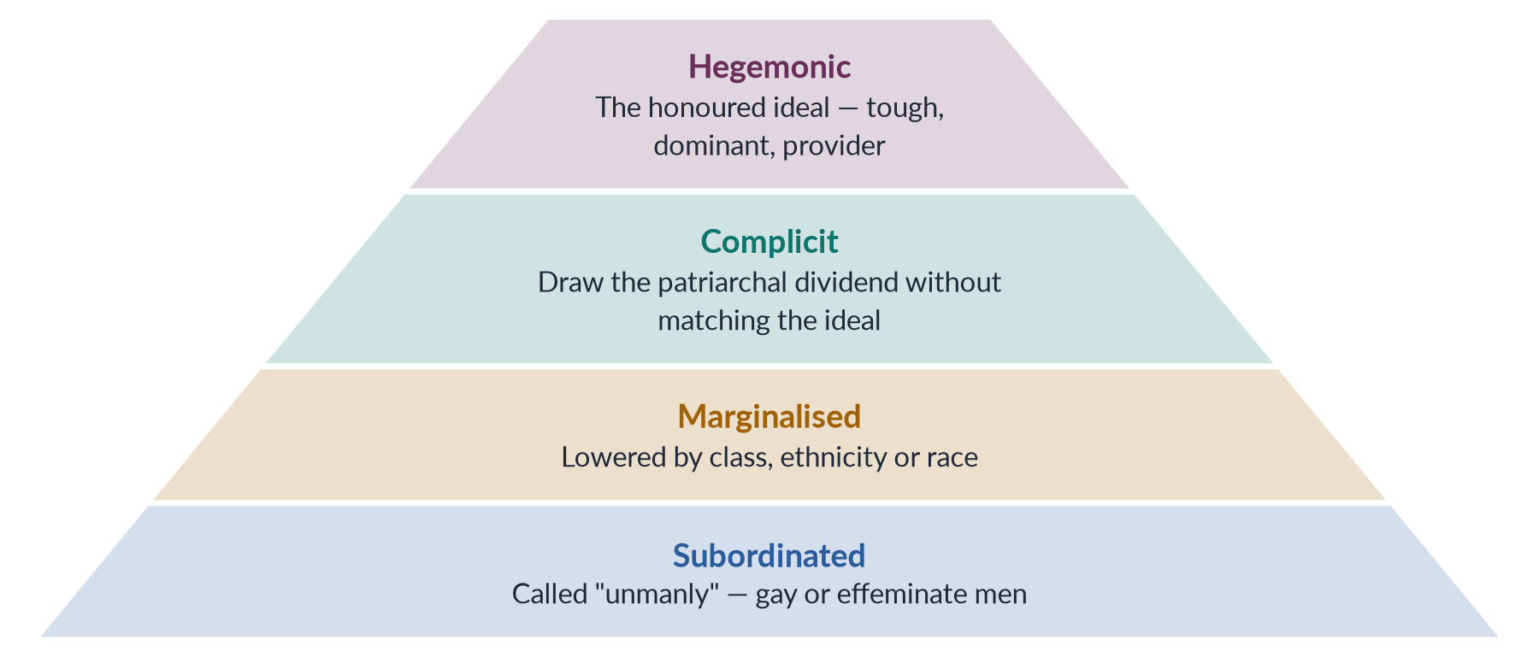
Figure 28 · Connell's hierarchy of masculinities — what men's feminism asks men to challenge.

5. What patriarchy costs men

i) The evidence
Men live shorter lives, have higher suicide rates, are most of the victims of homicide and carry the provider burden. bell hooks (The Will to Change, 2004) argued that patriarchy wounds men emotionally by forbidding tenderness.

ii) In Pakistan
The provider burden means dowries, debt and migration for work; the saying "mard ko dard nahi hota" (a man feels no pain) teaches boys to hide feelings; and distant fatherhood is the norm.

iii) Why it matters
These costs give men their own reason to change — but men's feminism insists that they do not cancel the much greater harm patriarchy does to women.

6. The men's movements: four directions

i) Pro-feminist
Organisations such as the US National Organization for Men Against Sexism support women's rights and challenge male privilege.

ii) Men's liberation
From the 1970s, groups focused on the costs of the male role — emotional repression and overwork.

iii) Mythopoetic
Robert Bly's Iron John (1990) urged men to recover a "deep masculinity" through ritual — criticised for romanticising manhood.

iv) Men's rights
An anti-feminist stream claiming men are now the victims — over custody, divorce and "false accusations". Michael Messner (1997) mapped these movements by how far they recognise privilege, costs and differences among men.
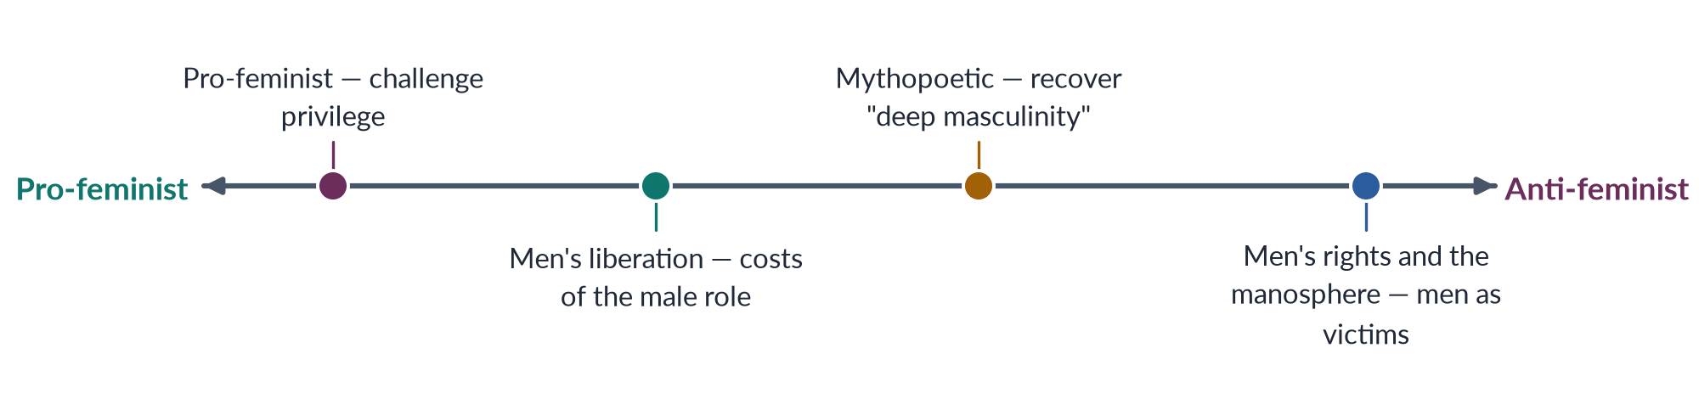
Figure 29 · Men's movements, from pro-feminist to anti-feminist.

7. Pro-feminist campaigns

i) White Ribbon
After the Montreal massacre of 6 December 1989, in which 14 women were killed, Canadian men launched the White Ribbon Campaign (1991), pledging never to commit, excuse or remain silent about violence against women.

ii) The UN and global networks
The Cairo population conference (1994) stressed male responsibility; MenEngage (2004) linked organisations worldwide; and UN Women's HeForShe campaign (2014) invited men to commit to equality.

8. The manosphere: the backlash online

i) What it is
The manosphere is a network of online communities and influencers who present feminism as an attack on men, promote dominance over women and blame women for men's problems.

ii) Why it appeals

(a) Aggrieved entitlement
Michael Kimmel describes "aggrieved entitlement" — the anger of men who feel promised a status they no longer receive.

(b) Economic insecurity
Unemployment and the loss of the breadwinner role make young men receptive to messages that blame women.

iii) Its effects
It spreads misogyny, normalises online abuse of women journalists, politicians and activists, and pushes some young men towards hostility to equality — the clearest evidence that masculinity is contested, and that feminism needs men who argue back.

9. The debate: can men be feminists?

i) Yes
bell hooks argued that feminism is a movement against sexism, not against men, and so is open to all who oppose sexism.

ii) Yes, but as allies
Many feminists prefer "pro-feminist" or "ally": men can support the movement but should not lead it, speak over women or claim credit.

iii) Caution
Critics warn of men joining for image, diverting attention and funds, and of men's groups sliding into men's rights.

iv) My position
Men can be feminists in the sense that matters — committed to equality and accountable to women's organisations — while recognising that they still hold the dividend they oppose.

10. Pakistan: why men's role is decisive

i) Men hold the decisions
Whether a girl goes to secondary school, whom and when she marries, whether she may work, vote or inherit — these are usually decided by fathers, brothers, husbands and elders. Any strategy that ignores men leaves the gatekeepers untouched.

ii) Men's violence
Honour killing, domestic violence and harassment are overwhelmingly committed by men, often to defend ghairat — so violence prevention must work with men's ideas of honour.

iii) Local models
The Islamabad NGO Rozan has worked since the late 1990s with boys, young men and police on gender, emotional health and violence; Ziauddin Yousafzai, father of Malala, built a girls' school in Swat and wrote Let Her Fly (2018).

11. What men can do in Pakistan

i) In the family
Send daughters to school, refuse child marriage, give sisters their inheritance, share care work, and reject violence.

ii) In institutions
Male legislators can sponsor and vote for pro-women laws; police officers can register FIRs without "compromise"; employers can enforce the workplace harassment law 2010; teachers can challenge stereotypes in textbooks.

iii) In religion and culture
Male scholars can show that Islam forbids forced marriage and guarantees women's inheritance and consent; writers and actors can model caring masculinities; influencers can answer the manosphere online.

12. Conclusion
Men can be feminists — not as leaders of women's struggle, but as accountable allies who challenge the masculinity that sustains patriarchy. Connell's theory explains why that change is necessary, the pro-feminist movements show it is possible, and the manosphere shows how strongly the dividend is defended. In Pakistan, where men stand at every gate of a woman's life, changing men is not an optional extra to feminism: it is one of its central tasks.

Why this answer scores
- Takes a clear position ("yes, as accountable allies") and argues both sides.
- Uses all three named lenses — Connell, pro-feminist movements, the manosphere — under separate headings.
- Shows local roots (Roy, Mumtaz Ali, Papa Mian, Jinnah), answering the "Western" charge.
- Gives practical roles for Pakistani men in the family, institutions and religion.
- A pyramid and a spectrum figure organise the theory and the movements.

Set 2 · Q. No. 4 · "Infinitely Elastic": The Gendered Impact of Structural Adjustment and IMF Programmes
AT A GLANCE · PREDICTION PAPER SET 2 · Q. NO. 4 · 20 MARKS
"Structural adjustment treats women's labour as infinitely elastic" (Diane Elson). Critically analyse the gendered impact of structural adjustment and IMF stabilisation programmes on women in developing countries, with particular reference to Pakistan's programmes of 2023–2024 and the care economy.

The answer map
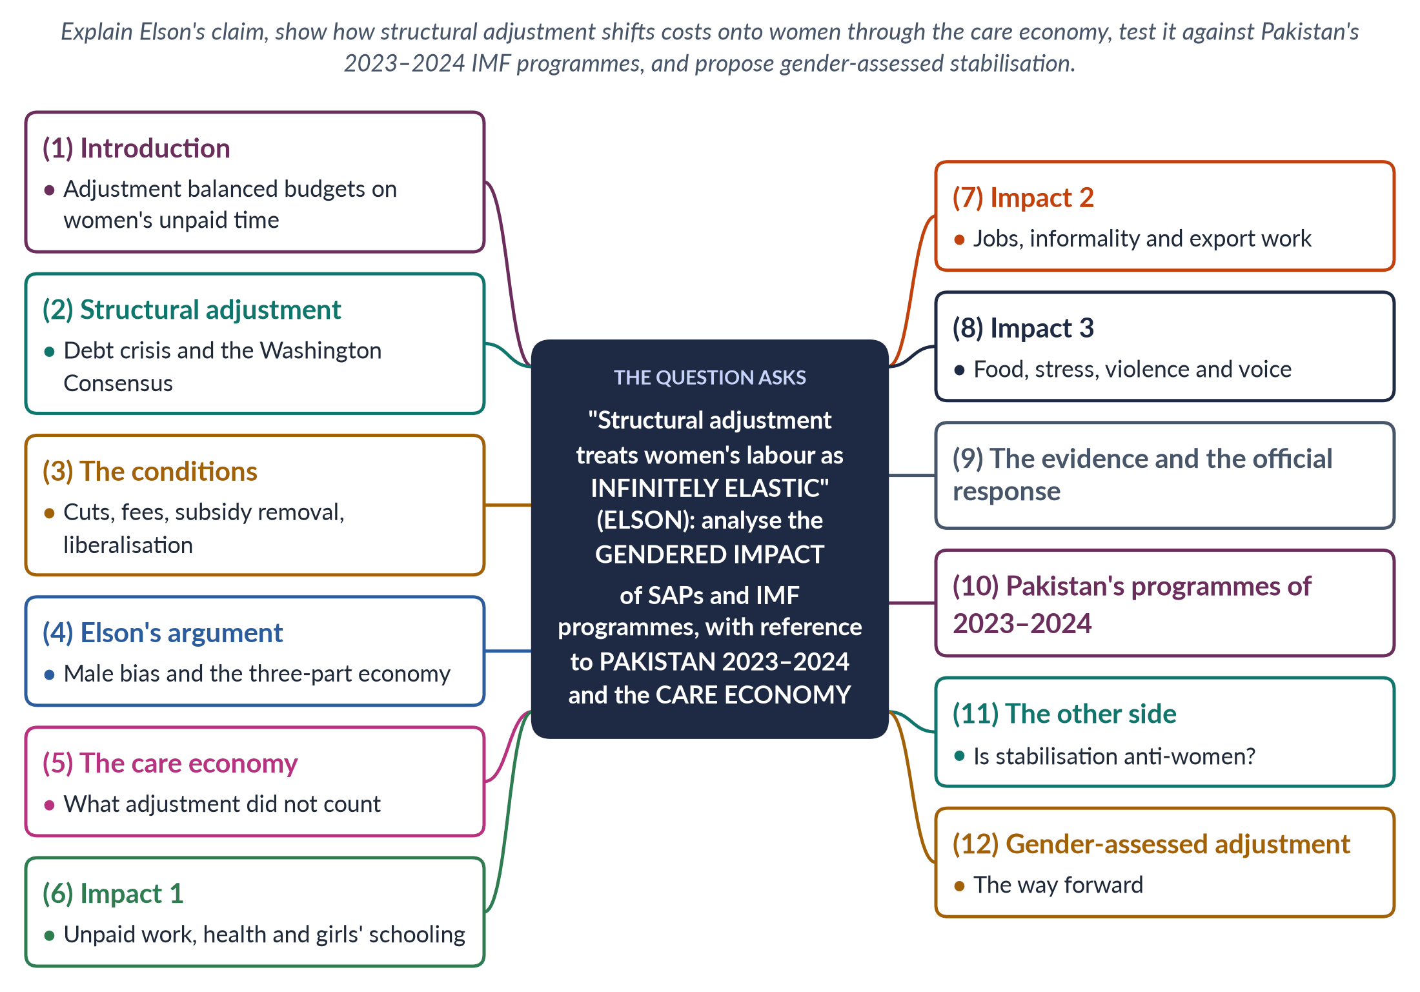
Figure 30 · The answer map: every branch is one numbered heading of the model answer below.

Decoding the question
The question begins with a quotation — explain it first: Diane Elson's claim that adjustment assumes women's unpaid work can stretch without limit. "Critically analyse the gendered impact" asks for effects and a balanced judgement (the defence of stabilisation must appear). The question names two contexts that need their own headings: Pakistan's programmes of 2023–2024 (the Stand-By Arrangement and the Extended Fund Facility) and the care economy.

The model answer

1. Introduction

i) Definition
Structural adjustment programmes (SAPs) are packages of economic reforms — spending cuts, subsidy removal, devaluation, privatisation and liberalisation — that the IMF and World Bank attach as conditions to loans for countries in debt or balance-of-payments crisis. IMF stabilisation programmes are their modern successors.

ii) The argument
Adjustment was designed as if the economy had only markets and the state. It ignored the household, where women's unpaid care keeps people alive. When services were cut and prices rose, the gap was filled by women's extra work — hence Diane Elson's charge that SAPs treat women's labour as "infinitely elastic". Pakistan's programmes of 2023–2024 show the same pattern, partly offset by the expansion of BISP. Stabilisation may be necessary, but it must be gender-assessed.

2. Structural adjustment

i) The debt crisis
SAPs spread after the debt crisis that began with Mexico in 1982, when many developing countries could not service their loans.

ii) The Washington Consensus
The policy package was summed up by John Williamson in 1989 as the "Washington Consensus": fiscal discipline, market prices, trade and financial liberalisation, privatisation and deregulation.

3. The conditions

i) Cutting the state
Cuts in spending on health, education, subsidies and public jobs; user fees for schools and clinics.

ii) Changing prices
Removal of food, fuel and power subsidies; devaluation, which raises the price of imports.

iii) Opening the economy
Privatisation, trade and financial liberalisation, and labour deregulation.

4. Elson's argument: male bias

i) The source
In Male Bias in the Development Process (1991), Diane Elson argued that SAPs carry a hidden male bias: they treat the economy as if only paid work existed.

ii) The three-part economy

(a) The market
Paid production, measured in GDP.

(b) The state
Public services — health, schools, water.

(c) The household
Unpaid care — cooking, cleaning, caring for children, the sick and the old — done mostly by women and never counted.

iii) The elastic assumption
When the state retreats and prices rise, planners assume the household will absorb the shock. In practice this means women's time must stretch — as if it were "infinitely elastic". It is not: beyond a point, women's health, girls' schooling and children's nutrition give way.
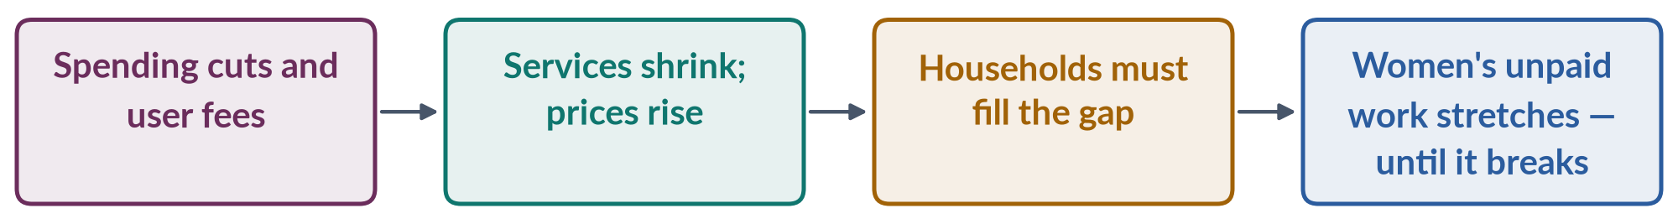
Figure 31 · How structural adjustment shifts costs onto women.

5. The care economy

i) What it is
The care economy is the paid and unpaid work of caring for people. Women do about three times as much unpaid care work as men worldwide (ILO, 2018).

ii) Why it was invisible
Marilyn Waring (If Women Counted, 1988) showed that GDP ignores it; Arlie Hochschild (1989) named women's "second shift" after paid work.

iii) Why it matters for adjustment
Because care was uncounted, its increase under adjustment was invisible in the statistics that judged the programmes a success. SDG target 5.4 now calls for unpaid care to be recognised and valued.

6. Impact 1: unpaid work, health and girls' schooling

i) More unpaid work
When hospitals charged fees or discharged patients early, women cared for the sick at home; when subsidies ended, women spent more time stretching food and fuel.

ii) Women's health
Cuts and user fees reduced women's use of maternal health services; maternal deaths rose in some countries.

iii) Girls withdrawn from school
School fees and household poverty led families to withdraw girls first, to save money and to help at home.

7. Impact 2: jobs, informality and export work

i) Lost public jobs
Public-sector cuts removed jobs in teaching, nursing and administration, where women were concentrated.

ii) Informal work
Women were pushed into informal work — petty trade, home-based production — to replace lost income, often for very low returns.

iii) Export jobs
New export jobs in garments and electronics went to women but were low-paid, insecure and without labour rights — the "global assembly line".

8. Impact 3: food, stress, violence and voice

i) Food
Removal of food subsidies hit poor women, who are responsible for feeding families.

ii) Stress and violence
Economic stress was linked with rising domestic tension and violence, and with men losing the breadwinner role.

iii) No voice
Programmes were negotiated by finance ministries and lenders with no participation by women.

9. The evidence and the official response

i) The evidence

(a) UNICEF
Adjustment with a Human Face (Cornia, Jolly and Stewart, 1987) documented the harm to children and women.

(b) The Commonwealth and DAWN
The Commonwealth Secretariat's Engendering Adjustment for the 1990s (1989) showed the burden on women; DAWN (1985) placed the debt crisis at the centre of its critique.

ii) The response
The IMF and World Bank added social safety nets, Poverty Reduction Strategy Papers (1999) and later "gender-responsive" language. Critics say the core conditions changed little.
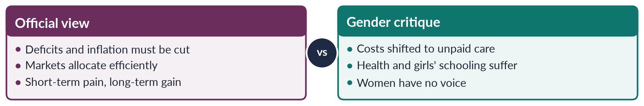
Figure 32 · The official view of adjustment and the gender critique.

10. Pakistan's programmes of 2023–2024

i) The programmes
Pakistan's first IMF adjustment programme began in 1988; many followed. The most recent are a Stand-By Arrangement (2023) and a 7-billion-dollar Extended Fund Facility approved in 2024.

ii) The conditions
Raising electricity and gas prices, widening the sales tax, cutting development spending and reducing subsidies.

iii) The gendered effects

(a) Household budgets
Higher prices for food and energy fall on women, who manage household budgets and cooking fuel.

(b) Services
Pressure on health and education budgets threatens maternal care and girls' schooling — in a country with a maternal mortality ratio of 186 (PMMS 2019) and female literacy of about 53% (Census 2023).

(c) Work
Fewer public jobs and rising informality, with female labour-force participation only 24.4% (LFS 2024–25).

iv) The safety net
The Benazir Income Support Programme (2008), which pays women, was expanded during the programmes — a partial answer to the gender critique, though cash transfers cannot replace public services.

11. The other side: is stabilisation anti-women?

i) The defence
Without stabilisation, inflation and default would hurt the poor — and women — even more. Recent programmes protect BISP spending, and macroeconomic stability is a precondition for growth and jobs.

ii) The reply
The question is not whether to stabilise but how: indirect taxes such as sales tax fall hardest on poor households, while cuts to health and education transfer costs to women's time. A programme can be stable and fair.

12. Gender-assessed adjustment: the way forward

i) Protect the essentials
Ring-fence spending on maternal health, girls' education and BISP; avoid user fees for primary health and schooling.

ii) Tax fairly
Shift from regressive sales taxes towards progressive direct taxes on income and property.

iii) Count care

(a) Measure it
Run regular time-use surveys so that unpaid care appears in the statistics.

(b) Budget for it
Use gender-responsive budgeting to assess every programme condition for its effect on women's time and income.

iv) Give women a voice
Include the Ministry of Women's Development, the NCSW and women's organisations in negotiating and monitoring programmes.

13. Conclusion

i) The insight
Elson's phrase captures the central flaw of structural adjustment: it balanced budgets by drawing on women's unpaid time, which it neither counted nor protected.

ii) The Pakistan lesson
Pakistan's programmes of 2023–2024 repeated the pattern through energy prices, sales tax and development cuts, softened by BISP. The lesson is not to reject stabilisation but to gender-assess it — because women's labour is not infinitely elastic, and when it breaks, health, schooling and development break with it.

Why this answer scores
- Explains the quotation first, through Elson's three-part economy.
- Gives the care economy its own heading (Waring, Hochschild, ILO 2018, SDG 5.4).
- Lists the impacts systematically and cites the evidence (UNICEF 1987; Commonwealth 1989; DAWN 1985).
- Applies the analysis to Pakistan's 2023 SBA and 2024 EFF, including BISP's expansion.
- Is critical: states the defence of stabilisation and answers it, ending with concrete reforms.
- A flow and a compare figure carry the argument.

Set 2 · Q. No. 5 · Honour Killing through Galtung's Triangle: Why the Laws of 2004 and 2016 Have Not Ended It
AT A GLANCE · PREDICTION PAPER SET 2 · Q. NO. 5 · 20 MARKS
Using Johan Galtung's typology of direct, structural and cultural violence, critically analyse honour killing in Pakistan. Why have legal reforms such as the Criminal Law (Amendment) Acts of 2004 and 2016 failed to eliminate the practice?

The answer map
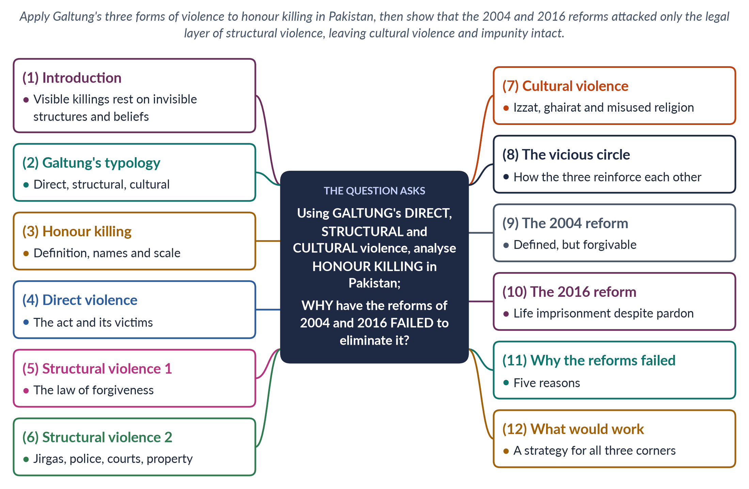
Figure 33 · The answer map: every branch is one numbered heading of the model answer below.

Decoding the question
Two tasks. First, "using Galtung's typology … critically analyse honour killing" — define the three forms and apply each to honour killing with Pakistani evidence; the analysis must show how they connect. Second, "why have legal reforms … failed" — name the 2004 and 2016 Acts, explain what each changed, and give causes of failure. Galtung's framework should organise the second half too: the reforms changed one corner of the triangle, not the others.

The model answer

1. Introduction

i) Definition
Honour killing is the murder of a woman — sometimes a man — by family or community members who claim she has brought shame on them: by choosing her own husband, seeking divorce, being raped, refusing a marriage or behaving "immodestly".

ii) The argument
Johan Galtung's typology shows that the visible killing (direct violence) rests on structural violence — laws, institutions and property relations that make killing safe — and on cultural violence — beliefs about izzat and ghairat that make it seem right. The reforms of 2004 and 2016 attacked the legal part of structural violence. They left the rest of the structure and almost all of the culture intact — which is why killings continue.

2. Galtung's typology

i) Direct violence
Violence with an identifiable perpetrator and victim — a shooting, a beating, a rape.

ii) Structural violence (1969)
Harm built into social structures — unequal laws, institutions and resources — that prevents people from meeting their needs, with no single actor to blame.

iii) Cultural violence (1990)
The beliefs, symbols and justifications — in religion, custom, language and media — that make direct and structural violence look right or acceptable.
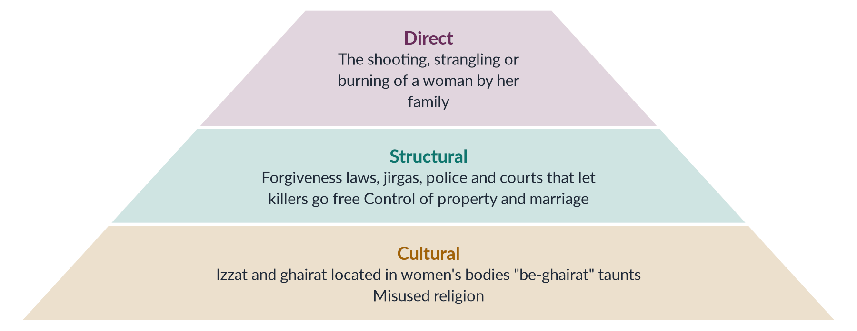
Figure 34 · Galtung's triangle applied to honour killing — the visible killing rests on invisible layers.

3. Honour killing: names and scale

i) Regional names
Karo-kari in Sindh, siyahkari in Balochistan, tor tora in Khyber Pakhtunkhwa and kala kali in Punjab.

ii) The scale
The HRCP recorded at least 405 honour killings in 2024; the SSDO recorded 547, with a conviction rate of about 0.5%. Many more are hidden as suicides or accidents.

4. Direct violence: the act

i) Who kills, and why
The killers are usually fathers, brothers, husbands or uncles, sometimes acting on a jirga's decision.

ii) The cases

(a) Samia Sarwar (1999)
Shot in her lawyers' Lahore office — the office of Hina Jilani and Asma Jahangir — while seeking divorce; her family went unpunished.

(b) Qandeel Baloch (2016)
The social-media figure was strangled by her brother in Multan in July 2016; he was sentenced to life in 2019, but the Lahore High Court acquitted him in 2022 after a parental pardon.

(c) Degari (2025)
A couple were killed on a tribal chief's orders in Degari, Balochistan, in 2025; a viral video forced arrests.

5. Structural violence 1: the law of forgiveness

i) The colonial legacy
The Pakistan Penal Code (1860) allowed "grave and sudden provocation" to reduce murder charges — a defence often claimed by "honour" killers.

ii) Qisas and Diyat
The Qisas and Diyat Ordinance (1990; Act 1997) made murder compoundable: the victim's heirs could forgive the killer or accept compensation. In honour killings the heirs are usually the killer's own family, so the family that ordered the killing could also pardon it.

6. Structural violence 2: institutions and property

i) Parallel justice
Jirgas and panchayats order or approve killings and "settle" them outside the courts.

ii) Police and courts
Police record honour killings as suicide or accident, investigations are weak, witnesses turn hostile and convictions are rare.

iii) Property and marriage
False karo-kari accusations are used to grab land, avoid giving women their inheritance or settle disputes; controlling a daughter's marriage keeps property within the clan.

7. Cultural violence: the beliefs behind the killing

i) Honour in women's bodies
Izzat (family honour) is located in women's sexuality and behaviour, and men's ghairat is measured by their control of women.

ii) Community pressure
A man who does not act is taunted as be-ghairat — without honour — and may be shunned.

iii) Misused religion and media
Killers invoke religion, although the Council of Islamic Ideology and many scholars condemn honour killing as un-Islamic; dramas and songs often romanticise male control.

8. The vicious circle

i) How the corners connect
Cultural beliefs justify structural arrangements (forgiveness laws, jirga authority); those structures enable direct violence by guaranteeing impunity; and impunity confirms the belief that killing restores honour.

ii) The implication
Breaking the circle requires action on all three corners at once.
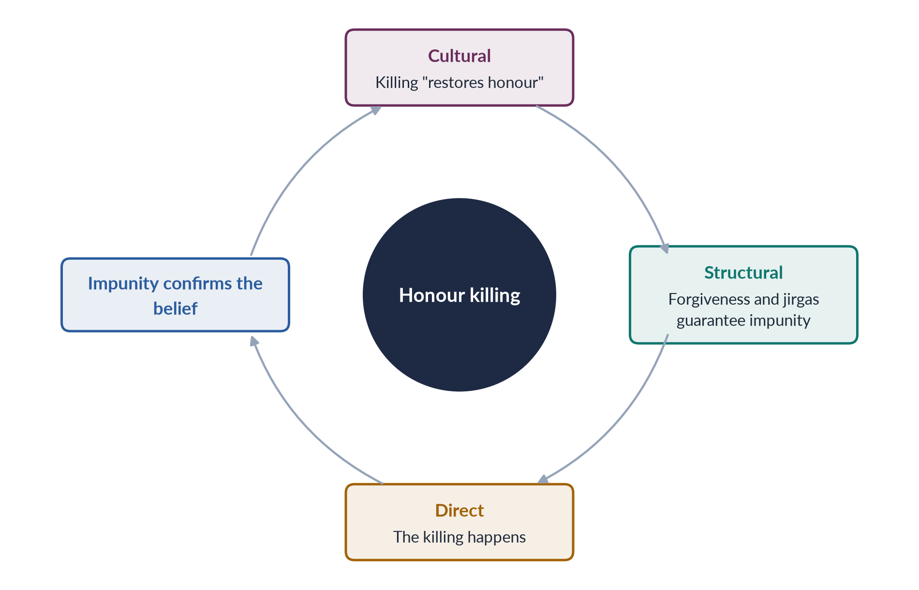
Figure 35 · How the three forms of violence sustain honour killing.

9. The 2004 reform: defined, but forgivable

i) What it did
The Criminal Law (Amendment) Act 2004 defined "honour crimes" in law and raised penalties.

ii) What it left
It kept the forgiveness loophole: heirs could still pardon the killer, so the core of structural violence remained.

10. The 2016 reform: life imprisonment despite pardon

i) The law
The Criminal Law (Amendment) (Offences in the name or pretext of Honour) Act, passed at a joint sitting in October 2016 after Qandeel Baloch's murder, from a bill moved by Senator Sughra Imam (2014), provides that heirs may forgive qisas, but the court must still award life imprisonment as ta'zir.

ii) Its significance
For the first time, a family pardon could not free an honour killer from a long sentence.

11. Why the reforms failed: five reasons

i) Motive must be proved
The 2016 law applies only if the court finds the killing was for honour — killers re-label murders as quarrels over property or "sudden provocation".

ii) Investigation and witnesses
Killings are disguised as suicide; families refuse to testify; witnesses turn hostile.

iii) Settlements continue
Pardons and jirga settlements still shape outcomes — as the 2022 acquittal in the Qandeel Baloch case showed.

iv) Parallel justice untouched
Jirgas continue to order and approve killings despite court rulings against them.

v) Culture unchanged
The reforms changed the law but not the belief that killing restores honour — cultural violence was left untouched.

12. What would work

i) Against structural violence

(a) Close the loophole fully
Make all murders of women by family members non-compoundable, whatever the motive claimed.

(b) Investigate and protect
Treat every suspicious female death as a possible murder; train police in forensics; protect couples and witnesses; prosecute jirga members.

ii) Against cultural violence
Enlist religious scholars to state clearly that honour killing is murder in Islam; reform school textbooks and media portrayals; work with men and boys on ideas of ghairat.

iii) Against vulnerability
Enforce women's inheritance and economic independence; provide shelters and safe houses.

13. Conclusion

i) The diagnosis
Galtung's triangle shows that honour killing is not only a crime by individuals: the visible act rests on forgiveness laws, jirgas and property relations, and on beliefs that place a family's honour in a woman's body.

ii) The verdict on the reforms
The 2004 and 2016 Acts were necessary steps, but they repaired one corner of the triangle. Until impunity ends and the culture of ghairat changes, the killings will continue.

Why this answer scores
- Defines all three of Galtung's forms with dates (1969, 1990) and applies each to honour killing with Pakistani evidence.
- Shows how the forms connect — the vicious circle — which is the analytical core.
- Explains precisely what the 2004 and 2016 Acts changed, and gives five reasons for failure.
- Uses cases (Samia Sarwar, Qandeel Baloch, Degari) and current data (HRCP and SSDO, 2024).
- A pyramid and a cycle figure carry the argument.

Set 2 · Q. No. 6 · "Feminism Is a Western Import": A Critical Evaluation
AT A GLANCE · PREDICTION PAPER SET 2 · Q. NO. 6 · 20 MARKS
"Feminism is a Western import." Critically evaluate this claim with reference to the history of women's activism in South Asia, postcolonial feminist critiques of Western feminism and the work of Muslim feminist scholars.

The answer map
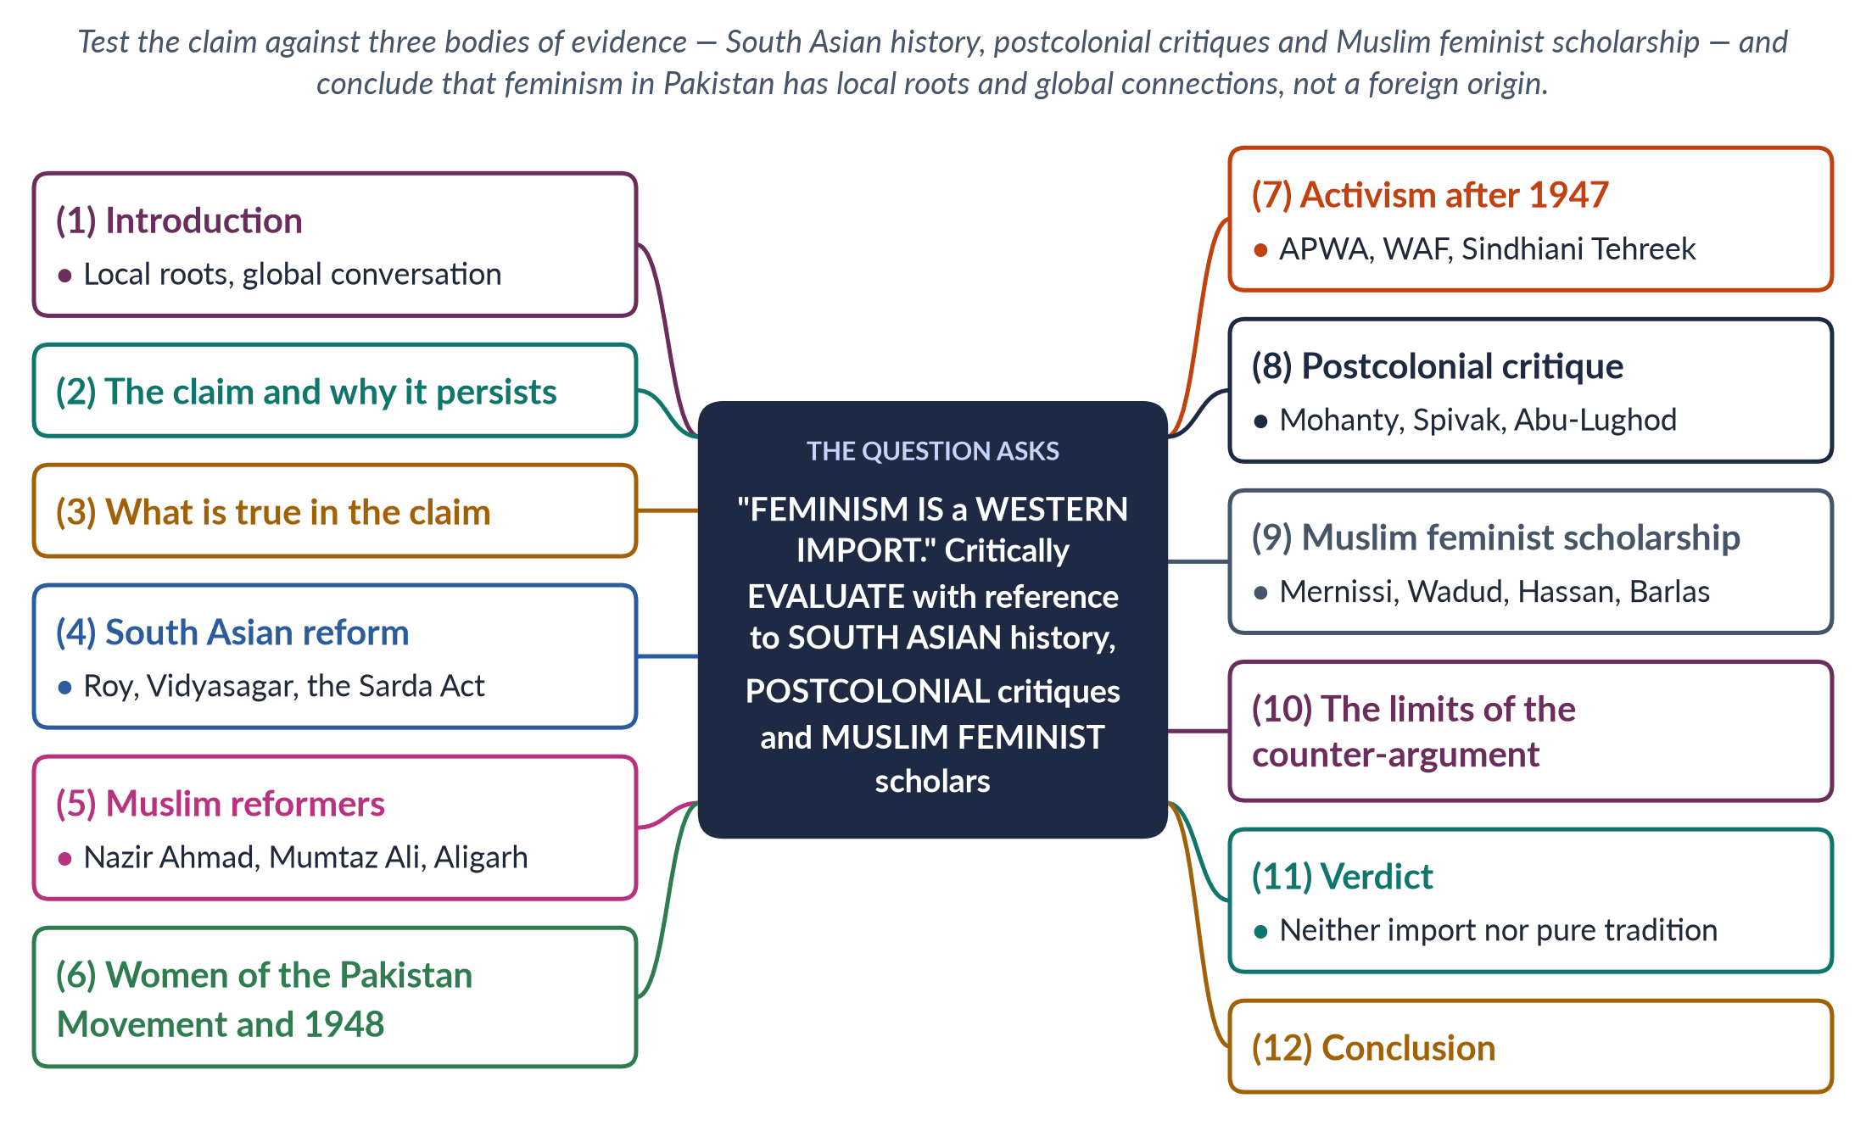
Figure 36 · The answer map: every branch is one numbered heading of the model answer below.

Decoding the question
"Critically evaluate" a quoted claim — weigh it, accept what is true and reject what is false, and end with a verdict. The question names three bodies of evidence: the history of women's activism in South Asia, postcolonial feminist critiques of Western feminism, and Muslim feminist scholars. Give each its own heading. A strong answer also admits the grain of truth in the claim.

The model answer

1. Introduction

i) Definition
Feminism is the belief that women and men should have equal rights and opportunities, and the movement to end women's subordination. The claim that it is a Western import holds that it is foreign to Muslim and South Asian societies, carried in by Western ideas, donors and NGOs.

ii) The argument
The claim is mostly false. Women's rights in South Asia were argued by local reformers, Muslim scholars and women of the Pakistan Movement long before the Western "second wave", and postcolonial and Muslim feminists have built their own critiques of Western feminism. What is true is that feminism has always been part of a global conversation, and that some Pakistani activism has depended on Western funding and vocabulary. Feminism in Pakistan is best described as locally rooted and globally connected.

2. The claim and why it persists

i) Who makes it
Conservative religious parties, some media commentators and critics of the Aurat March argue that feminism is a "Western" or "anti-family" agenda.

ii) Why it persuades

(a) Colonial memory
British rulers used the "status of women" to justify colonial rule — Katherine Mayo's Mother India (1927), which Gandhi called "a drain inspector's report", is the classic example.

(b) Donors and NGOs
Since the 1990s much gender work in Pakistan has been donor-funded, giving the impression of a foreign agenda.

(c) Vocabulary
Terms such as "gender", "empowerment" and "bodily autonomy" arrived in English.

3. What is true in the claim

i) Global influence is real
Western feminism supplied ideas and tools: the waves, CEDAW (1979), the Beijing Platform (1995) and the language of human rights.

ii) Dependence is real
NGO-isation — professionalised, donor-funded gender projects — has sometimes made activism accountable to donors rather than to Pakistani women.

iii) But influence is not origin
Borrowing tools is not the same as importing the cause. Pakistani women chose, adapted and sometimes rejected Western ideas.

4. South Asian reform before the West's second wave

i) Hindu reformers
Raja Ram Mohan Roy campaigned against sati, abolished by the Bengal Sati Regulation of 1829; Ishwar Chandra Vidyasagar won the Widows' Remarriage Act (1856); Tarabai Shinde wrote a fierce critique of male power in 1882.

ii) Laws for women
The Age of Consent Act (1891), the Child Marriage Restraint Act (1929) and the Dissolution of Muslim Marriages Act (1939) were products of debates inside the subcontinent.

5. Muslim reformers

i) Writers
Nazir Ahmad's Mirat-ul-Uroos (1869) promoted girls' education; Sayyid Mumtaz Ali wrote Huquq-un-Niswan (1898) and, with Muhammadi Begum, published Tahzib-e-Niswan.

ii) Institutions
Sheikh Abdullah and Wahid Jahan Begum founded a girls' school at Aligarh (1906); Begum Rokeya wrote her feminist utopia Sultana's Dream (1905); the All-India Muslim Ladies' Conference met from 1914.

iii) The pattern
Reform within tradition, with education first — a Muslim, South Asian path to women's rights.

6. Women of the Pakistan Movement

i) Political mobilisation
The Muslim League formed a Central Women's Sub-Committee at Patna in 1938. Fatima Jinnah, Begum Jahanara Shahnawaz (the only Muslim woman delegate at the Round Table Conferences), Begum Ra'ana Liaquat Ali Khan and Fatima Sughra, who hoisted the League flag on the Punjab Civil Secretariat in 1947, led women into politics.

ii) The Quaid's view
Muhammad Ali Jinnah told students at Aligarh on 10 March 1944 that "no nation can rise to the height of glory unless your women are side by side with you".

iii) The 1948 inheritance victory
Women legislators and demonstrators won the West Punjab Muslim Personal Law (Shariat) Application Act 1948, giving women inheritance in agricultural land — rights won by appealing to Islam against custom.

7. Activism after 1947

i) Welfare and reform
APWA (1949) built schools and clinics; protests after PM Bogra's second marriage led to the Rashid Commission and the Muslim Family Laws Ordinance 1961.

ii) Resistance
The Women's Action Forum (1981) challenged the Hudood Ordinances (1979) and marched on 12 February 1983; the Sindhiani Tehreek (from 1982) mobilised rural women — hardly a Westernised elite.
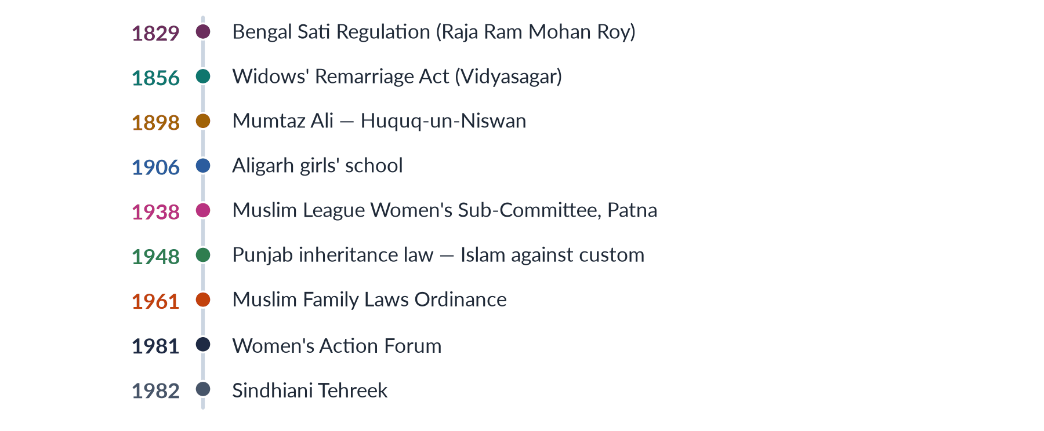
Figure 37 · Women's rights in South Asia and Pakistan — a local history.

8. Postcolonial critiques of Western feminism

i) Mohanty
Chandra Talpade Mohanty's "Under Western Eyes" (1984) showed how Western feminism created a single, victimised "Third World Woman" — poor, veiled, passive — ignoring her agency and history.

ii) Spivak
Gayatri Chakravorty Spivak's "Can the Subaltern Speak?" (1988) described colonial rule over sati as "white men saving brown women from brown men" — the poor woman spoken for, never heard.

iii) Abu-Lughod and Narayan
Lila Abu-Lughod asked "Do Muslim Women Really Need Saving?" (2002), and Uma Narayan (1997) argued that calling Third World feminism "Westernised" erases local women's own critiques.

iv) What this proves
The sharpest critics of Western feminism are feminists from the South — proof that feminism is not a single Western product.

9. Muslim feminist scholarship

i) The method
Muslim (Islamic) feminism seeks gender justice by re-reading the Qur'an and Sunnah, separating the divine message from patriarchal interpretation and custom, on the basis of adl (justice) and equal dignity.

ii) The scholars

(a) Mernissi
Fatima Mernissi (The Veil and the Male Elite, 1987) questioned the chains of misogynist hadith.

(b) Wadud and Hassan
Amina Wadud (Qur'an and Woman, 1992) read the Qur'an from a woman's perspective; the Pakistani-American scholar Riffat Hassan showed that the Qur'an does not create woman from a rib.

(c) Barlas
Asma Barlas ("Believing Women" in Islam, 2002) argued that the Qur'an is anti-patriarchal.

iii) Movements
Sisters in Islam (Malaysia, 1988) and Musawah (2009) campaign for equality in Muslim family law.

10. The limits of the counter-argument

i) Not every custom is authentic
Postcolonial critique can be misused to defend harmful customs — honour killing and child marriage are not "authentic culture" to be protected.

ii) Debate within Pakistan
Secular feminists such as Afiya Zia (Faith and Feminism in Pakistan, 2018) warn that relying on religious arguments limits rights; Saba Mahmood (Politics of Piety, 2005) argues that pious women also exercise agency. Feminism in Pakistan is itself plural.

11. Verdict: neither import nor pure tradition

i) Local roots
The history from Mumtaz Ali to WAF shows that women's rights were argued in local and Islamic terms before and alongside Western influence.

ii) Global connections
Feminism has always travelled — Pakistani activists used CEDAW, Beijing and the waves as tools, adapting them to local needs.

iii) The best description
Feminism in Pakistan is locally rooted and globally connected — "glocal" rather than imported.

12. Conclusion

i) The claim fails
The claim that feminism is a Western import ignores two centuries of South Asian reform, the women of the Pakistan Movement, the Muslim feminist re-reading of scripture and the postcolonial feminists who criticised the West itself.

ii) What remains true
It contains a warning worth heeding: activism that depends on foreign funds and borrowed language loses legitimacy. The answer is not to abandon feminism but to ground it in Pakistani history, the Constitution and Islam's principles of justice — as Pakistani women have done since 1898.

Why this answer scores
- Evaluates a claim: admits its grain of truth (colonial memory, donors, NGO-isation) before rejecting it.
- Uses all three named bodies of evidence under separate headings, each with dated names and texts.
- Draws on Pakistani history (Patna 1938, Jinnah 1944, the 1948 inheritance law, WAF, Sindhiani Tehreek).
- Notes the limits of the counter-argument and the debate within Pakistani feminism.
- A timeline figure shows the local history at a glance; the verdict is clear.

Set 2 · Q. No. 7 · Pakistan's Family Laws from a Gender Perspective
AT A GLANCE · PREDICTION PAPER SET 2 · Q. NO. 7 · 20 MARKS
Critically evaluate the family laws of Pakistan — on marriage, divorce, dower, maintenance, inheritance and the minimum age of marriage — from a gender perspective, with reference to the Muslim Family Laws Ordinance 1961 and the recent child-marriage laws.

The answer map
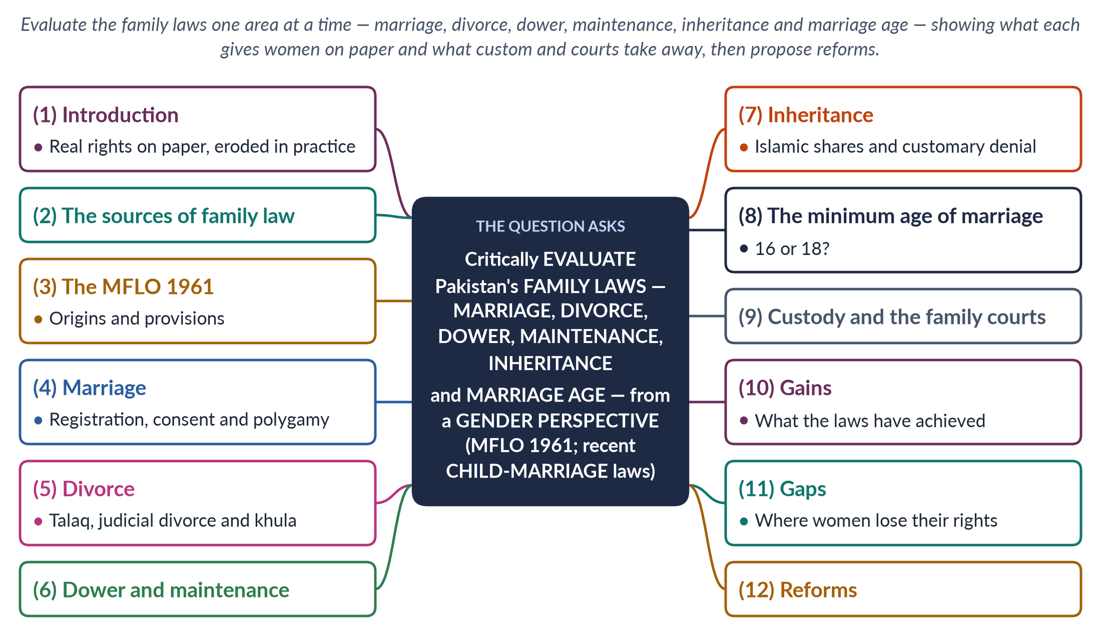
Figure 38 · The answer map: every branch is one numbered heading of the model answer below.

Decoding the question
"Critically evaluate … from a gender perspective" asks how far each law treats women justly and how it works in practice. The question lists six areas — marriage, divorce, dower, maintenance, inheritance and minimum age — so each needs a heading. It names two legal anchors: the MFLO 1961 and the recent child-marriage laws (Sindh 2013, Islamabad 2025, Punjab 2026). End with a balanced verdict and reforms.

The model answer

1. Introduction

i) Definition
Family law governs marriage, divorce, dower, maintenance, custody and inheritance. For Muslims in Pakistan it rests on Islamic law as codified and reformed by statute.

ii) The argument
Pakistan's family laws give women significant rights on paper — registration of marriage, limits on polygamy, khula, dower, maintenance and inheritance shares. But in practice those rights are eroded by custom, poverty, slow courts and low awareness, and the federal marriage age of 16 for girls still permits child marriage. The laws are better than their enforcement; reform must target both.

2. The sources of family law

i) Colonial-era statutes
The Guardians and Wards Act (1890), the Child Marriage Restraint Act (1929), the Shariat Application Act (1937) and the Dissolution of Muslim Marriages Act (1939).

ii) Pakistani statutes
The West Punjab Shariat Application Act (1948), which extended inheritance to agricultural land; the Muslim Family Laws Ordinance (1961); the Family Courts Act (1964); and the Dowry and Bridal Gifts (Restriction) Act (1976).

iii) Minority laws
The Sindh Hindu Marriage Act (2016) and the federal Hindu Marriage Act (2017) allowed Hindu marriages to be registered.

3. The MFLO 1961

i) Its origins
Protests after Prime Minister Bogra's second marriage (1955) led to the Rashid Commission (report 1956), whose recommendations Ayub Khan enacted as the MFLO.

ii) Its main provisions

(a) Marriage
Compulsory registration of marriages; a second marriage requires the permission of an Arbitration Council.

(b) Divorce
Written notice of talaq to the Union Council chairman; divorce effective only after 90 days, allowing reconciliation.

(c) Family protection
Maintenance remedies; orphaned grandchildren may inherit; and the girls' marriage age was raised to 16.

iii) Its significance
It was the first major reform of Muslim family law in Pakistan, and remains its backbone.

4. Marriage

i) Consent
Islam requires the woman's consent. The Supreme Court's Saima Waheed decision (2004) upheld an adult woman's right to marry without a guardian's (wali's) consent. Yet forced marriage remains common; the Prevention of Anti-Women Practices Act 2011 made it a crime (section 498B PPC).

ii) Registration
Registration protects proof of marriage, dower and inheritance, but many rural marriages go unregistered.

iii) Polygamy
The Arbitration Council requirement restrains polygamy, but unpermitted second marriages often go unpunished, and the first wife's remedy is slow.

5. Divorce

i) Talaq
A husband may divorce unilaterally, but the MFLO's notice and 90-day rule restrain instant divorce.

ii) Judicial divorce
The 1939 Act lists grounds on which a wife may seek dissolution, such as cruelty, failure to maintain or desertion.

iii) Khula
In Khurshid Bibi v. Muhammad Amin (1967) the Supreme Court recognised a wife's right to khula — divorce at her request, usually returning the dower. Family-court amendments (2002, 2015) speeded it up. Khula is now the most common route to divorce for women.

iv) Delegated divorce
The nikah-nama allows talaq-e-tafweez — a delegated right of divorce for the wife — but families often strike out the clause.
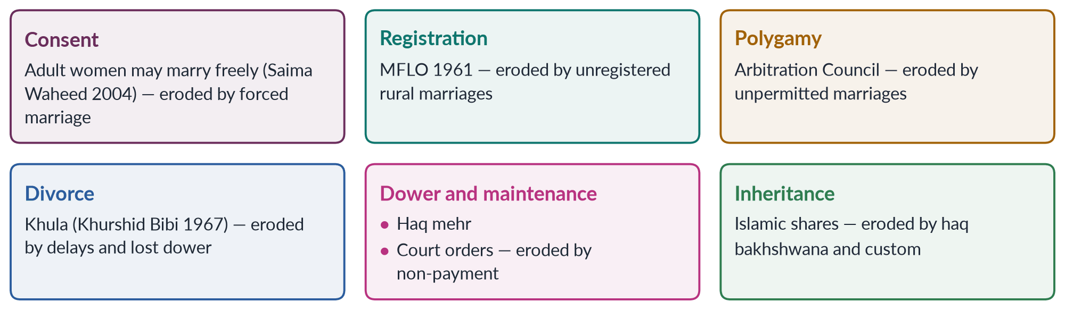
Figure 39 · The family-law rights of a Muslim woman in Pakistan — and where they are eroded.

6. Dower and maintenance

i) Dower (haq mehr)
Haq mehr is the husband's obligation and the wife's property. In practice it is often set low, deferred and never paid, or surrendered in khula.

ii) Maintenance
The husband must maintain his wife and children. Family courts can order maintenance, but orders are hard to enforce, leaving divorced women in poverty.

iii) Dowry: the reverse burden
Dowry, paid by the bride's family, is not an Islamic requirement, yet it burdens poor families and fuels violence; the 1976 Act limiting it is not enforced.

7. Inheritance

i) The Islamic shares
Women inherit as daughters, wives, mothers and sisters; a daughter's share is half a son's, balanced in Islamic law by men's duty of maintenance and the wife's dower.

ii) Customary denial
Custom deprives women of even these shares: sisters are pressured to "gift" them to brothers (haq bakhshwana), and women own very little land.

iii) The legal response
The Prevention of Anti-Women Practices Act 2011 criminalised depriving women of inheritance by deceit, and the Enforcement of Women's Property Rights Act 2020 (Islamabad) created an ombudsperson to restore women's property quickly.

8. The minimum age of marriage

i) The federal age of 16
The Child Marriage Restraint Act 1929, as amended by the MFLO, sets 16 for girls and 18 for boys — an unequal and low standard.

ii) The recent laws

(a) Sindh (2013)
The Sindh Child Marriages Restraint Act 2013 set 18 for both sexes — the first province to do so.

(b) Islamabad (2025)
The Islamabad Capital Territory Child Marriage Restraint Act 2025 set 18, receiving assent on 30 May 2025 despite opposition from the Council of Islamic Ideology.

(c) Punjab (2026)
The Punjab Assembly passed a child-marriage restriction bill in April 2026.

iii) The religious question
The Federal Shariat Court held in 2021 that fixing a minimum marriage age is not against Islam — removing the main objection to reform.
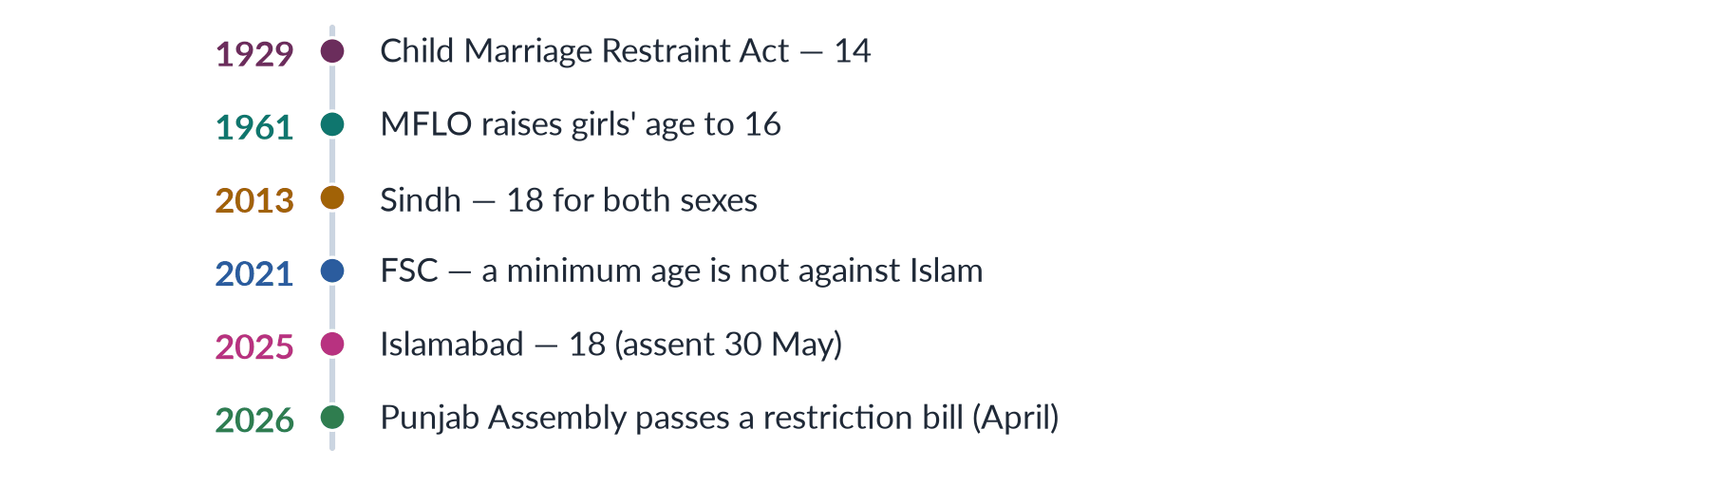
Figure 40 · The minimum age of marriage for girls in Pakistan.

9. Custody and the family courts

i) Custody
Under the Guardians and Wards Act 1890, courts decide by the child's welfare; mothers usually keep young children (hizanat), but fathers remain guardians.

ii) The family courts
The Family Courts Act 1964 created special courts, but cases often take years, and costs and travel deter poor women.

10. Gains

i) Restraints on male power
Registration, notice of divorce and limits on polygamy curbed unilateral male power.

ii) Women's exits and remedies
Khula, judicial divorce and family courts gave women legal exits and remedies.

iii) Recent progress
Marriage at 18 in Sindh and Islamabad, the property-rights law of 2020 and the FSC's 2021 ruling show steady progress.

11. Gaps

i) Law versus custom
Unregistered marriages, unpermitted polygamy, forced marriage, unpaid dower and haq bakhshwana show custom overriding law.

ii) An unequal age
The federal age of 16 remains for girls outside Sindh and Islamabad.

iii) Access to justice
Slow, costly courts, unenforced maintenance and low legal awareness keep rights out of reach — especially for rural women, a clear case of intersectional disadvantage.

12. Reforms

i) Harmonise the law
Make 18 the minimum marriage age for both sexes in every province and in federal law, and make registration of every marriage compulsory and enforced.

ii) Enforce the rights
Penalise unregistered and unpermitted marriages; enforce dower and maintenance through attachment of salaries; extend the property-rights ombudsperson model to all provinces.

iii) Make justice accessible
Time limits for family cases, free legal aid, women judges and mobile courts; protect the talaq-e-tafweez clause in the nikah-nama.

iv) Change attitudes
Legal-literacy campaigns and religious scholars explaining women's Islamic rights to consent, dower and inheritance.

13. Conclusion

i) The balance
Pakistan's family laws, built on the MFLO 1961 and recent reforms, give women real rights — consent, registration, restraint of polygamy, khula, dower, maintenance and inheritance.

ii) The verdict
Custom, cost and delay take much of this away, and the age of 16 still permits child marriage outside Sindh and Islamabad. The task now is less to write new law than to harmonise and enforce the law Pakistan already has.

Why this answer scores
- Covers all six named areas under separate headings, each with law, case and practice.
- Explains the MFLO 1961 precisely and uses the child-marriage laws of 2013, 2025 and 2026, with the FSC's 2021 ruling.
- Cites the key cases — Khurshid Bibi 1967, Saima Waheed 2004.
- Balances gains and gaps and ends with specific reforms.
- A grid and a timeline figure show rights versus practice and the marriage-age history.

Set 2 · Q. No. 8(a) · Short Note: Gender and Good Governance
AT A GLANCE · PREDICTION PAPER SET 2 · Q. NO. 8(A) · SHORT NOTE · 10 MARKS
Write short notes on the following: Gender and good governance: why gender equality is essential to good governance.

The answer map
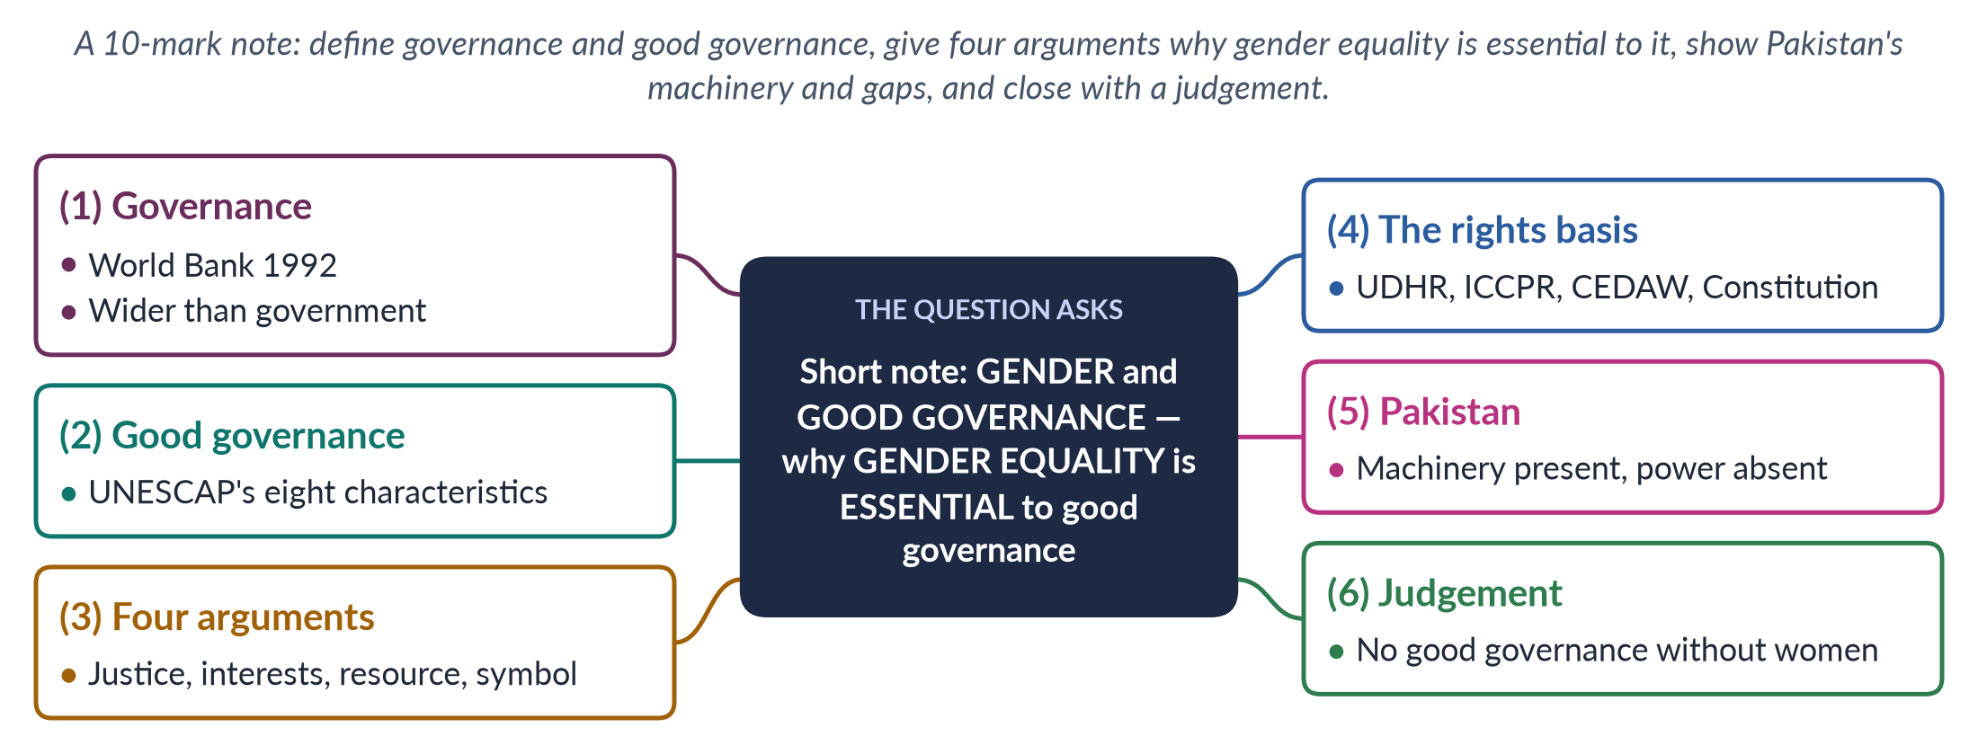
Figure 41 · The answer map for the short note: every branch is one headed point.

Decoding the question
A 10-mark note (about 550–650 words). Defining governance has never been asked — a blind spot. Define governance and good governance precisely, then answer the "why": give reasons, linked to the characteristics of good governance, and apply them to Pakistan.

The model answer

1. Governance

i) Definition
The World Bank (1992) defined governance as "the manner in which power is exercised in the management of a country's economic and social resources". The term spread after its 1989 report on Sub-Saharan Africa spoke of a "crisis of governance".

ii) Governance versus government
Government is the set of institutions holding state power; governance is the whole process of managing public affairs — including markets, parties, civil society, the media and informal bodies such as jirgas. The UNDP (1997) described it as the exercise of authority through which citizens articulate interests, exercise rights, meet obligations and mediate differences.

2. Good governance

i) The eight characteristics
UNESCAP lists participation, rule of law, transparency, responsiveness, consensus orientation, equity and inclusiveness, effectiveness and efficiency, and accountability.

ii) Gender is built in
Participation "by both men and women" is part of the definition itself: governance that excludes half the population cannot be participatory, equitable or responsive.
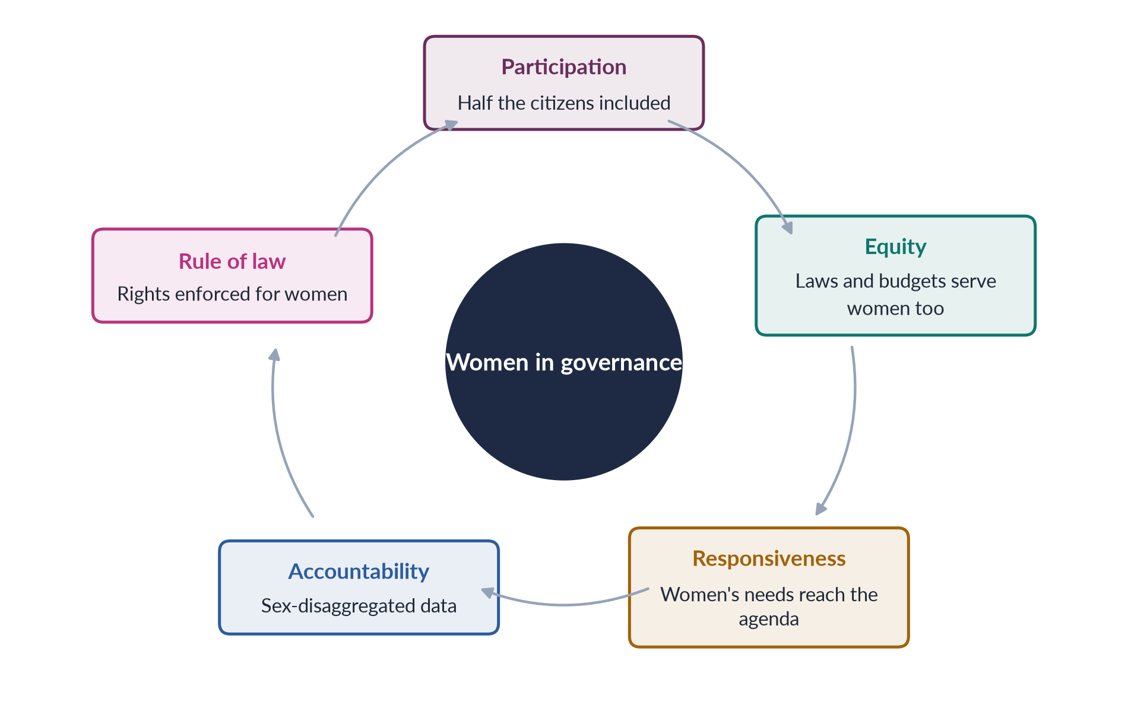
Figure 42 · Gender equality runs through every characteristic of good governance.

3. Why gender equality is essential: four arguments

i) Justice
Women are half the citizens; excluding them from decisions is unjust.

ii) Interests
Women have distinct experiences — of care, maternity, violence and work — that men may overlook. The village pump example shows it: an all-male council places the pump near the market, while the women who fetch water need it near their homes. Who sits at the table changes what is decided. Jane Mansbridge (1999) adds that women's presence matters most where interests are not yet on the agenda — as domestic violence was before women entered parliaments.

iii) Resource
Governance that excludes women wastes half the nation's talent.

iv) Symbol
Women in power change ideas about who can lead and inspire girls — Benazir Bhutto (1988) and Maryam Nawaz (2024).

4. The rights basis

i) International law
The UDHR (Article 21, 1948) and the ICCPR (Article 25, 1966) guarantee the right to take part in government; CEDAW Article 7 requires equality in political and public life, and Article 4(1) permits temporary special measures such as quotas; SDG target 5.5 calls for women's equal leadership.

ii) The Constitution
Articles 25, 32 (women in local government) and 34 (full participation of women), and the reserved seats under Articles 51, 59 and 106.

5. Pakistan: machinery present, power absent

i) The machinery
The Women's Division (1979), the NCSW (2000; Act 2012), the National Policy for Development and Empowerment of Women (2002), the Gender Reform Action Plan, a Gender Responsive Budgeting Initiative, harassment ombudspersons (2010) and a property ombudsperson (2020).

ii) Accountability tools
Good governance needs sex-disaggregated data — such as the Labour Force Survey's figure of 24.4% female participation (2024–25) — and gender-responsive budgets, so that citizens can see whether policy serves women.

iii) The gaps
No women federal ministers in 2025; a 10% job quota but few women in top grades; Ayesha Malik became the first woman Supreme Court judge only in 2022; and all-male jirgas still order vani and honour punishments.

6. Judgement

i) The verdict
In Hanna Pitkin's terms (1967), quotas have given Pakistan descriptive representation; good governance requires substantive representation — policies that actually serve women. Good governance and gender equality are inseparable: without women's participation, governance fails its own tests of participation, equity, responsiveness and accountability.

ii) The way forward
Pakistan has built the machinery; it now needs the resources and political will — women in cabinets and senior posts, gender-responsive budgets and accountable data — to make it work.

Why this answer scores
- Gives the World Bank (1992) definition and separates governance from government.
- Lists UNESCAP's eight characteristics and shows that gender is built into them.
- Answers the "why" with four clear arguments and the village pump example.
- Applies the argument to Pakistan's machinery and gaps; a cycle figure links gender to each characteristic.

Set 2 · Q. No. 8(b) · Short Note: World-System Theory and the International Sexual Division of Labour
AT A GLANCE · PREDICTION PAPER SET 2 · Q. NO. 8(B) · SHORT NOTE · 10 MARKS
Write short notes on the following: World-system theory and the international sexual division of labour.

The answer map
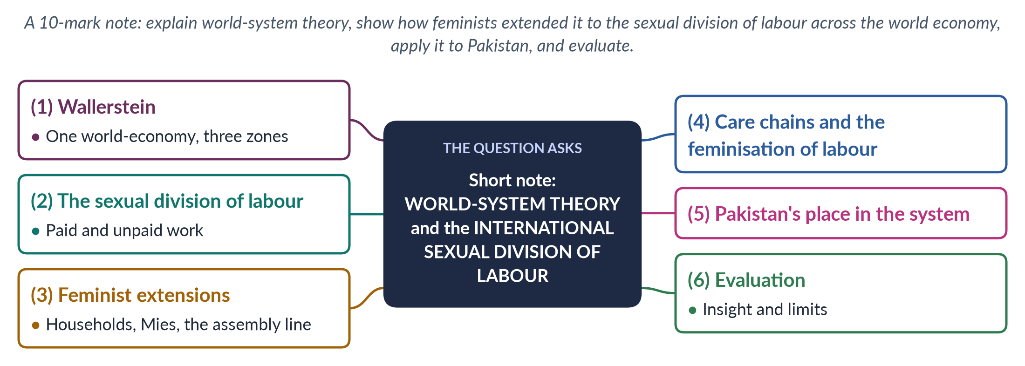
Figure 43 · The answer map for the short note: every branch is one headed point.

Decoding the question
A 10-mark note (about 550–650 words). Two concepts must be joined: world-system theory (Wallerstein) and the international sexual division of labour — how work is divided by gender across the world economy, not only within households. Explain the theory, then the feminist extension, then Pakistan.

The model answer

1. Wallerstein's world-system

i) One world-economy
Immanuel Wallerstein (The Modern World-System, 1974) argued that since the sixteenth century there has been a single capitalist world-economy. It differs from dependency theory by treating the world as one system, adding a middle zone — the semi-periphery — and tracing a history of five centuries.

ii) Three zones

(a) The core
Rich countries specialising in finance, technology and high-value production.

(b) The semi-periphery
Countries in between, which both exploit the periphery and are exploited by the core.

(c) The periphery
Countries supplying raw materials and cheap labour; surplus flows to the core through unequal exchange.
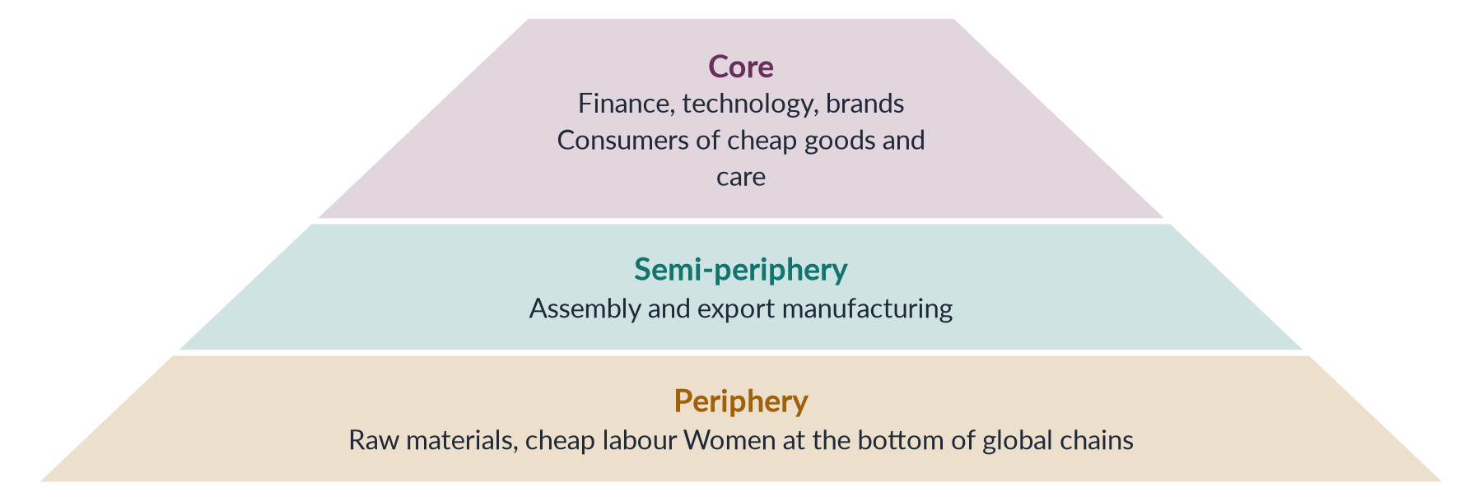
Figure 44 · The world-system — and where women's labour sits within it.

2. The sexual division of labour

i) The idea
The sexual division of labour assigns different work to women and men — men to paid, "productive" work and women to unpaid, "reproductive" care.

ii) Its international form
The international sexual division of labour describes how global capitalism draws on this division across countries: women in the periphery supply the cheapest labour for global production and care.

3. Feminist extensions of world-system theory

i) The household
Joan Smith and Immanuel Wallerstein (1992) showed that households combine wages with unpaid work, so employers can pay below a living wage — women's unpaid labour fills the gap.

ii) Mies
Maria Mies (Patriarchy and Accumulation on a World Scale, 1986) linked the exploitation of nature, colonies and women, and described "housewifisation" — defining women as housewives so their paid work could be treated as a supplement and paid less. Her study of the lace makers of Narsapur in India showed women producing for world markets at home while being counted as housewives doing leisure work.

iii) The global assembly line
Annette Fuentes and Barbara Ehrenreich (1983) described the "global assembly line" of young women in export factories.

4. Care chains and the feminisation of labour

i) Feminisation of labour
Guy Standing (1989) showed that global competition made jobs more flexible, informal and low-paid — "feminised" — and drew women into them.

ii) Global care chains
Arlie Hochschild (2000) described poor women migrating to care for richer families' children, leaving their own children with relatives — a transfer of care from periphery to core.

iii) The evidence of harm
The Rana Plaza collapse in Bangladesh (24 April 2013) killed more than 1,100 people, mostly women garment workers.

5. Pakistan's place in the system

i) Periphery or lower semi-periphery
Pakistan exports textiles, cotton and rice and depends on external finance.

ii) Women at the bottom
Women work at the bottom of global chains — cotton picking, home-based stitching and embroidery for piece rates — while men migrate to the Gulf; remittances reached a record of more than 38 billion dollars in 2024–25. Home-based workers — Mies's "housewifisation" in action — won legal recognition first in Sindh, through the Home-Based Workers Act 2018.

iii) Leverage
The EU's GSP+ status (2014), tied to 27 conventions including CEDAW, gives some leverage for labour and women's rights.

6. Evaluation

i) Insight
The theory explains why women's labour is cheap across the world economy and links household inequality to global capitalism.

ii) Limits
It risks portraying women as passive victims and underplays local patriarchy and women's agency; Naila Kabeer (The Power to Choose, 2000) found that factory work gave many Bangladeshi women their first independent income and greater bargaining power.

iii) The line to take
Global capitalism both exploits and opens opportunities for women; outcomes depend on labour rights, state policy and women's organising.

Why this answer scores
- Explains Wallerstein's three zones precisely and joins them to the sexual division of labour.
- Names the feminist extensions with dates (Mies 1986, Smith and Wallerstein 1992, Fuentes and Ehrenreich 1983, Standing 1989, Hochschild 2000).
- Applies the theory to Pakistan (textiles, home-based work, remittances, GSP+).
- Evaluates with Kabeer's counter-evidence; a pyramid figure maps women's place in the system.

Set 3 · The Mixed Paper
Probable and medium questions alongside difficult ones — the shape of most real papers.
Set 3 mixes medium questions (gender roles and stereotypes; patriarchy; women's paid work; the notes) with difficult ones (BISP through Moser and Kabeer; reserved seats and substantive representation; the three case studies compared). Its short-note question returns to the older "any TWO" form, with three notes to choose from — all three are answered.

Roll Number
FEDERAL PUBLIC SERVICE COMMISSION
COMPETITIVE EXAMINATION-2027
FOR RECRUITMENT TO POSTS IN BS-17
UNDER THE FEDERAL GOVERNMENT
GENDER STUDIES

TIME ALLOWED: THREE HOURS TOTAL MARKS: 100
PART-I (MCQS): MAXIMUM 30 MINUTES PART-I (MCQS): MAXIMUM MARKS = 20
PART-II PART-II: MAXIMUM MARKS = 80

NOTE: | (i) First attempt PART-I (MCQS) on separate Answer Sheet which shall be taken back after 30 minutes.
 | (ii) Overwriting/cutting of the options/answers will not be given credit.

PART-I (MCQS) (COMPULSORY)
Q. No. 1. (i) Select the best option/answer and fill in the appropriate box on the Answer Sheet.
(ii) Answers given anywhere else, other than Answer Sheet, will not be considered. (20×1=20)
1. Gender schema theory (1981), which holds that children sort the world through mental maps of "masculine" and "feminine", was proposed by:
(a) Sandra Bem | (b) Lawrence Kohlberg | (c) Albert Bandura | (d) None of these
2. In Kohlberg's theory, the stage at which a child understands that gender does not change with clothes or activities is:
(a) Gender identity | (b) Gender stability | (c) Gender constancy | (d) None of these
3. "Heteronormativity" refers to:
(a) The assumption that heterosexuality is the only normal sexuality
(b) The study of hormones
(c) The equal treatment of all sexualities
(d) None of these
4. The Supreme Court's 2009 order recognising a third gender in CNICs came in a petition filed by:
(a) Asma Jahangir | (b) Hina Jilani | (c) Benazir Bhutto | (d) None of these
5. Sexual Politics (1970), a founding text of radical feminism, was written by:
(a) Kate Millett | (b) Shulamith Firestone | (c) Germaine Greer | (d) None of these
6. Engels' The Origin of the Family, Private Property and the State (1884) linked women's subordination to:
(a) Biology | (b) The rise of private property
(c) Religion | (d) None of these
7. "Dual-systems theory" holds that women's oppression results from:
(a) Capitalism alone | (b) Patriarchy alone
(c) Capitalism and patriarchy together | (d) None of these
8. The term "ecofeminism" was coined in 1974 by:
(a) Vandana Shiva | (b) Françoise d'Eaubonne | (c) Carolyn Merchant | (d) Bina Agarwal
9. The UN Decade for Women ran from:
(a) 1975–1985 | (b) 1976–1985 | (c) 1980–1990 | (d) None of these
10. UN Security Council Resolution 1325 (2000) concerns:
(a) Women, peace and security | (b) Child marriage
(c) Maternal health | (d) None of these
11. The first Aurat March was held in:
(a) 2016 | (b) 2017 | (c) 2018 | (d) 2019
12. The distinction between women's "practical" and "strategic" gender interests (1985) was first drawn by:
(a) Maxine Molyneux | (b) Ester Boserup | (c) Diane Elson | (d) None of these
13. W. W. Rostow's The Stages of Economic Growth (1960) is the classic text of:
(a) Dependency theory | (b) World-system theory
(c) Structural functionalism | (d) None of these
14. Which SDG target calls for recognising and valuing unpaid care and domestic work?
(a) 5.2 | (b) 5.3 | (c) 5.4 | (d) 5.5
15. Female labour-force participation in Pakistan in the Labour Force Survey 2024–25 was:
(a) 14.5% | (b) 21.4% | (c) 33.8% | (d) None of these
16. Pakistan's Lady Health Worker Programme was launched in:
(a) 1988 | (b) 1994 | (c) 2002 | (d) 2008
17. The "critical mass" of women needed to change the culture of a legislature is usually put at about:
(a) 10% | (b) 17% | (c) 30% | (d) 50%
18. Pakistan's first woman Foreign Minister (2011) was:
(a) Tehmina Janjua | (b) Hina Rabbani Khar | (c) Sherry Rehman | (d) Maleeha Lodhi
19. Sharmeen Obaid-Chinoy's Oscar-winning documentary Saving Face (2012) dealt with:
(a) Honour killing | (b) Child marriage | (c) Girls' education | (d) None of these
20. Section 2(r) of the Punjab Protection of Women against Violence Act 2016 recognises all of the following as violence EXCEPT:
(a) Economic abuse | (b) Stalking | (c) Cybercrime | (d) None of these
**********

Roll Number
FEDERAL PUBLIC SERVICE COMMISSION
COMPETITIVE EXAMINATION-2027
FOR RECRUITMENT TO POSTS IN BS-17
UNDER THE FEDERAL GOVERNMENT
GENDER STUDIES

TIME ALLOWED: THREE HOURS TOTAL MARKS: 100
PART-I (MCQS): MAXIMUM 30 MINUTES PART-I (MCQS): MAXIMUM MARKS = 20
PART-II PART-II: MAXIMUM MARKS = 80

NOTE: | (i) Part-II is to be attempted on the separate Answer Book.
 | (ii) Attempt ONLY FOUR questions from PART-II. ALL questions carry EQUAL marks.
 | (iii) All the parts (if any) of each Question must be attempted at one place instead of at different places.
 | (iv) Write Q. No. in the Answer Book in accordance with Q. No. in the Q. Paper.
 | (v) No Page/Space be left blank between the answers. All the blank pages of Answer Book must be crossed.
 | (vi) Extra attempt of any question or any part of the question will not be considered.

PART-II
Q. No. 2. What are gender roles and gender stereotypes? Discuss how the family, school textbooks, religion and the media construct them in Pakistan. How can harmful stereotypes be changed? (20)
Q. No. 3. Critically evaluate the Benazir Income Support Programme through the lenses of Caroline Moser's practical and strategic gender needs and Naila Kabeer's concept of empowerment. Has it empowered women or merely reached them? (20)
Q. No. 4. What is patriarchy? Critically compare the explanations of patriarchy offered by radical, Marxist and socialist feminists. Which explanation best accounts for women's subordination in Pakistan? (20)
Q. No. 5. Female labour-force participation in Pakistan was only 24.4 per cent in 2024–25. Analyse the economic, social and institutional barriers to women's paid employment and the burden of unpaid care work. What policies would raise women's participation? (20)
Q. No. 6. More than two decades after the Legal Framework Order 2002, have reserved seats produced substantive representation for women in Pakistan? Evaluate with reference to Hanna Pitkin's types of representation and the debate on critical mass versus critical actors. (20)
Q. No. 7. Compare the case studies of Mukhtaran Mai, Malala Yousafzai and Sharmeen Obaid-Chinoy. What do they reveal about violence, voice and the role of the state and the media in Pakistan? (20)
Q. No. 8. Write short notes on any TWO of the following: (10+10)
(a) Technology-facilitated violence against women in Pakistan.
(b) Sustainable Development Goal 5 and Pakistan's progress.
(c) The National Commission on the Status of Women.
**********

Set 3 · Part I Explained
Each MCQ of Set 3 with its options. The correct answer is printed in bold straight after each question, with a one-line reason.
1. Gender schema theory (1981), which holds that children sort the world through mental maps of "masculine" and "feminine", was proposed by:
(a) Sandra Bem (b) Lawrence Kohlberg (c) Albert Bandura (d) None of these
Answer: (a) Sandra Bem — Sandra Bem (1981); Kohlberg proposed cognitive-developmental stages, Bandura social learning.
2. In Kohlberg's theory, the stage at which a child understands that gender does not change with clothes or activities is:
(a) Gender identity (b) Gender stability (c) Gender constancy (d) None of these
Answer: (c) Gender constancy — Gender constancy (about age 6–7), after identity (2–3) and stability (4–5).
3. "Heteronormativity" refers to:
(a) The assumption that heterosexuality is the only normal sexuality (b) The study of hormones (c) The equal treatment of all sexualities (d) None of these
Answer: (a) The assumption that heterosexuality is the only normal sexuality — A key concept of queer theory: the assumption of two opposite genders and that only heterosexuality is normal.
4. The Supreme Court's 2009 order recognising a third gender in CNICs came in a petition filed by:
(a) Asma Jahangir (b) Hina Jilani (c) Benazir Bhutto (d) None of these
Answer: (d) None of these — Dr Muhammad Aslam Khaki (Khaki v. SSP (Operations) Rawalpindi).
5. Sexual Politics (1970), a founding text of radical feminism, was written by:
(a) Kate Millett (b) Shulamith Firestone (c) Germaine Greer (d) None of these
Answer: (a) Kate Millett — Kate Millett (1970); Firestone wrote The Dialectic of Sex (1970).
6. Engels' The Origin of the Family, Private Property and the State (1884) linked women's subordination to:
(a) Biology (b) The rise of private property (c) Religion (d) None of these
Answer: (b) The rise of private property — Engels called the overthrow of mother-right, with private property, "the world historical defeat of the female sex".
7. "Dual-systems theory" holds that women's oppression results from:
(a) Capitalism alone (b) Patriarchy alone (c) Capitalism and patriarchy together (d) None of these
Answer: (c) Capitalism and patriarchy together — Heidi Hartmann, "The Unhappy Marriage of Marxism and Feminism" (1979): two linked systems.
8. The term "ecofeminism" was coined in 1974 by:
(a) Vandana Shiva (b) Françoise d'Eaubonne (c) Carolyn Merchant (d) Bina Agarwal
Answer: (b) Françoise d'Eaubonne — Françoise d'Eaubonne (1974); Bina Agarwal later proposed feminist environmentalism (1992).
9. The UN Decade for Women ran from:
(a) 1975–1985 (b) 1976–1985 (c) 1980–1990 (d) None of these
Answer: (b) 1976–1985 — 1976–1985, after International Women's Year (1975), with the themes Equality, Development and Peace.
10. UN Security Council Resolution 1325 (2000) concerns:
(a) Women, peace and security (b) Child marriage (c) Maternal health (d) None of these
Answer: (a) Women, peace and security — Resolution 1325 (31 October 2000) calls for women's participation in peace-making and protection in conflict.
11. The first Aurat March was held in:
(a) 2016 (b) 2017 (c) 2018 (d) 2019
Answer: (c) 2018 — 8 March 2018, first in Karachi.
12. The distinction between women's "practical" and "strategic" gender interests (1985) was first drawn by:
(a) Maxine Molyneux (b) Ester Boserup (c) Diane Elson (d) None of these
Answer: (a) Maxine Molyneux — Maxine Molyneux, "Mobilization without Emancipation?" (1985); Caroline Moser turned it into practical and strategic gender needs.
13. W. W. Rostow's The Stages of Economic Growth (1960) is the classic text of:
(a) Dependency theory (b) World-system theory (c) Structural functionalism (d) None of these
Answer: (d) None of these — Modernisation theory (five stages from traditional society to high mass consumption).
14. Which SDG target calls for recognising and valuing unpaid care and domestic work?
(a) 5.2 (b) 5.3 (c) 5.4 (d) 5.5
Answer: (c) 5.4 — Target 5.4 (5.2 violence; 5.3 child marriage; 5.5 leadership).
15. Female labour-force participation in Pakistan in the Labour Force Survey 2024–25 was:
(a) 14.5% (b) 21.4% (c) 33.8% (d) None of these
Answer: (d) None of these — 24.4% (21.4% in 2020–21; 14.5% is Balochistan's rate).
16. Pakistan's Lady Health Worker Programme was launched in:
(a) 1988 (b) 1994 (c) 2002 (d) 2008
Answer: (b) 1994 — 1994, under Benazir Bhutto.
17. The "critical mass" of women needed to change the culture of a legislature is usually put at about:
(a) 10% (b) 17% (c) 30% (d) 50%
Answer: (c) 30% — About 30% (Dahlerup, 1988; ECOSOC target, 1990).
18. Pakistan's first woman Foreign Minister (2011) was:
(a) Tehmina Janjua (b) Hina Rabbani Khar (c) Sherry Rehman (d) Maleeha Lodhi
Answer: (b) Hina Rabbani Khar — Hina Rabbani Khar (2011); Tehmina Janjua was the first woman Foreign Secretary (2017).
19. Sharmeen Obaid-Chinoy's Oscar-winning documentary Saving Face (2012) dealt with:
(a) Honour killing (b) Child marriage (c) Girls' education (d) None of these
Answer: (d) None of these — Acid attacks; A Girl in the River (2016) dealt with honour killing.
20. Section 2(r) of the Punjab Protection of Women against Violence Act 2016 recognises all of the following as violence EXCEPT:
(a) Economic abuse (b) Stalking (c) Cybercrime (d) None of these
Answer: (d) None of these — All three are listed, with domestic and sexual violence, psychological abuse and abetment.

Set 3 · Q. No. 2 · Gender Roles and Stereotypes: How Pakistan Makes Them, and How to Change Them
AT A GLANCE · PREDICTION PAPER SET 3 · Q. NO. 2 · 20 MARKS
What are gender roles and gender stereotypes? Discuss how the family, school textbooks, religion and the media construct them in Pakistan. How can harmful stereotypes be changed?

The answer map
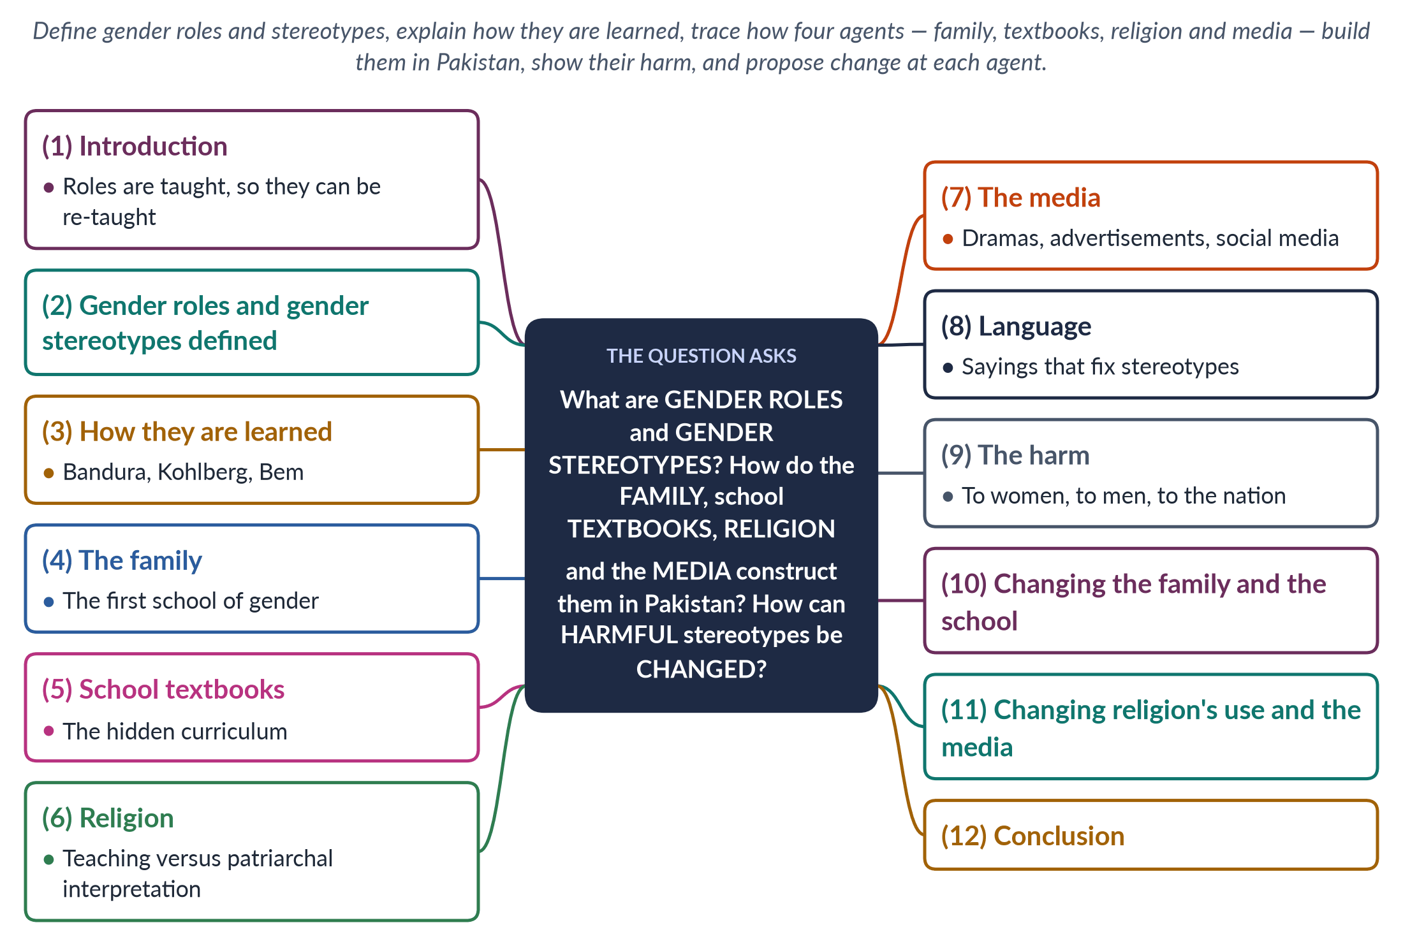
Figure 45 · The answer map: every branch is one numbered heading of the model answer below.

Decoding the question
Three tasks. "What are" — define gender roles and gender stereotypes separately, with examples. "How do … construct them" — the question names four agents (family, textbooks, religion, media); each needs a heading with Pakistani examples, ideally tied to a theory of learning. "How can harmful stereotypes be changed" — practical measures, best organised agent by agent. This is a constructionist question: show that roles are learned and therefore changeable.

The model answer

1. Introduction

i) Definitions in brief
Gender roles are the behaviours, duties and occupations a society expects of women and men; gender stereotypes are fixed, over-simple beliefs about what women and men are like.

ii) The argument
Both are socially constructed. Simone de Beauvoir wrote that "one is not born, but rather becomes, a woman" (1949), and in Pakistan the becoming happens through the family, school, religion as interpreted, and the media. Because these agents teach roles, they can also re-teach them — which is why change must work through the same institutions.

2. Gender roles and gender stereotypes

i) Gender roles
The social and cultural expectations of being male or female — a definition tested in the 2025 MCQs. In Pakistan the classic division assigns men the provider role and public life, and women the homemaker role and the private sphere (chador aur chaar-diwari).

ii) Gender stereotypes
Fixed beliefs such as "women are emotional", "men do not cry", "girls are weak at mathematics" or "a woman's place is the home".

iii) How they differ, and connect
Roles are expectations of behaviour; stereotypes are beliefs about nature. Stereotypes justify roles: if women are "naturally" caring, they "belong" at home.

3. How roles and stereotypes are learned

i) Social learning
Albert Bandura and Walter Mischel showed that children learn gender through reward, punishment and imitation — praised for "brave like a man", scolded for "crying like a girl".

ii) Cognitive development
Lawrence Kohlberg (1966) showed children working out gender in stages — identity (2–3), stability (4–5) and constancy (6–7).

iii) Gender schema
Sandra Bem (1981) showed that a mental map sorts the world into "for boys" and "for girls" and filters what the child notices and remembers.
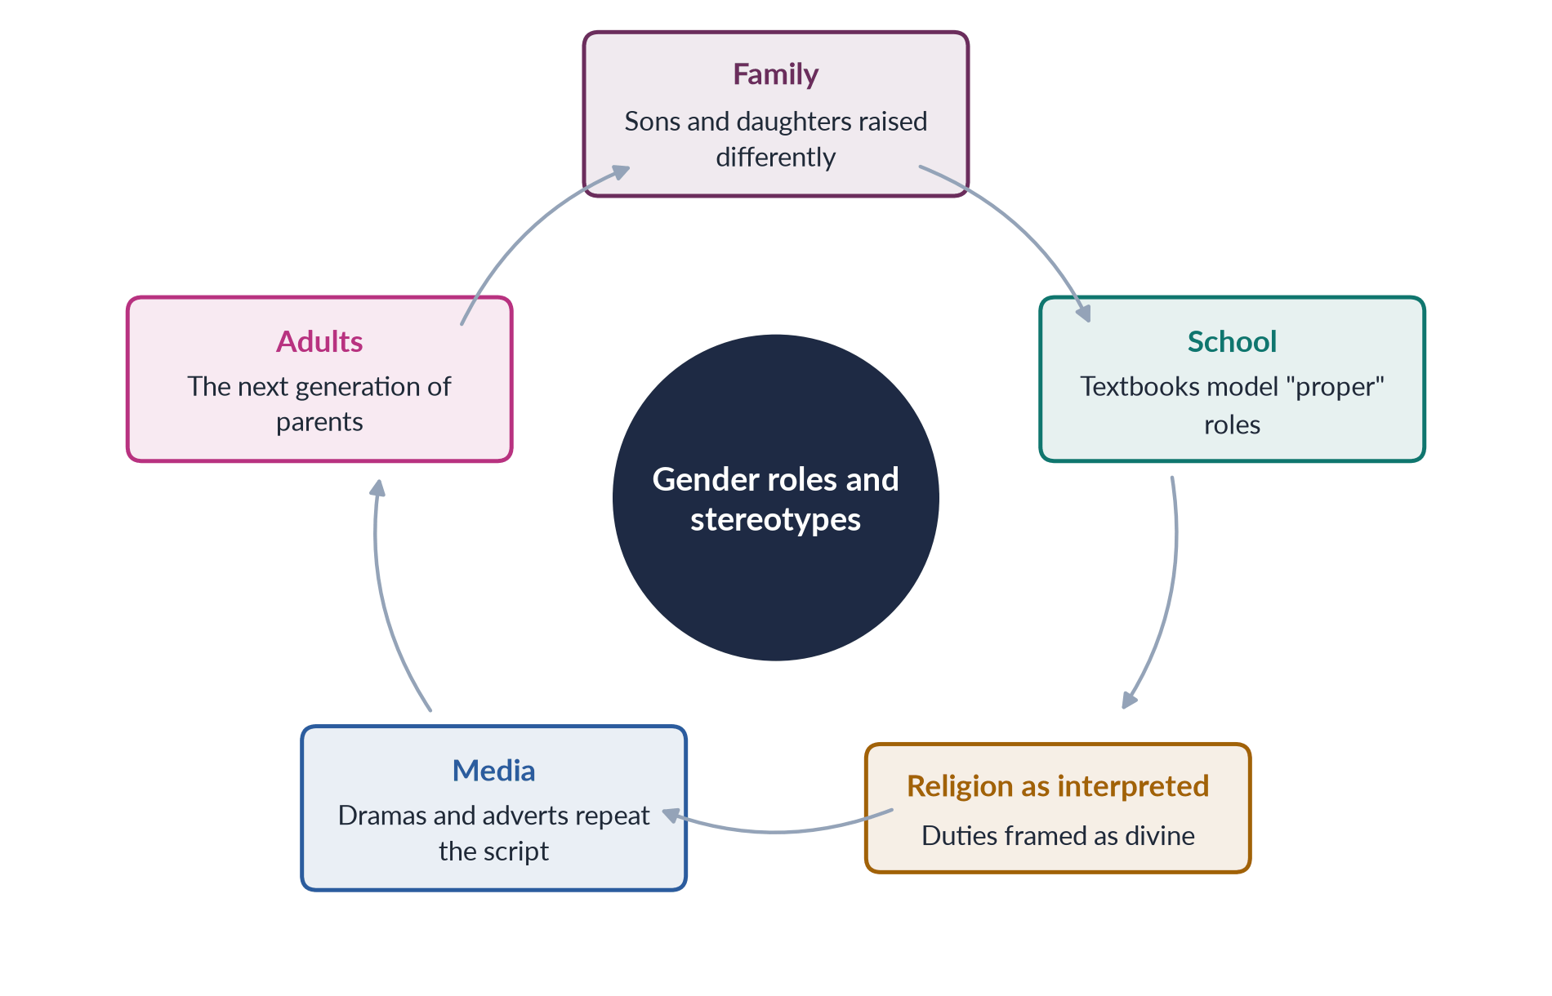
Figure 46 · How gender roles are reproduced across generations.

4. The family: the first school of gender

i) Different upbringing
Boys are given freedom of movement and the expectation of earning; girls are given housework, restrictions on movement and the expectation of marriage.

ii) Unequal investment
Daughters are seen as paraya dhan — "someone else's wealth" — so families invest less in their education and health; sons are expected to support parents in old age.

iii) Models at home
Children see fathers deciding and mothers serving, and learn the pattern as natural.

iv) Marriage as destiny
From childhood, girls hear that marriage is their goal and that a good wife is obedient and patient; boys hear that they must control the family's honour (izzat) through the women of the house.

5. School textbooks: the hidden curriculum

i) Images and roles
Textbooks often show mothers cooking and fathers in offices, and boys and girls behaving differently; women appear far less often than men, and rarely as scientists, leaders or professionals.

ii) The hidden curriculum
Beyond the books, schools teach gender through seating, sports, discipline and the subjects girls are steered towards.

iii) Why it matters
School carries the authority of the state, so its picture of gender looks official and correct.

6. Religion: teaching versus patriarchal interpretation

i) The teaching
Islam affirms women's equal moral worth, their right to education, consent in marriage, mahr and inheritance.

ii) Patriarchal interpretation
Custom presented as religion — denial of inheritance, forced marriage, restrictions on girls' schooling — is often justified in religious language. Muslim feminist scholars such as Riffat Hassan and Amina Wadud separate the Qur'an's message from patriarchal interpretation.

iii) The implication
Religion is not inherently the source of stereotypes; how it is interpreted and taught decides whether it reinforces or challenges them.

7. The media: dramas, advertisements and social media

i) Television dramas
Popular dramas often glorify the suffering, sacrificing wife and romanticise male control and jealousy.

ii) Advertisements
Adverts show women selling detergent and fairness creams and men selling cars and banking — linking women to the home and to appearance.

iii) Social media
It spreads both new images of women — athletes, pilots, entrepreneurs — and new misogyny, including online abuse of outspoken women.

iv) Role models
When the media show women succeeding — a woman chief minister (Maryam Nawaz, 2024), a woman Supreme Court judge (Ayesha Malik, 2022), a Nobel laureate (Malala, 2014) — they weaken the stereotype that public life belongs to men.

8. Language: sayings that fix stereotypes

i) Insults
"Choorian pehen lo" ("put on bangles", meaning "coward") makes womanhood an insult; "aurat ki aql" ("a woman's wit") means foolishness.

ii) Blame
"Zan, zar, zameen" — women, gold and land — names women as a cause of conflict.

iii) Masculinity
"Mard ko dard nahi hota" ("a man feels no pain") teaches boys to hide feelings — part of what R. W. Connell calls hegemonic masculinity.

9. The harm

i) To women
Stereotypes restrict women's education, work and mobility: female literacy is about 53% (Census 2023) and female labour-force participation 24.4% (LFS 2024–25).

ii) To men
The provider burden, emotional repression and pressure to prove manhood through control — even violence — harm men too.

iii) To the nation
Pakistan ranked 143rd of 145 in the Global Gender Gap Report 2026, wasting half its talent.

10. Changing the family and the school

i) The family

(a) Equal investment
Campaigns — and incentives such as girls' stipends — that reward families for educating daughters.

(b) Shared care
Fathers sharing care and housework, modelled in public campaigns.

ii) The school

(a) Textbook reform
Revise textbooks to show women and men in varied roles — doctors, engineers, farmers, caregivers — and include women in Pakistan's history, from Fatima Jinnah to Malala Yousafzai.

(b) Teacher training
Train teachers to avoid steering girls and boys into different subjects and to challenge stereotypes in class.

11. Changing religion's use and the media

i) Religious scholars
Enlist scholars to teach women's Islamic rights to education, consent and inheritance, and to reject customs that contradict them.

ii) The media

(a) Content
Encourage dramas and adverts that show women as capable professionals and men as caring partners.

(b) Online space
Enforce the Prevention of Electronic Crimes Act 2016 against online abuse, and support women's digital voices.

iii) Law and policy
Laws send signals: the workplace harassment law (2010) and 18-year marriage age in Sindh (2013) and Islamabad (2025) challenge old roles directly.

12. Conclusion

i) The core point
Gender roles and stereotypes are not natural facts but lessons — taught by families, textbooks, religion as interpreted, the media and language.

ii) The way forward
Because they are taught, they can be re-taught. Change must work through the same agents that build them, so that the next generation of Pakistani children learns that ability, not sex, decides what a person can be.

Why this answer scores
- Defines roles and stereotypes separately and shows how they connect.
- Explains how they are learned (Bandura, Kohlberg, Bem) before the agents.
- Gives each of the four named agents its own heading with Pakistani examples, plus language.
- Organises remedies agent by agent, matching the analysis.
- A cycle figure shows how roles reproduce across generations.

Set 3 · Q. No. 3 · BISP through Moser and Kabeer: Has It Empowered Women or Merely Reached Them?
AT A GLANCE · PREDICTION PAPER SET 3 · Q. NO. 3 · 20 MARKS
Critically evaluate the Benazir Income Support Programme through the lenses of Caroline Moser's practical and strategic gender needs and Naila Kabeer's concept of empowerment. Has it empowered women or merely reached them?

The answer map
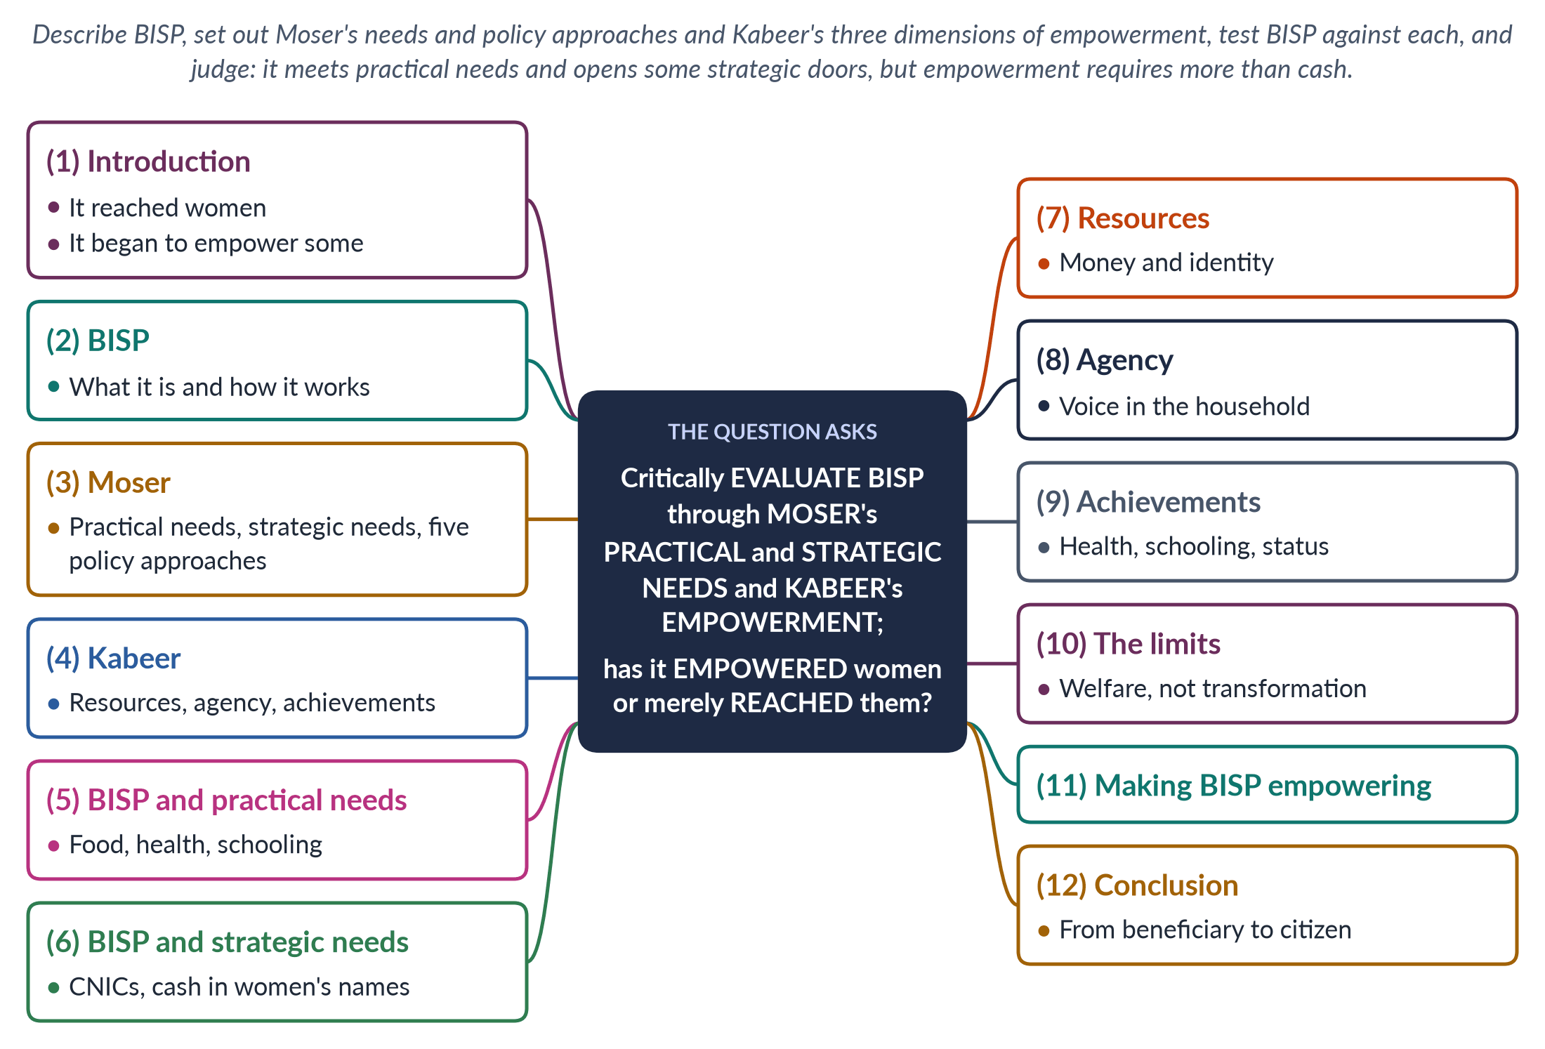
Figure 47 · The answer map: every branch is one numbered heading of the model answer below.

Decoding the question
"Critically evaluate" a programme through two named frameworks — so explain each framework precisely before applying it. Moser gives the distinction between practical and strategic gender needs (and her five policy approaches); Kabeer gives resources, agency and achievements. The final question — "empowered or merely reached?" — demands a clear verdict, recognising that reaching women is itself a step. This is a GAD question applied to Pakistan's largest social-protection programme.

The model answer

1. Introduction

i) The programme in a sentence
The Benazir Income Support Programme (BISP), launched in 2008, is Pakistan's largest cash-transfer programme. Its defining feature is that it pays women.

ii) The argument
BISP has certainly reached women: it put cash and national identity cards into the hands of millions of poor women. In Moser's terms it meets practical needs and opens a door to strategic ones; in Kabeer's terms it gives women resources and some agency, but rarely changes the structures that limit their choices. It is a vital first step towards empowerment, not empowerment itself.

2. BISP: what it is

i) Design
BISP pays regular cash to poor families, through the woman of the household, who must hold a CNIC to receive it.

ii) Linked programmes

(a) Waseela-e-Taleem
An education conditional cash transfer that pays mothers when children attend school.

(b) Benazir Nashonuma
Nutrition support for pregnant women and young children.

iii) Why pay women?
Paying the woman rests on evidence that money in women's hands is more likely to be spent on children's food, health and schooling, and on the hope that it strengthens women's position at home.

iv) Its place in policy
BISP was expanded during the IMF programmes of 2023 and 2024 as Pakistan's main social safety net.

3. Moser's framework

i) Practical gender needs
Immediate, material needs arising from women's existing roles — food, water, health care, income. Meeting them makes women's lives easier without challenging the gender division of labour.

ii) Strategic gender needs
Long-term interests in changing women's subordinate position — land and property rights, freedom from violence, political voice, control over one's own body.

iii) Five policy approaches
Caroline Moser (1993) classified policies for women as welfare (women as mothers), equity, anti-poverty, efficiency and empowerment — only the last aims to transform power relations.

4. Kabeer's framework

i) The definition
Naila Kabeer (1999) defined empowerment as "the expansion in people's ability to make strategic life choices in a context where this ability was previously denied to them".

ii) Three dimensions

(a) Resources
Material, human and social assets — the preconditions of choice.

(b) Agency
The ability to define goals and act on them — decision-making, bargaining, resistance.

(c) Achievements
The outcomes — well-being and changed status.

iii) The key insight
Resources alone are not empowerment: a woman can hold money she cannot control.
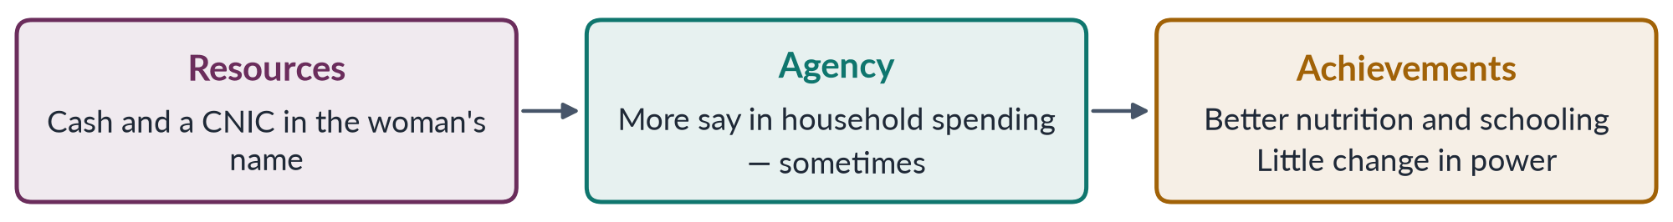
Figure 48 · Kabeer's three dimensions applied to BISP.

5. BISP and practical needs

i) Food and survival
Regular cash helps poor households buy food and fuel, especially in times of inflation and after disasters such as the 2022 floods.

ii) Health and nutrition
Benazir Nashonuma supports pregnant women and young children in a country where about 42% of women of reproductive age are anaemic (NNS 2018).

iii) Schooling
Waseela-e-Taleem rewards school attendance, addressing the poverty that keeps girls at home.

iv) Verdict on practical needs
BISP clearly meets practical gender needs — its core purpose.

6. BISP and strategic needs

i) The CNIC effect
Because payment requires a CNIC, BISP drove millions of women to register — and a CNIC is the key to voting, bank accounts, inheritance claims and SIM cards. It was a major reason the voter registration gap narrowed from 12.8% (2013) to 7.7% (2024).

ii) Money in women's names
Paying women rather than men recognises women as economic actors and gives them a resource the household depends on.

iii) Verdict on strategic needs
BISP opens doors to strategic change — identity, citizenship, financial access — but does not itself change land rights, mobility or violence.

7. Resources

i) What BISP adds
Cash, a CNIC and, increasingly, a bank or mobile account — material and social resources many poor women never had.

ii) What it does not add
It does not give women land, skills or jobs; female labour-force participation remains 24.4% (LFS 2024–25).

8. Agency

i) Evidence of greater voice
Some studies suggest that women receiving BISP gain greater say in household decisions — over food, children's schooling and health.

ii) The limits of agency
In many households the cash is collected by the woman but spent by men; mobility restrictions mean male relatives accompany women to payment points. Agency depends on intra-household bargaining, which cash alone does not transform.

iii) Longwe's ladder
Sara Longwe's framework ranks empowerment from welfare and access up to conscientisation, participation and control. BISP lifts women onto the first two rungs; it rarely reaches the upper three, where women become aware of discrimination, organise and share control over resources.

9. Achievements

i) Well-being
Better nutrition and school attendance in recipient families are real achievements.

ii) Status
A woman who brings regular income may gain respect; but the programme rarely changes social norms about women's roles, work or mobility.

10. The limits: welfare, not transformation

i) In Moser's terms
BISP sits mainly in the welfare and anti-poverty approaches — women reached as mothers and household managers, not as citizens claiming rights.

ii) The risk of reinforcing roles
Conditional transfers can add to women's unpaid work (collecting payments, meeting conditions) and reinforce the idea that women's responsibility is care.

iii) Exclusion at the margins
Women without a CNIC, or without documents to get one, are the hardest to reach — often the poorest, most remote or most controlled.

iv) A safety net is not a ladder
Cash cannot replace public services cut under austerity, nor create jobs — a point made in the feminist critique of structural adjustment.
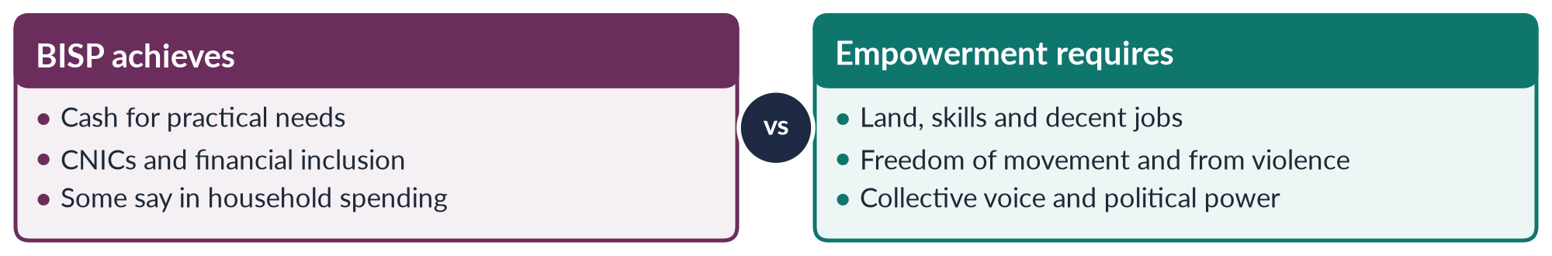
Figure 49 · BISP: what it achieves and what empowerment would require.

11. Making BISP empowering

i) From cash to capabilities
Link BISP to skills training, savings groups and jobs, so that resources become livelihoods.

ii) Women's own accounts and control
Pay into accounts only the woman can access, with digital literacy training.

iii) Collective voice
Organise recipients into women's committees, as in Kabeer's emphasis on collective agency; link them to local government, where 33% of seats were reserved for women in 2000–01.

iv) Strategic links
Use BISP's reach to promote inheritance registration, legal aid and awareness of laws against violence.

12. Conclusion

i) The verdict
BISP has reached women more effectively than any previous programme in Pakistan, and in doing so it met practical needs and opened doors to strategic ones — identity, citizenship and financial inclusion.

ii) The way forward
But reaching is not yet empowering: without land, skills, jobs, mobility and collective voice, cash leaves the structures of subordination intact. BISP should be treated as the foundation on which an empowerment strategy is built — moving women from beneficiaries to citizens.

Why this answer scores
- Explains both frameworks precisely — Moser's needs and five approaches; Kabeer's resources, agency and achievements.
- Applies each dimension to BISP in its own heading, with evidence (CNICs, the registration gap, NNS 2018, LFS 2024–25).
- Answers "empowered or merely reached?" with a nuanced verdict and concrete reforms.
- A flow and a compare figure organise the evaluation.

Set 3 · Q. No. 4 · Explaining Patriarchy: Radical, Marxist and Socialist Feminism Compared
AT A GLANCE · PREDICTION PAPER SET 3 · Q. NO. 4 · 20 MARKS
What is patriarchy? Critically compare the explanations of patriarchy offered by radical, Marxist and socialist feminists. Which explanation best accounts for women's subordination in Pakistan?

The answer map
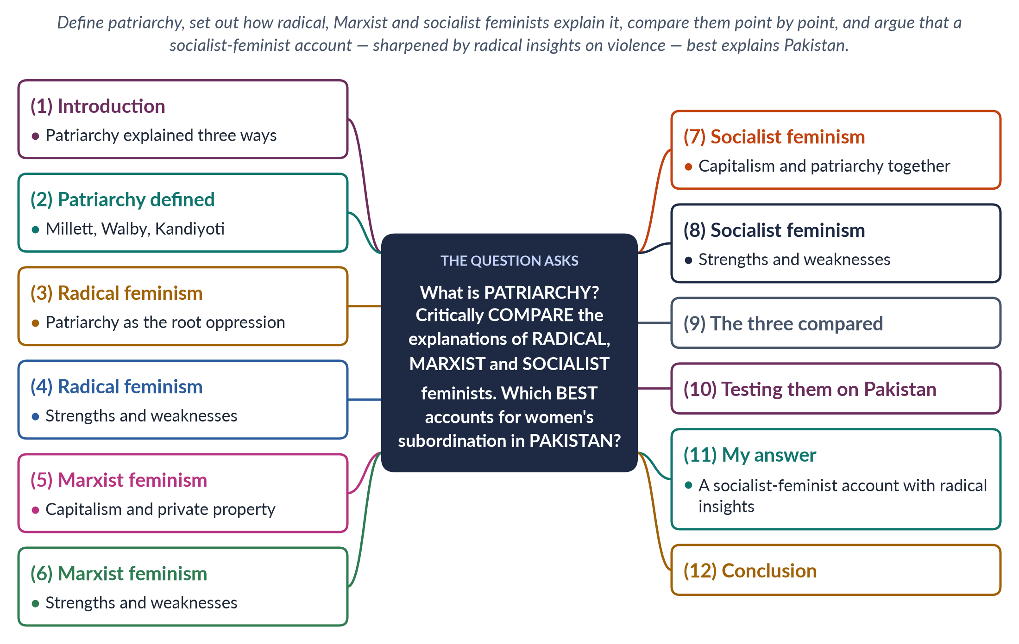
Figure 50 · The answer map: every branch is one numbered heading of the model answer below.

Decoding the question
Three tasks. "What is patriarchy?" — a precise definition, with the main theorists. "Critically compare" the three schools — explain each, then compare point by point (cause, site, remedy, thinkers, weaknesses); a table or figure helps. "Which best accounts for … Pakistan" — a reasoned judgement, tested against Pakistani evidence.

The model answer

1. Introduction

i) Definition
Patriarchy — literally "rule of the father" — is a social system in which men hold power over women in the family, economy, politics, religion and culture, and in which this power is presented as natural.

ii) The argument
Radical feminists see patriarchy as the oldest and deepest oppression, rooted in control of women's bodies; Marxist feminists see it as a product of capitalism and private property; socialist feminists see two linked systems working together. In Pakistan, where women's subordination is both material (property, work, wages) and bodily (honour, violence, marriage), the socialist-feminist account — sharpened by radical insights on violence — explains most.

2. Patriarchy defined

i) Millett
Kate Millett (Sexual Politics, 1970) made patriarchy the key concept of feminism: "sexual politics" — power relations between the sexes — run through family, religion, literature and force.

ii) Walby
Sylvia Walby (Theorizing Patriarchy, 1990) identified six structures: paid work, household production, culture, sexuality, male violence and the state — and distinguished private patriarchy (in the home) from public patriarchy (in work and the state).

iii) Kandiyoti
Deniz Kandiyoti ("Bargaining with Patriarchy", 1988) described "classic patriarchy" in the belt from North Africa to South Asia, where young brides gain power later as mothers of sons and mothers-in-law — a "patriarchal bargain".

3. Radical feminism: patriarchy as the root

i) The core claim
"Radical" comes from the Latin radix, root. Patriarchy is the oldest and most universal oppression, older than class or capitalism, and it operates above all through the family, sexuality, the body and violence.

ii) The thinkers

(a) Millett and Firestone
Millett located patriarchy in culture and force; Shulamith Firestone (The Dialectic of Sex, 1970) located its root in biology and reproduction, calling women a "sex class".

(b) Brownmiller and MacKinnon
Susan Brownmiller (Against Our Will, 1975) argued that rape keeps all women in fear; Catharine MacKinnon (1979) showed that sexual harassment is sex discrimination.

iii) The slogan and the method
"The personal is political" (Carol Hanisch, 1969–70), and consciousness-raising in women-only groups.

4. Radical feminism: strengths and weaknesses

i) Strengths
It exposed violence, rape and harassment as political, not private, and produced rape crisis centres, women's shelters and harassment law.

ii) Weaknesses
It treats all women as one, ignoring class and race (bell hooks, Audre Lorde); Firestone's biology risks determinism; and a universal patriarchy struggles to explain change.

5. Marxist feminism: capitalism and property

i) Engels
Friedrich Engels (The Origin of the Family, Private Property and the State, 1884) argued that with private property men wanted heirs, so monogamy was imposed on women — "the world historical defeat of the female sex".

ii) Housework as labour
Marxist feminists showed that women's unpaid domestic labour reproduces the worker for capital: Margaret Benston (1969), Mariarosa Dalla Costa and Selma James (1972) and Silvia Federici (1975) — "They say it is love. We say it is unwaged work."

iii) The remedy
End private property and capitalism; bring women into paid work and socialise care.

6. Marxist feminism: strengths and weaknesses

i) Strengths
It made unpaid work visible and explained women's role as a cheap reserve army of labour.

ii) Weaknesses
It is "sex-blind": it reduces gender to class, cannot explain why men of all classes dominate women, and underplays violence and sexuality. Socialist states left women with a double burden.

7. Socialist feminism: two systems together

i) The core claim
Women's oppression results from capitalism and patriarchy working together, in paid work and the family.

ii) The thinkers

(a) Mitchell
Juliet Mitchell (Woman's Estate, 1971) identified four structures: production, reproduction, sexuality and the socialisation of children.

(b) Hartmann
Heidi Hartmann ("The Unhappy Marriage of Marxism and Feminism", 1979) called Marxism sex-blind and proposed dual systems; male unions' demand for a "family wage" pushed women home.

(c) Eisenstein, Young and Mies
Zillah Eisenstein spoke of "capitalist patriarchy"; Iris Marion Young (1980) argued for a unified system; Maria Mies (1986) described "housewifisation".

iii) The remedy
Change both the economy and the family — economic independence, socialised care, and an end to male privilege at home.

8. Socialist feminism: strengths and weaknesses

i) Strengths
It joins class and gender, paid and unpaid work, and explains the double burden — Arlie Hochschild's "second shift" (1989).

ii) Weaknesses
The link between the two systems is hard to specify, and it can still underplay violence and sexuality, the radical feminists' strongest ground.
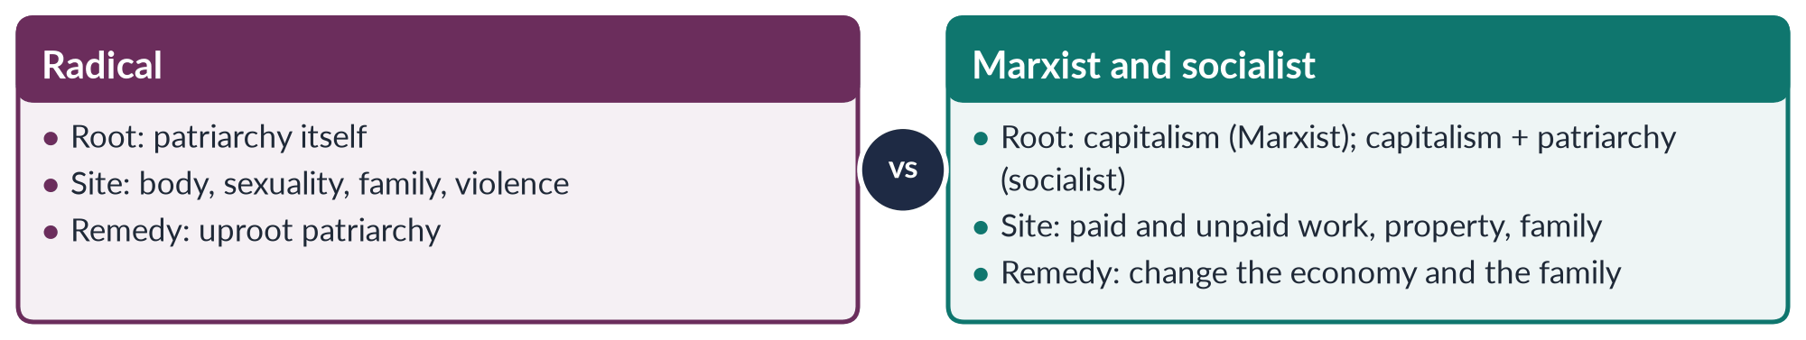
Figure 51 · Three explanations of patriarchy compared.

9. The three compared

i) Cause
Radical: patriarchy itself; Marxist: capitalism and property; socialist: both together.

ii) Site
Radical: body, sexuality and violence; Marxist: the economy; socialist: the economy and the family.

iii) Who benefits
Radical: men as a group; Marxist: capital; socialist: capital and men.

iv) Remedy
Radical: transform culture and sexuality; Marxist: abolish capitalism; socialist: change production and reproduction together.

10. Testing them on Pakistan

i) Evidence for the radical account
Honour killing (HRCP recorded at least 405 in 2024), domestic violence (28% of ever-married women since age 15, PDHS 2017–18), forced marriage and control of women's mobility show patriarchy operating through the body and honour, across classes.

ii) Evidence for the Marxist account
Most employed women work in agriculture, much of it as unpaid family helpers; home-based workers stitch for piece rates; women's labour-force participation is 24.4% (LFS 2024–25). Women's work is cheap because it is treated as secondary.

iii) Evidence for the socialist account
Property and patriarchy are fused: women are denied inheritance to keep land in the male line; karo-kari accusations are used to grab land; marriage within the clan protects property. Kandiyoti's classic patriarchy describes this joint system exactly.

11. My answer

i) Socialist feminism explains most
Pakistan's patriarchy is both economic — land, inheritance, unpaid and cheap labour — and social — honour, marriage, seclusion. Only an account that joins capitalism (and feudal property) with patriarchy captures this fusion.

ii) Sharpened by radical insights
The socialist account must borrow the radical feminists' focus on violence and the body: honour killing and harassment are not reducible to economics.

iii) Spoken in local terms
Pakistani movements have succeeded when they framed these insights in constitutional and Islamic language — the 1948 inheritance law and the 2016 honour law are examples.

12. Conclusion

i) The comparison
Radical feminism explains patriarchy's grip on the body; Marxist feminism explains its use of unpaid and cheap labour; socialist feminism explains how the two reinforce each other.

ii) The verdict
For Pakistan, where land, honour and labour are bound together, a socialist-feminist account sharpened by radical insights best explains women's subordination — and points to remedies in both the economy and the family.

Why this answer scores
- Defines patriarchy with three theorists (Millett, Walby, Kandiyoti).
- Explains each school with its thinkers and dates, then weighs strengths and weaknesses.
- Compares them point by point (cause, site, beneficiary, remedy) with a compare figure.
- Tests each account on Pakistani evidence before reaching a reasoned verdict.

Set 3 · Q. No. 5 · Why Only 24.4%? Barriers to Women's Paid Work and the Burden of Unpaid Care
AT A GLANCE · PREDICTION PAPER SET 3 · Q. NO. 5 · 20 MARKS
Female labour-force participation in Pakistan was only 24.4 per cent in 2024–25. Analyse the economic, social and institutional barriers to women's paid employment and the burden of unpaid care work. What policies would raise women's participation?

The answer map
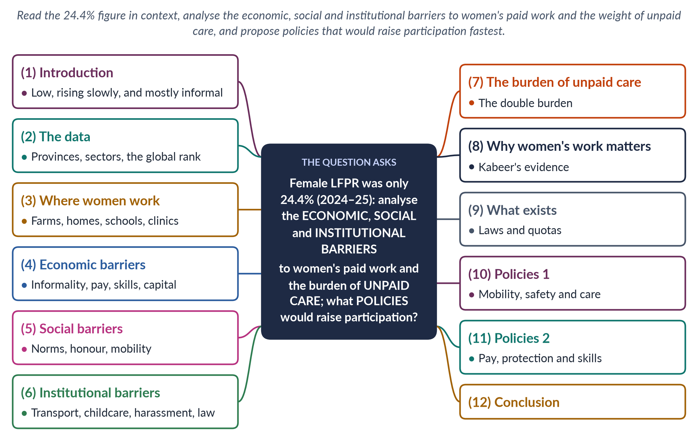
Figure 52 · The answer map: every branch is one numbered heading of the model answer below.

Decoding the question
The stem supplies the key figure — 24.4% (LFS 2024–25) — so begin by reading it in context. "Analyse" the barriers, which the question divides into economic, social and institutional: give each its own heading. "The burden of unpaid care work" needs a separate heading (the double burden). "What policies" asks for specific, practical measures — ideally ranked by impact.

The model answer

1. Introduction

i) Definition
The female labour-force participation rate (LFPR) is the share of working-age women who are employed or seeking work.

ii) The argument
At 24.4% in 2024–25 — up from 21.4% in 2020–21 — Pakistan's female LFPR is among the lowest in the world, and most women who work do so in unpaid or informal jobs. The causes are not women's unwillingness but a web of economic, social and institutional barriers, tied together by the unpaid care women carry at home. Raising participation requires making work safe, reachable, compatible with care and decently paid.

2. The data

i) By province
Female LFPR is 33.8% in Punjab, 21.1% in Khyber Pakhtunkhwa, 20.5% in Sindh and 14.5% in Balochistan.

ii) The global comparison
In the World Economic Forum's Global Gender Gap Report 2026, Pakistan ranked 144th on economic participation and opportunity — its weakest sub-index.

iii) The trend
The rise from 21.4% to 24.4% shows change is possible, but the gap with men remains vast.

3. Where women work

i) Agriculture
Most employed women work in agriculture — cotton picking, livestock, harvesting — much of it as unpaid family helpers, with wages often paid to husbands.

ii) Home-based work
Millions stitch, embroider and pack at home for piece rates through middlemen — what Maria Mies called "housewifisation".

iii) Services and professions
Teaching, nursing, Lady Health Workers, domestic work and a small but growing number in banking, IT, the civil service and the courts — Justice Ayesha Malik became the first woman Supreme Court judge in 2022.

4. Economic barriers

i) Informality and low pay
Most women's work is informal, without contracts, minimum wages or social security; the gender pay gap is wide.

ii) Skills and education
Female literacy is about 53% (Census 2023), limiting access to better jobs.

iii) Capital and assets
Women rarely own land or have access to credit, which blocks self-employment and business.

iv) Rural women's hidden work
Agricultural women work long hours without land, credit or extension services, exposed to heat and pesticides, and are rarely counted as farmers in their own right.

5. Social barriers

i) Norms of the breadwinner and honour
The belief that the man is the breadwinner and that a working woman shames the family's honour keeps many women at home.

ii) Accepted and unaccepted work
Teaching and medicine are acceptable; factory, retail and field jobs often are not.

iii) Marriage and the "missing" educated women
Many educated women leave work at marriage or the first child — the "doctor brides" phenomenon, in which women medical graduates never practise.

iv) The joint family
In joint families, a daughter-in-law's time belongs to the household: in-laws may forbid paid work outside the home, and care for elders falls on her.

6. Institutional barriers

i) Mobility and transport
Unsafe, crowded public transport and street harassment make the journey to work the first barrier; women-only buses are few.

ii) Childcare and maternity
Childcare is scarce and expensive; the federal Maternity and Paternity Leave Act 2020 and the Sindh Maternity Benefits Act 2018 cover mainly formal workers.

iii) Harassment at work
The Protection against Harassment of Women at the Workplace Act 2010 (amended 2022) requires inquiry committees and an ombudsperson, but enforcement is weak in the private and informal sectors.

iv) Workplace barriers
Occupational segregation, the glass ceiling (invisible barriers to the top), the sticky floor (low-wage, low-mobility jobs) and the motherhood penalty.
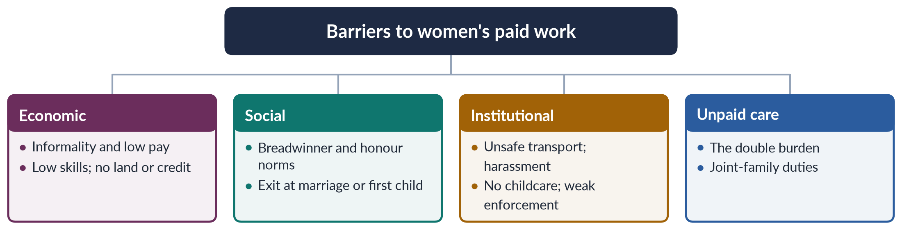
Figure 53 · Why women's labour-force participation is low.

7. The burden of unpaid care

i) The scale
Women do about three times as much unpaid care work as men worldwide (ILO, 2018) — cooking, cleaning, caring for children, the sick and the elderly.

ii) The double burden
Women who take paid jobs keep their unpaid work: Arlie Hochschild named this the "second shift" (1989). Caroline Moser described women's triple role — productive, reproductive and community-managing.

iii) An example
A village teacher earns a salary but still cooks, cleans and cares for children and in-laws before and after school; without childcare, transport or help at home, many such women stop work after marriage or a first child.

iv) Why it is invisible
Unpaid care is excluded from GDP — Marilyn Waring (If Women Counted, 1988) — so policy ignores it. SDG target 5.4 calls for it to be recognised, reduced and shared.

8. Why women's work matters

i) For women
Paid work gives income, independence, networks and voice. Naila Kabeer (The Power to Choose, 2000) found that Bangladeshi garment work gave many women their first independent income and greater bargaining power.

ii) For the economy
A country that keeps three-quarters of its women out of the labour force wastes half its talent and loses growth.

9. What exists

i) Laws
The harassment law (2010), maternity and paternity leave (2020), the Sindh Home-Based Workers Act 2018 and the Punjab Domestic Workers Act 2019.

ii) Quotas
A 10% quota for women in federal jobs — though many posts remain unfilled, and the private sector has no equivalent.

10. Policies 1: mobility, safety and care

i) Safe transport
More women-only and safe public transport, lighting, and enforcement against street harassment — the change that would raise participation fastest.

ii) Childcare
Public and workplace daycare, required for large employers and government offices.

iii) Shared care
Paid paternity leave and campaigns for men's share of housework; time-use surveys to count care.

11. Policies 2: pay, protection and skills

i) Fair pay
Equal pay for work of equal value (comparable worth) and enforced minimum wages.

ii) Protect informal workers
Extend social security and minimum wages to home-based and domestic workers in every province.

iii) Skills and digital work
Vocational and digital training, using the narrowing mobile-internet gender gap (38% to 25%, GSMA 2024–25) for online work.

iv) Enforce and lead
Strict enforcement of the harassment law in private firms, and more women in management and on boards.

12. Conclusion

i) The diagnosis
Pakistan's female LFPR of 24.4% reflects not women's choices but a system: informal and low-paid work, norms of honour and breadwinning, unsafe transport, scarce childcare and a crushing burden of unpaid care.

ii) The way forward
The fastest gains would come from safe transport, childcare, enforced harassment law, protected home-based and digital work and equal pay. Making paid work compatible with care — and sharing care with men — is the key that unlocks the rest.

Why this answer scores
- Reads the stem's 24.4% in context (trend, provinces, global rank of 144th).
- Uses the question's own categories — economic, social, institutional — as headings, with unpaid care separate.
- Grounds the analysis in theory (Hochschild, Moser, Waring, Kabeer, Mies).
- Proposes specific policies, identifying which would work fastest.
- A tree figure maps the barriers.

Set 3 · Q. No. 6 · Reserved Seats and Substantive Representation: Pitkin, Critical Mass and Critical Actors
AT A GLANCE · PREDICTION PAPER SET 3 · Q. NO. 6 · 20 MARKS
More than two decades after the Legal Framework Order 2002, have reserved seats produced substantive representation for women in Pakistan? Evaluate with reference to Hanna Pitkin's types of representation and the debate on critical mass versus critical actors.

The answer map
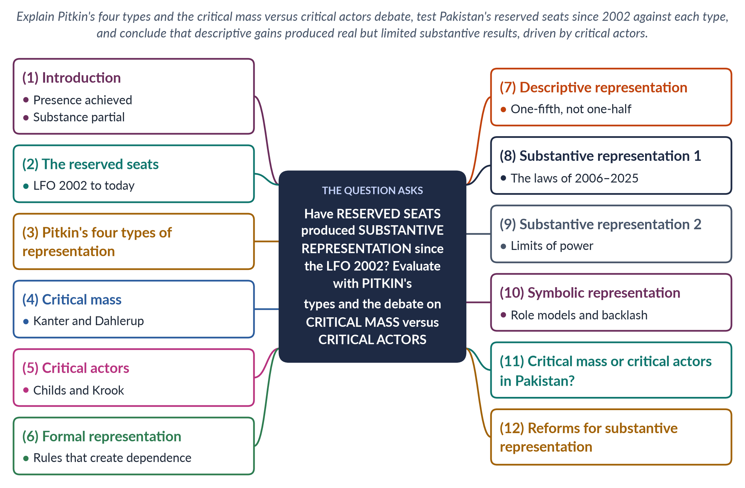
Figure 54 · The answer map: every branch is one numbered heading of the model answer below.

Decoding the question
"Have reserved seats produced substantive representation?" — a yes/no question that needs a qualified verdict. The framework is named: Pitkin's types (formal, descriptive, substantive, symbolic) — use each as a lens — and the critical mass versus critical actors debate. "More than two decades after the LFO 2002" means trace the record from 2002 to the present, with laws and data.

The model answer

1. Introduction

i) Definitions
Reserved seats are legislative seats only women can fill. Substantive representation means representatives act for the interests of the represented — in Pakistan's case, laws and policies that serve women.

ii) The argument
Since the Legal Framework Order 2002, reserved seats have given women a descriptive presence of about one-fifth of the National Assembly. That presence has produced real substantive gains — the pro-women laws of 2006–2025 — but these came less from numbers alone than from critical actors, cross-party caucuses and civil society. Formal rules that make reserved-seat members dependent on party leaders limit what presence can achieve.

2. The reserved seats

i) The history in brief
Reserved seats existed in 1956 (10), 1962 (6), 1973 (10) and 1985 (20), then lapsed after 1988; the elections of 1990, 1993 and 1997 had none.

ii) The LFO 2002
The Legal Framework Order 2002, validated by the 17th Amendment (2003), created 60 women's seats in an enlarged National Assembly, 17 in the Senate and 128 in the provincial assemblies.

iii) Today
After the 25th Amendment (2018) the Assembly has 336 seats: 266 general, 60 women and 10 non-Muslim. Seats are filled by proportional representation from party priority lists.

3. Pitkin's four types

i) Formal
The rules by which representatives are authorised and held accountable.

ii) Descriptive
Representatives resemble those they represent.

iii) Substantive
Representatives act for the interests of the represented.

iv) Symbolic
Representatives stand for the represented and shape how they feel about politics. (Hanna Pitkin, The Concept of Representation, 1967.)

4. Critical mass

i) Kanter
Rosabeth Moss Kanter (1977) found that women forming less than about 15% of a group are tokens — highly visible, isolated and pressured to conform.

ii) Dahlerup
Drude Dahlerup (1988) applied the idea to politics: once women reach a critical mass of about 30%, the culture and agenda change. ECOSOC adopted a 30% target in 1990.

5. Critical actors

i) Childs and Krook
Sarah Childs and Mona Lena Krook (2009) argued that critical actors — individuals, women or men, who initiate and push reforms — matter more than numbers.

ii) Critical acts
Dahlerup herself spoke of critical acts — such as quotas or new institutions — that change the rules for others.
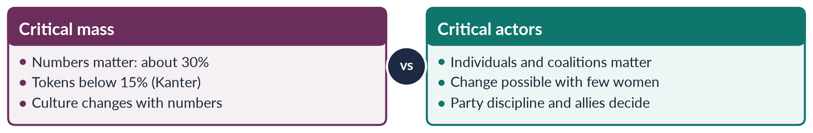
Figure 55 · Two theories of how women's presence becomes policy.

6. Formal representation: rules that create dependence

i) No constituency
Reserved-seat members are selected from party lists, not elected by voters, so they have no constituency to answer to.

ii) Dependence on leaders
Their place depends on party leaders, who often fill lists with relatives and loyalists; members must often ask a male general-seat colleague for development funds for the women who contact them.

iii) Two classes of members
They are sometimes treated as "second-class" members, with fewer funds and offices.

7. Descriptive representation: one-fifth, not one-half

i) The numbers
Women hold about one-fifth of the National Assembly — but only 11 won general seats in 2024, about 4% of the 266 general seats.

ii) Beyond parliament
In 2025 there were no women federal ministers.

iii) Verdict
The quota lifted women above tokenism (15%) but below critical mass (30%).

8. Substantive representation 1: the laws

i) A record of legislation

(a) 2006–2012
The Protection of Women Act 2006, the workplace harassment law and section 509 PPC (2010), the acid and anti-women practices laws (2011, private members' bills) and the NCSW Act 2012.

(b) 2013–2025
Provincial domestic-violence laws (Sindh 2013, Balochistan 2014, Punjab 2016, KP 2021, Islamabad 2025), the honour and anti-rape laws (2016), and the Islamabad child-marriage law (2025).

ii) The caucus
The Women's Parliamentary Caucus (2008), founded under Speaker Fahmida Mirza, built cross-party support for these laws.

iii) Activity
Monitors such as FAFEN and PILDAT have found women among the most active members in questions and debates.

9. Substantive representation 2: the limits of power

i) Marginal posts
Women are given "soft" portfolios and few committee chairs; economic policy remains male-dominated.

ii) Party discipline
Party lines override women's common interests, and reserved-seat members cannot defy leaders who chose them.

iii) Elite composition
Most reserved-seat members are urban and elite; poor, rural and minority women remain under-represented.

iv) Implementation
Laws passed are often weakly enforced, and backlash — such as the Council of Islamic Ideology's opposition to the Punjab law of 2016 — slows them.

10. Symbolic representation

i) Role models
Benazir Bhutto (1988), Fahmida Mirza (2008), Hina Rabbani Khar (2011) and Maryam Nawaz (2024) changed ideas about who can lead.

ii) Normalisation
Women's visible presence in parliament has made women's issues normal parliamentary business.

iii) Backlash
Women legislators also face sexist remarks and online abuse — a sign that symbolic change is contested.

11. Critical mass or critical actors in Pakistan?

i) The honour-killing law: a case of critical actors
Senator Sughra Imam moved the anti-honour-killing bill in 2014; it passed the Senate in 2015 but stalled in the National Assembly. After Qandeel Baloch's murder (July 2016), women legislators, the caucus, civil society and media pressed again, and a joint sitting passed the Act in October 2016.

ii) The lesson
With fewer than 30% of seats, Pakistan's women legislators still won major laws — through critical actors, coalitions and public pressure. Numbers created the opportunity; actors used it.
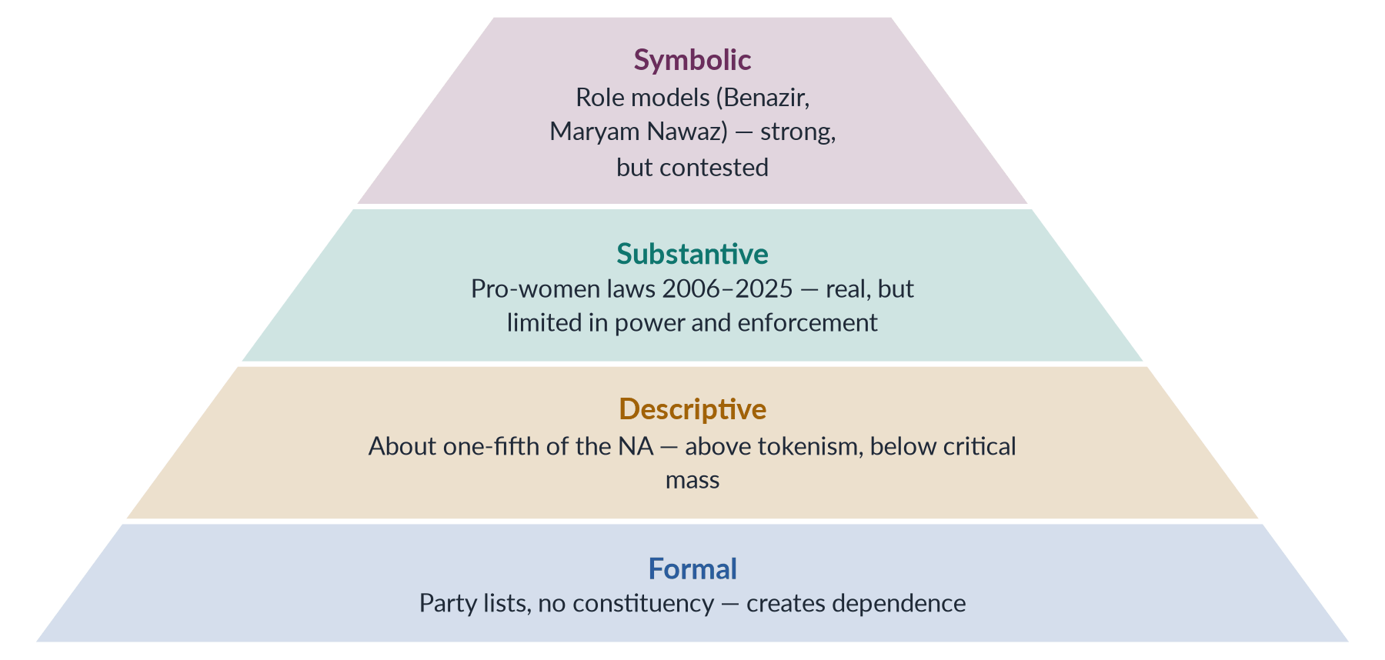
Figure 56 · Pitkin's four types tested on Pakistan's reserved seats.

12. Reforms for substantive representation

i) Change the formal rules
Move towards direct election — for example, women-only constituencies or rotating reserved constituencies — or, as an interim step, assign reserved-seat members districts with equal development funds.

ii) Increase numbers where power lies
Enforce and raise the 5% ticket rule of section 206, with a share in winnable seats; appoint women to key ministries and committee chairs.

iii) Strengthen critical actors
Fund and empower the Women's Parliamentary Caucus and provincial caucuses; link them to the NCSW and women's organisations; require transparent party lists that include rural and minority women.

13. Conclusion

i) The verdict
Reserved seats have not been a façade: they produced a descriptive presence of about one-fifth and a substantial record of pro-women legislation. But formal dependence, marginal posts and weak enforcement have limited their substantive power.

ii) The theory confirmed
Pakistan's experience supports Childs and Krook more than a simple critical-mass view: change came from critical actors using the space quotas created. The next step is to turn presence into power — through direct election, winnable tickets and women in real decision-making posts.

Why this answer scores
- Uses all four of Pitkin's types as lenses, and both sides of the critical mass / critical actors debate.
- Traces the record from the LFO 2002 to 2025 with laws, data and the caucus.
- Uses the honour-killing law as a worked case of critical actors.
- Reaches a qualified verdict and proposes reforms for each weakness.
- A compare and a pyramid figure organise theory and evidence.

Set 3 · Q. No. 7 · Mukhtaran Mai, Malala Yousafzai and Sharmeen Obaid-Chinoy: Violence, Voice, the State and the Media
AT A GLANCE · PREDICTION PAPER SET 3 · Q. NO. 7 · 20 MARKS
Compare the case studies of Mukhtaran Mai, Malala Yousafzai and Sharmeen Obaid-Chinoy. What do they reveal about violence, voice and the role of the state and the media in Pakistan?

The answer map
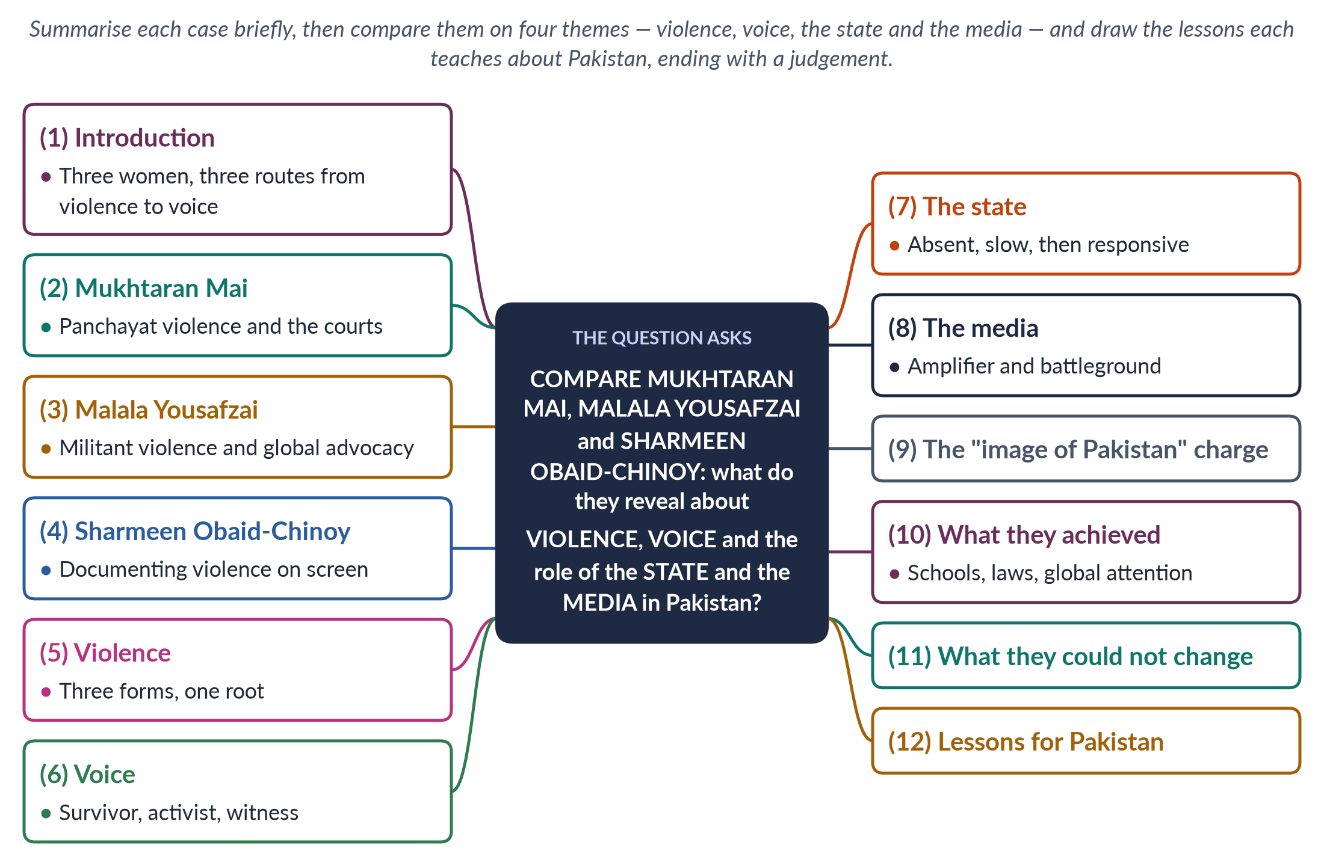
Figure 57 · The answer map: every branch is one numbered heading of the model answer below.

Decoding the question
"Compare" means set the three cases side by side on common themes — not three separate summaries. Keep each case summary short, then organise most of the answer by the four themes the question names: violence, voice, the state and the media. A comparison of the three case studies has never been asked — a blind spot — but each case has been asked singly (Mukhtaran Mai 2019, Sharmeen Obaid-Chinoy 2020, Malala 2025).

The model answer

1. Introduction

i) The three cases
Mukhtaran Mai, a survivor of panchayat-ordered gang rape; Malala Yousafzai, a schoolgirl shot by the Taliban for demanding education; and Sharmeen Obaid-Chinoy, a filmmaker who documented acid attacks and honour killing.

ii) The argument
Together they show that violence against women in Pakistan is rooted in patriarchal power — tribal, militant and familial — and sustained by impunity. Each woman turned violence into voice by a different route: survival, activism and documentation. The state was absent or slow until the media — national and global — forced a response. Their courage changed laws and debates; it could not by itself change the structures that produce violence.

2. Mukhtaran Mai

i) The crime
On 22 June 2002, in Meerwala, Muzaffargarh (South Punjab), a panchayat dominated by the powerful Mastoi clan ordered the gang rape of Mukhtaran Mai, of the weaker Tatla clan, to "punish" an accusation against her twelve-year-old brother.

ii) The legal journey
An anti-terrorism court sentenced six men to death (2002); the Lahore High Court acquitted five (2005); the Supreme Court upheld the acquittals on 21 April 2011.

iii) Her response
She refused silence or suicide, used her compensation to open her village's first girls' school, founded a women's welfare organisation and wrote In the Name of Honor (2006).

3. Malala Yousafzai

i) The context
In Swat, the Taliban under Maulana Fazlullah banned girls' education from 2009 and destroyed more than a hundred girls' schools.

ii) The attack
Malala, who had written a BBC Urdu diary as "Gul Makai" (2009), was shot in the head on her school bus on 9 October 2012.

iii) Her advocacy
She addressed the United Nations on 12 July 2013, founded the Malala Fund (2013) and shared the Nobel Peace Prize in 2014 with Kailash Satyarthi, at 17 the youngest laureate.

4. Sharmeen Obaid-Chinoy

i) The filmmaker
Born in Karachi in 1978, she became Pakistan's first Oscar winner — and won twice.

ii) The two films

(a) Saving Face (Oscar 2012)
Co-directed with Daniel Junge, it followed acid-attack survivors Zakia and Rukhsana and surgeon Dr Mohammad Jawad, alongside the passage of the Acid Control and Acid Crime Prevention Act 2011.

(b) A Girl in the River (Oscar 2016)
It told the story of Saba Qaiser, shot by her father and uncle near Gujranwala for marrying by choice, who survived but was pressured to forgive them.

5. Violence: three forms, one root

i) Three perpetrators
A tribal panchayat (Mukhtaran Mai), a militant movement (Malala), and husbands and fathers (Sharmeen's subjects).

ii) One root
In every case violence punished a woman or girl for transgressing a male-defined order — of clan honour, of religious control, of family izzat.

iii) In Galtung's terms
Direct violence (rape, shooting, acid) rested on structural violence (parallel justice, forgiveness laws, weak policing) and cultural violence (honour, misused religion).
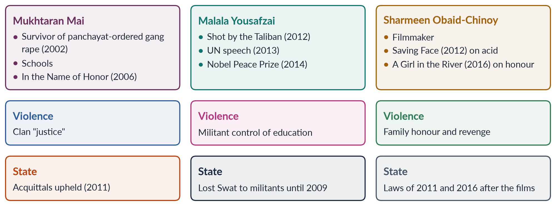
Figure 58 · The three case studies compared.

6. Voice: survivor, activist, witness

i) The survivor
Mukhtaran Mai broke the expected silence and spoke as a survivor, turning personal violence into public testimony.

ii) The activist
Malala spoke before and after the attack, as an activist for a right — education — rather than only as a victim.

iii) The witness
Sharmeen spoke as a witness, giving other women's stories a national and global audience — and showing survivors' agency, as when Zakia sought justice.

7. The state: absent, slow, then responsive

i) Absent
The state failed to prevent the crimes: panchayat justice in Meerwala; the Taliban's control of Swat until the 2009 military operation; impunity for acid attackers and honour killers.

ii) Slow and defensive
Mukhtaran Mai's case ended in acquittals; the government placed her on the Exit Control List in 2005 (later reversed), and President Musharraf's remark about women "crying rape" provoked outrage.

iii) Responsive under pressure
After the films and public outrage, the state legislated: the Acid Act 2011, the honour-killing law of October 2016 — after Prime Minister Nawaz Sharif said "there is no honour in honour killing" — and constitutional commitment to education under Article 25A.

8. The media: amplifier and battleground

i) Amplifier
A local imam's sermon and a journalist made Mukhtaran Mai's case national and global; the BBC diary and international coverage made Malala known; Sharmeen's films reached Oscar audiences and Pakistani television.

ii) Battleground
The same media spread conspiracy theories — Malala as a "Western agent", an "I am not Malala" day by a private schools' federation in 2014 — and the charge that the films "defamed Pakistan".

9. The "image of Pakistan" charge

i) The charge
Critics say these cases "wash Pakistan's dirty linen in public" and serve foreign agendas.

ii) The reply
Silence protects abusers. The cases also show Pakistani reformers — lawyers, doctors, legislators, the women themselves — and they led to Pakistani laws. Shame belongs to the violence, not to those who expose it.

10. What they achieved

i) Mukhtaran Mai
Schools in Meerwala, a women's organisation, and a voice in the debate that preceded the Protection of Women Act 2006.

ii) Malala
Global attention to girls' education, the Malala Fund's grants in Pakistan and beyond, and a symbol of resistance to militancy.

iii) Sharmeen Obaid-Chinoy
Public debate that helped secure the Acid Act 2011 and the honour-killing law 2016.

11. What they could not change

i) Impunity
Mukhtaran Mai's attackers were acquitted; honour killers still win pardons — Qandeel Baloch's brother was acquitted in 2022.

ii) Structures
More than 25 million children remain out of school, most of them girls; panchayats and jirgas still operate.

iii) The limits of individual courage
Individual courage and media attention can start change; only state action and social change can complete it.

12. Lessons for Pakistan

i) End parallel justice
Prosecute jirgas and panchayats that order violence.

ii) End impunity
Make crimes against women non-compoundable, strengthen investigation and protect witnesses.

iii) Use the media responsibly
Support survivor-centred journalism and documentary, and counter disinformation.

iv) Educate girls
Enforce Article 25A, so that Malala's cause becomes national policy.

13. Conclusion

i) The comparison in brief
Three women, three forms of violence — clan, militant and familial — and three routes to voice: survivor, activist and witness.

ii) The verdict
Their stories reveal a state that was absent or slow until the media forced it to act, and a society divided between those who saw them as heroines and those who saw them as threats to Pakistan's image. Their legacy is real — schools, laws, global attention — but incomplete until Pakistan ends the impunity their cases exposed.

Why this answer scores
- Compares on the four themes the question names, rather than summarising three cases separately.
- Keeps each case summary short but dated and precise (22 June 2002; 21 April 2011; 9 October 2012; Oscars 2012 and 2016).
- Uses Galtung to show the common root of the three forms of violence.
- Addresses the "image of Pakistan" charge fairly.
- A grid figure sets the three cases side by side.

Set 3 · Q. No. 8(a) · Short Note: Technology-Facilitated Violence against Women in Pakistan
AT A GLANCE · PREDICTION PAPER SET 3 · Q. NO. 8(A) · SHORT NOTE · 10 MARKS
Write short notes on any TWO of the following: Technology-facilitated violence against women in Pakistan.

The answer map
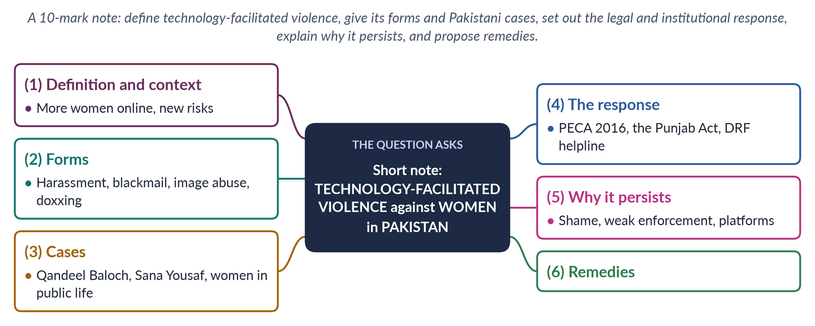
Figure 59 · The answer map for the short note: every branch is one headed point.

Decoding the question
A 10-mark note (about 550–650 words). Technology-facilitated violence is part of the contemporary layer — the 2026 paper asked about the digital gender gap. Define it, give its forms, Pakistani cases, the law (PECA 2016) and a short assessment with remedies.

The model answer

1. Definition and context

i) Definition
Technology-facilitated gender-based violence is violence against women carried out or amplified through phones, the internet and social media — harassment, stalking, threats and abuse that cause psychological, social and sometimes physical harm.

ii) The context
More Pakistani women are online than ever: the mobile-internet gender gap fell from 38% to 25% (GSMA, 2024–25), bringing about eight million more women online. Digital space offers voice, work and learning — and new forms of control.

iii) Why it is gender-based
It targets women as women: sexualised abuse and threats to family "honour" aim to push women out of public space — extending Liz Kelly's continuum of violence (1988) into the digital world.

2. Forms

i) Harassment and threats
Abusive messages, sexual comments and threats, often from strangers and sometimes coordinated against outspoken women.

ii) Blackmail and image-based abuse
Threats to share private images — real or doctored — to extort money, sex or obedience; fake profiles that damage a woman's reputation.

iii) Stalking and doxxing
Tracking a woman's location and publishing her private details (doxxing), exposing her to offline danger.

iv) Control within the family
Husbands and relatives monitoring phones, restricting women's access to the internet, or using online activity as "proof" of dishonour.
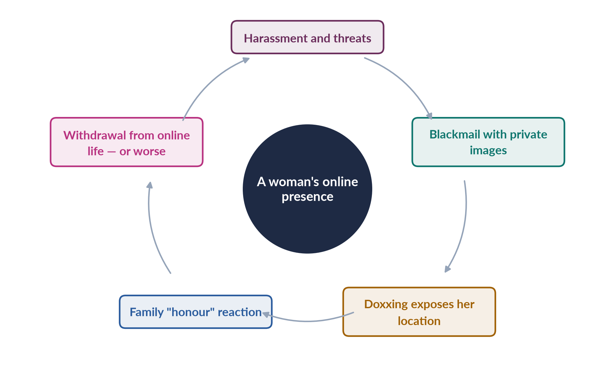
Figure 60 · How online violence becomes offline harm.

3. Cases

i) Qandeel Baloch (2016)
The social-media figure was strangled by her brother in Multan in July 2016, who claimed her online videos dishonoured the family — the case that led to the October 2016 honour-killing law.

ii) Sana Yousaf (2025)
The 17-year-old social-media creator was shot dead in Islamabad in June 2025 after refusing a man's advances.

iii) Women in public life
Women journalists, politicians and activists face trolling, doctored images and sexual slurs; marchers in the Aurat March faced online abuse and threats.

4. The legal and institutional response

i) PECA 2016
The Prevention of Electronic Crimes Act 2016 criminalises offences against the dignity and modesty of a person (sections 20–21) and cyber-stalking (section 24).

ii) The Punjab Act 2016
The Punjab Protection of Women against Violence Act 2016 lists cybercrime and stalking among the forms of violence in section 2(r).

iii) Helplines
The Digital Rights Foundation has run a cyber-harassment helpline since 2016.

5. Why it persists

i) Shame and silence
Victims fear that reporting will expose the images or messages to their families, so many stay silent — the same silence that leaves 56% of women who suffer violence never seeking help (PDHS 2017–18).

ii) Weak enforcement
Investigation capacity is limited, cases are slow and conviction is rare.

iii) Platforms and anonymity
Anonymous accounts and slow platform responses make abusers hard to identify and content hard to remove.

iv) Victim-blaming
Families and even police often blame the woman for being online at all — asking why she posted photos — rather than the abuser.

v) The digital divide in knowledge
Many women, especially new users, lack digital-safety skills.

6. Remedies

i) Enforcement
Specialised, well-staffed cyber-crime units with women officers, fast removal of abusive content and time-bound investigation.

ii) Prevention
Digital-safety education in schools and for new women users; campaigns against victim-blaming.

iii) Support
Expand helplines, legal aid and counselling; link online abuse to protection orders under the provincial violence laws.

iv) Platforms
Require platforms to respond quickly to complaints in Urdu and regional languages.

v) The line to take
Digital space is both a site of feminist voice and a new arena of patriarchal control; closing the mobile gap must go together with making the internet safe for women.

Why this answer scores
- A clear definition set in the context of the narrowing mobile gap (38% to 25%).
- Organises forms into four headings and gives Pakistani cases (Qandeel Baloch, Sana Yousaf).
- Names the law precisely (PECA 2016, sections 20–21 and 24; the Punjab Act 2016).
- Explains why it persists and offers practical remedies; a cycle figure shows online harm becoming offline harm.

Set 3 · Q. No. 8(b) · Short Note: SDG 5 and Pakistan's Progress
AT A GLANCE · PREDICTION PAPER SET 3 · Q. NO. 8(B) · SHORT NOTE · 10 MARKS
Write short notes on any TWO of the following: Sustainable Development Goal 5 and Pakistan's progress.

The answer map
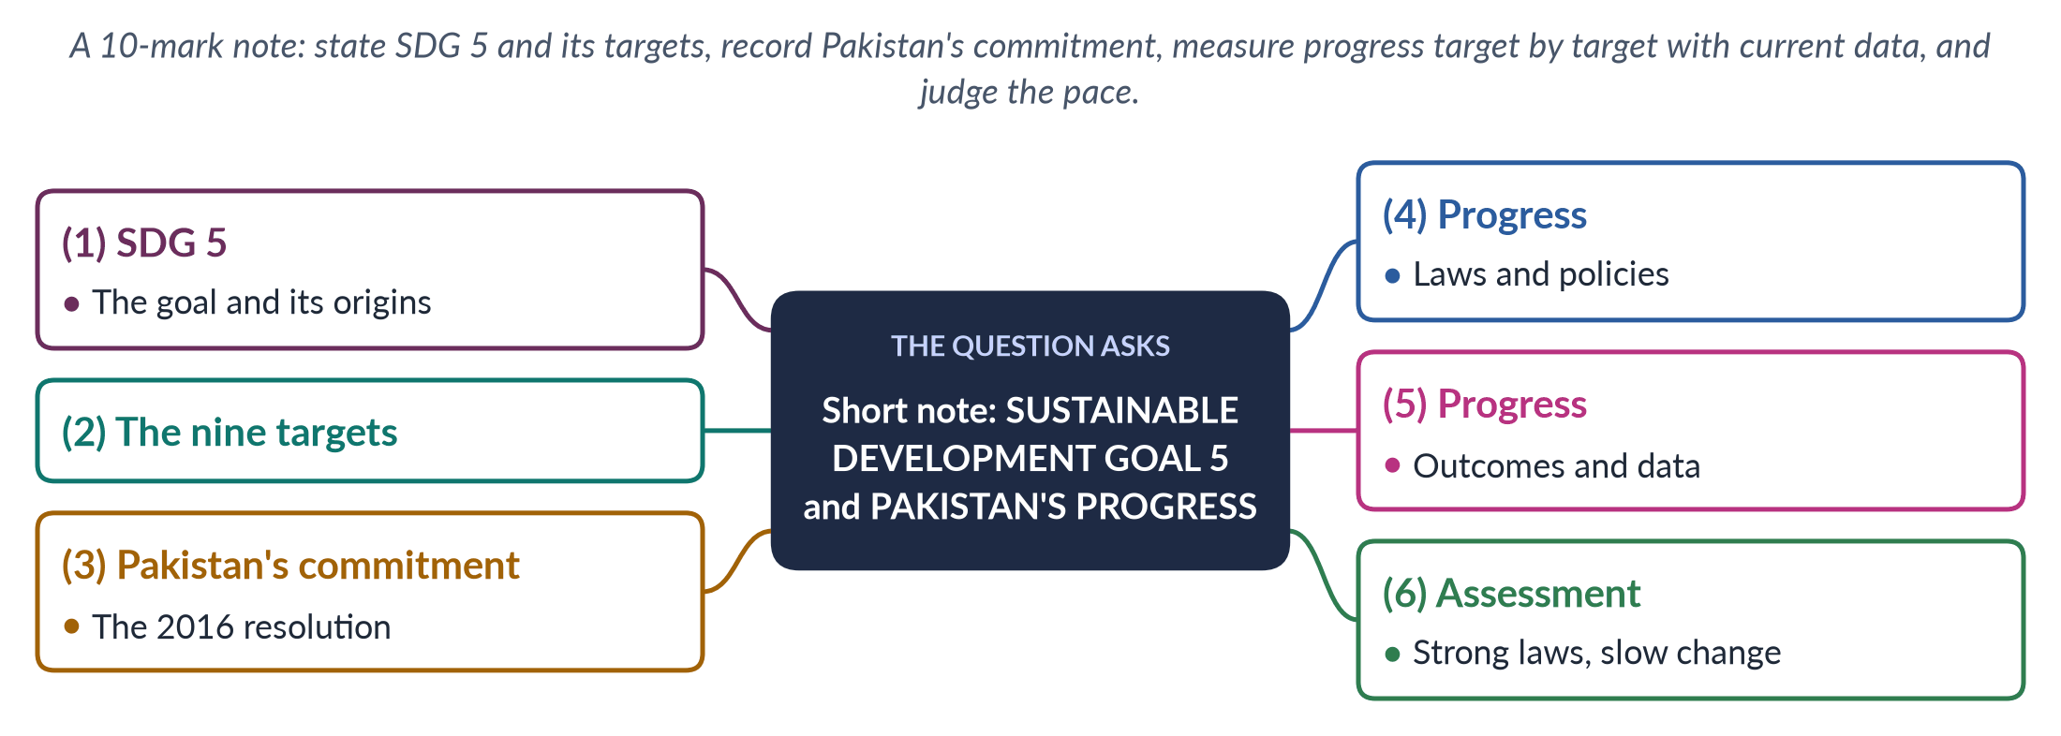
Figure 61 · The answer map for the short note: every branch is one headed point.

Decoding the question
A 10-mark note (about 550–650 words). The SDGs have never been asked as a descriptive question, though MCQs asked which SDG targets gender equality (2026). State the goal and its targets, then measure Pakistan's progress with dated data, target by target, and end with a judgement.

The model answer

1. SDG 5: the goal

i) The goal
SDG 5 — "Achieve gender equality and empower all women and girls" — is one of the 17 Sustainable Development Goals adopted by the UN in 2015 for the period to 2030.

ii) Its origins
It succeeded MDG 3 (gender equality and women's empowerment) and carries forward the commitments of CEDAW (1979) and the Beijing Platform for Action (1995).

iii) A cross-cutting goal
Gender targets also run through the other goals — poverty, health (SDG 3), education (SDG 4), decent work (SDG 8) and peace and justice (SDG 16) — so SDG 5 is both a goal and a lens on all the others.

2. The nine targets

i) Rights and violence
5.1 end discrimination; 5.2 eliminate violence, including trafficking; 5.3 eliminate child, early and forced marriage and female genital mutilation.

ii) Work and power
5.4 recognise and value unpaid care and domestic work; 5.5 ensure women's full participation and equal leadership; 5.6 universal access to sexual and reproductive health.

iii) Means of implementation
5.a equal rights to economic resources, land and property; 5.b use technology to empower women; 5.c adopt and strengthen policies and laws for gender equality.

3. Pakistan's commitment

i) The 2016 resolution
In February 2016 the National Assembly unanimously adopted the SDGs as Pakistan's national development agenda — one of the first parliaments to do so.

ii) The machinery
SDG support units were set up federally and in the provinces to track progress.

4. Progress: laws and policies
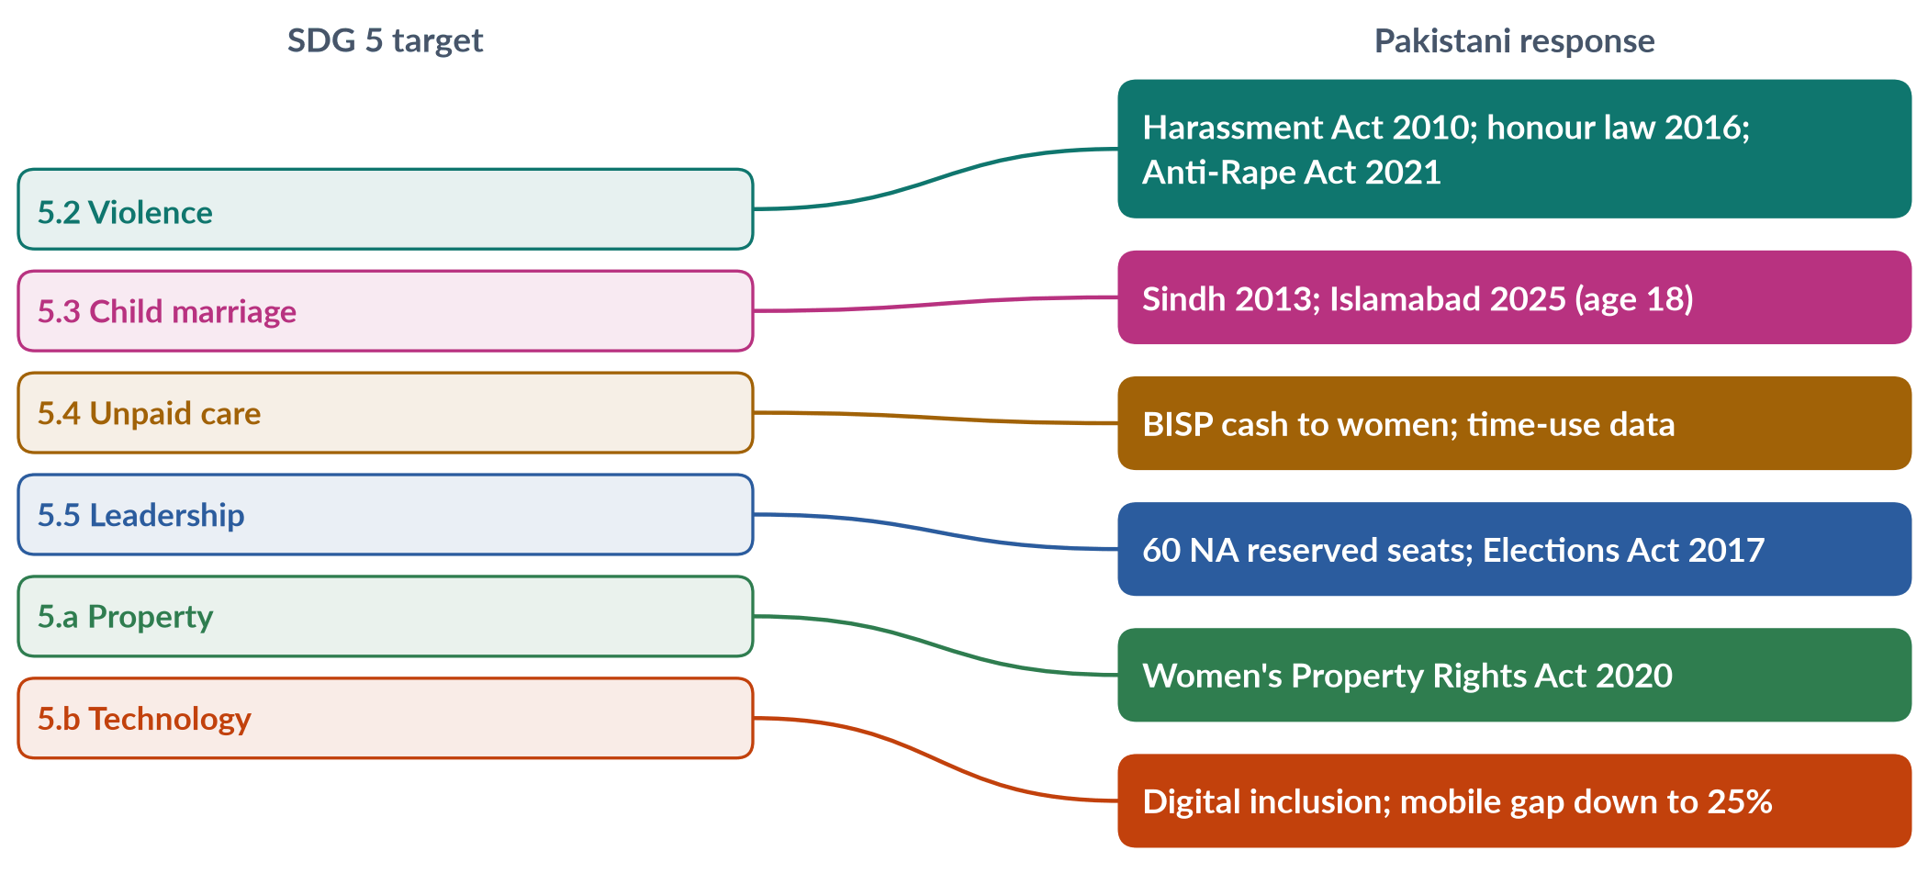
Figure 62 · How SDG 5 targets connect to Pakistani laws and programmes.

i) Violence (5.2)
The workplace harassment law (2010), the honour-killing law (2016), the Anti-Rape (Investigation and Trial) Act 2021 and domestic-violence laws in every province and Islamabad (2013–2025).

ii) Child marriage (5.3)
Marriage at 18 in Sindh (2013) and Islamabad (2025), and a Punjab bill passed in April 2026.

iii) Leadership and property (5.5, 5.a)
60 reserved National Assembly seats, the Elections Act 2017 (5% tickets; 10% turnout rule) and the Enforcement of Women's Property Rights Act 2020.

5. Progress: outcomes and data

i) The overall picture
Pakistan ranked 143rd of 145 in the Global Gender Gap Report 2026, up from last (148th of 148) in 2025.

ii) Work and care
Female labour-force participation is 24.4% (LFS 2024–25); unpaid care remains uncounted in national accounts.

iii) Health
The maternal mortality ratio was 186 per 100,000 live births (PMMS 2019), far above the SDG 3.1 target of below 70.

iv) Leadership
Only 11 women won general National Assembly seats in 2024, and there were no women federal ministers in 2025.

v) Education
Female literacy is about 53% (Census 2023), and more than 25 million children are out of school, most of them girls — a gap that drags on every other target.

vi) Technology
The mobile-internet gender gap fell from 38% to 25% (GSMA, 2024–25) — one of the clearest gains.

6. Assessment

i) Strong on paper
Pakistan has adopted laws and policies for most targets — a record that is strong on 5.c.

ii) Slow in outcomes
Outcomes — work, health, leadership, violence — are changing slowly; enforcement, funding and provincial capacity after the 18th Amendment are the main constraints.

iii) The lesson of the MDGs
Pakistan missed most MDG targets, including those on gender parity in education and maternal mortality — a warning that commitments without enforcement and funding repeat the same result.

iv) The verdict
At the current pace Pakistan will not achieve SDG 5 by 2030. Faster progress needs enforcement of existing laws, investment in girls' education and maternal health, childcare and safe transport for women's work, and sex-disaggregated data to track every target.

Why this answer scores
- States the goal and all nine targets, grouped for clarity.
- Records Pakistan's February 2016 parliamentary commitment.
- Measures progress target by target, with laws and dated data (GGGR 2026, LFS 2024–25, PMMS 2019, GSMA).
- A mapping figure links targets to Pakistani laws; the verdict is clear.

Set 3 · Q. No. 8(c) · Short Note: The National Commission on the Status of Women
AT A GLANCE · PREDICTION PAPER SET 3 · Q. NO. 8(C) · SHORT NOTE · 10 MARKS
Write short notes on any TWO of the following: The National Commission on the Status of Women.

The answer map
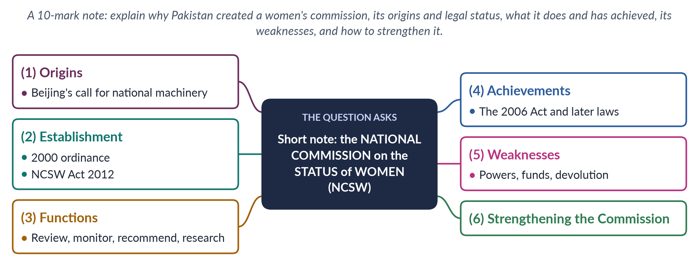
Figure 63 · The answer map for the short note: every branch is one headed point.

Decoding the question
A 10-mark note (about 550–650 words). The NCSW appears often in MCQs (it was set up under Pervez Musharraf — MCQ 2016) but has never been a descriptive question. Cover its origins, legal status, functions, achievements and weaknesses, ending with reforms.

The model answer

1. Origins

i) The global call
The Beijing Platform for Action (1995), in Critical Area H, called on governments to create strong national machinery for the advancement of women. CEDAW, to which Pakistan acceded in 1996, requires states to review laws and policies for discrimination.

ii) Pakistan's earlier machinery
Pakistan already had a Women's Division (1979), later the Ministry of Women Development; the Zari Sarfaraz Commission (1983–85) had reported on women's status, but its report was shelved. A permanent, expert watchdog was missing.

2. Establishment and legal status

i) The 2000 ordinance
The National Commission on the Status of Women was set up by ordinance in 2000, under Pervez Musharraf.

ii) The NCSW Act 2012
The NCSW Act 2012 gave the Commission a statutory basis and greater financial and administrative autonomy, strengthening its independence from the government of the day.

iii) Provincial commissions
After the 18th Amendment (2010) made women's development largely provincial, provinces created their own bodies — the Punjab Commission on the Status of Women (2014), for example.
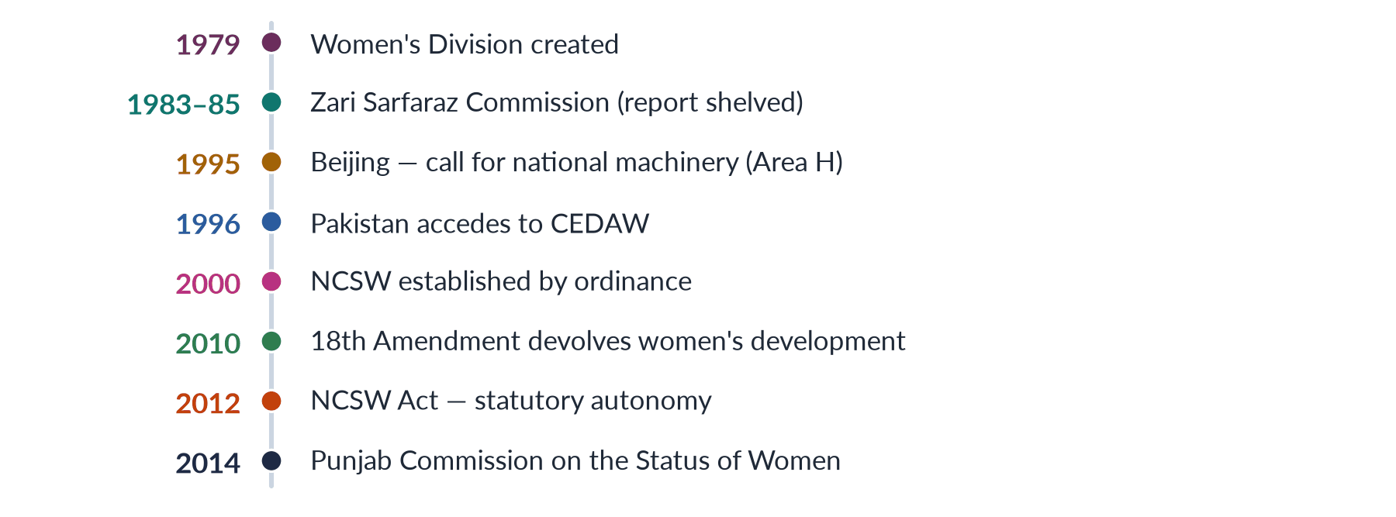
Figure 64 · The NCSW and Pakistan's women's machinery.

3. Functions

i) Review laws and policies
The Commission examines laws, rules and government policies for their effect on women and recommends repeal or reform of discriminatory provisions.

ii) Monitor implementation
It monitors how laws and commitments — including CEDAW and the SDGs — are carried out, and how institutions treat women.

iii) Recommend and research
It commissions research, collects data and advises the government and parliament on women's rights.

iv) Link state and society
It works with women's organisations, legislators and international bodies, bringing civil-society evidence into the state.

4. Achievements

i) The Hudood reform
After years of campaigning by women's groups, a report of the NCSW contributed to the Protection of Women (Criminal Laws Amendment) Act 2006, which moved rape out of the Zina Ordinance and back into the Penal Code.

ii) Later laws
It supported the laws of 2010–2016 — on workplace harassment (2010), acid and anti-women practices (2011), and honour killing (2016) — alongside the Women's Parliamentary Caucus (2008).

iii) An ally inside the state
With provincial commissions and harassment ombudspersons, the NCSW became an ally of the women's movement inside the state — part of what scholars call "state feminism" in Pakistan's reform phase.

5. Weaknesses

i) Advisory, not binding
Its recommendations are not binding; governments can delay or ignore them, so its influence depends on political will and on allies in parliament and civil society.

ii) Funds and staff
It has often been under-funded and short of staff, which limits its research, monitoring and reach beyond Islamabad.

iii) Devolution and overlap
After the 18th Amendment, the division of work between the federal Commission, provincial commissions and the federal Ministry of Human Rights (2015) has been unclear.

iv) Low public profile
Few women — especially in rural areas — know the Commission exists or how it can help them.

6. Strengthening the Commission

i) Powers
Require governments to respond formally to its recommendations within a fixed time and to table them in parliament.

ii) Resources and independence
Guarantee adequate public funding, transparent appointment of members and timely filling of vacancies.

iii) Coordination
Create a clear division of roles with provincial commissions and the Ministry of Human Rights, and a joint gender data system.

iv) Outreach
Open district-level complaint and information desks and use digital channels to reach women directly.

v) The line to take
The NCSW shows Pakistan has built the machinery for women's rights; what it still lacks is the power and resources to make that machinery decisive.

Why this answer scores
- Places the NCSW in its global context (Beijing Area H, CEDAW) and Pakistan's earlier machinery.
- Gives its legal history precisely (ordinance 2000; NCSW Act 2012; provincial commissions).
- Balances achievements (2006 Act, later laws) against weaknesses, ending with reforms.
- A timeline figure shows the evolution of Pakistan's women's machinery.

